Tamkang Times No.1198
Indonesian Gloria 1 and Gloria 2 High School Faculty and Students Make First Visit to Tamkang

21 faculty and students from Indonesia's Yayasan Pendidikan Kristen Gloria 1 and Gloria 2 High Schools visited Tamkang University on November 14 at 9 AM. Hosted by the Office of International and Cross-Strait Affairs, the visit included a tour of the Artificial Innovative Intelligence (AII) College, a comprehensive seminar, and academic program experiences, aiming to deepen their understanding of the university and increase their interest in pursuing education at Tamkang.

The group first visited the AII College, where they happily took a group photo in front of the AI Smart Interactive Wall with the Dean of the AI Innovation College, Prof. Tzung-Hang Lee. They explored various AI-integrated facilities in the immersive environment, such as "Q&A Interaction," "Mixed Reality," and "Career Navigation." The "Magic Mirror Journey," featuring facial fortune-telling, particularly piqued the curiosity of the visiting students and teachers.

Next, they proceeded to the Hsu Shou-Chlien International Conference Center for a comprehensive seminar. Dean of International Affairs Prof. Chien-Mu Yeh introduced the campus environment, teaching features, academic colleges, and programs such as the all-English undergraduate programs and the International Foundation Program. An interactive quiz session with prizes was held to reinforce their impression of Tamkang, and the students responded enthusiastically. The seminar also featured 2 Indonesian students currently studying in Tamkang: Nicholas Honggowarsito from the Department of Diplomacy and International Relations and Sharen Michelle Hariyanto, a third-year student in International Business who previously attended Gloria 1 High School. They shared their experiences studying at Tamkang and encouraged their younger peers to join the university.

The academic program experiences began with Professor Chien-Chang Chen from the Department of Computer Science and Information Engineering introducing the department's features and plans. He demonstrated the e-Pen Calligraphy system "Virtual Stroke," a technology that allows users to write characters with hand gestures, which then appear on the screen—amazing the visitors. Next, Chair Pin-Ju Juan from the Department of International Tourism Management introduced the department's unique characteristics. Assoc. Prof. Weili Jasmine Chen from the International Tourism Management Department led the group in a session of the "Forest Healing Guidance" course, where the students engaged with each other using expressive art therapy cards to experience interaction and art-assisted therapy.

The group’s leading teacher, Paulina Sigit, expressed her gratitude to Tamkang for organizing the visit, allowing students to explore the university’s learning environment and experience some academic programs. Joyce Tricia Lianto, a student from Gloria 2 High School, shared that the visit was highly engaging and provided her with valuable information about studying at Tamkang University.
2024/12/18

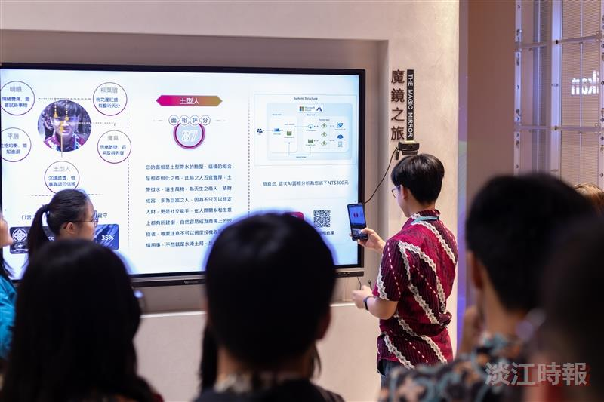
Visiting students experienced the "Magic Mirror Journey" facial fortune-telling feature in the immersive environment of the AI Innovation College and accessed their fortune-telling results using their smartphones.

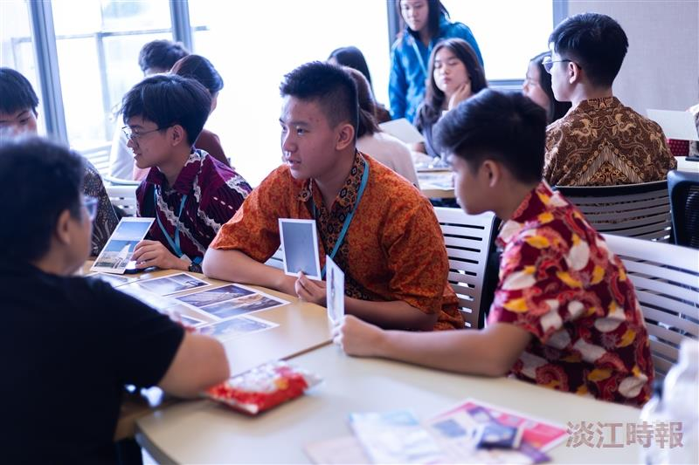
Visiting students interacted and engaged using expressive art therapy cards, experiencing part of the "Forest Healing Guidance" course.

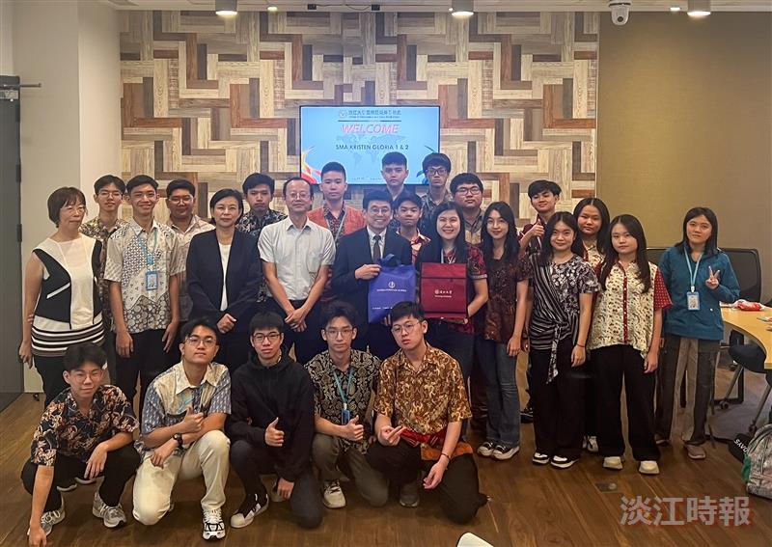
21 faculty and students from Indonesia's Gloria 1 and Gloria 2 High Schools visited Tamkang University on November 14. Hosted by the Office of International and Cross-Strait Affairs, the visit featured an admissions seminar and academic program experiences.

