Tamkang Times No.1198
Prof. Chung-Li Dong and Yu-Cheng Huang 's Highly Valued Paper Featured on International Journal Cover

In November, Professor Chung-Li Dong from the Department of Physics published 2 papers in international journals. The first paper, "Direct Identification of O-O Bond Formation Through Three-Step Oxidation During Water Splitting by Operando Soft X-ray Absorption Spectroscopy," was featured on the cover of Advanced Science. The second paper, "Energy Storage Chemistry: Atomic and Electronic Fundamental Understanding Insights for High-Performance Supercapacitors," was published in Applied Physics Reviews.

Department Chair Prof. Cheng-Hao Chuang explained that both journals are top-tier academic platforms. Advanced Science focuses on fundamental principles and applications in materials science and is recognized in the fields of physics and materials, classified as a Q1 journal with an impact factor exceeding 15 and still rising. Applied Physics Reviews, a high-level review journal under the American Institute of Physics (AIP), has an impact factor exceeding 19. “The academic relevance and significance of these two papers in both applications and physical mechanisms fully showcase Tamkang’s research strength and international competitiveness in physics.”

Prof. Dong explained that the first paper was co-authored with Tamkang alumnus Yu-Cheng Huang, who is now a jointly supervised Ph.D. student of Professor Wu-Ching Chou at National Chiao Tung University’s Department of Electrophysics. Both Dong and Huang were listed among the world’s most highly cited researchers in 2023, with only 18 scholars in Taiwan achieving this recognition. The second paper was co-authored with postdoctoral researcher Thanigai Arul Kumaravelu, along with 2 former foreign postdoctoral researchers.

Regarding the cover-selected first paper, Prof. Dong noted that scientists are dedicated to developing efficient water-splitting technologies to address climate change and energy crises. The research team utilized advanced instruments to observe, for the first time, how water molecules decompose to form gas. This study provides a critical scientific foundation for the development of future hydrogen energy technologies. The second paper employed synchrotron X-ray techniques to study the performance of various types of supercapacitors. The team directly observed changes in the atomic and electronic structures of electrode materials during charging and discharging, offering important scientific evidence and direction for optimizing and designing new high-efficiency energy storage devices.

Prof. Chuang highlighted that the Physics Department specializes in astronomy, X-ray technologies, and quantum computing. Through collaborative models involving synchrotron research stations and interdisciplinary research, the department continues to grow its research capacity. He emphasized that outstanding research outcomes stem from selecting the right talent, providing excellent experimental environments, and securing sufficient funding, which are critical to advancing scientific research capabilities.
2024/12/18

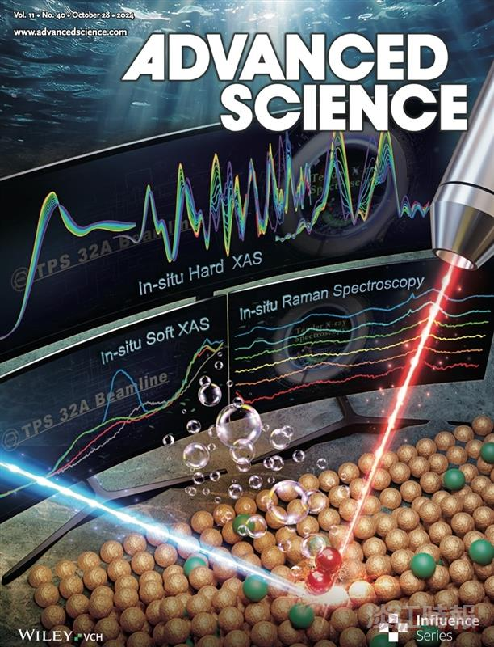
Professor Chung-Li Dong from the Department of Physics and alumnus Huang Yu-Cheng’s research paper was featured on the cover of Advanced Science.

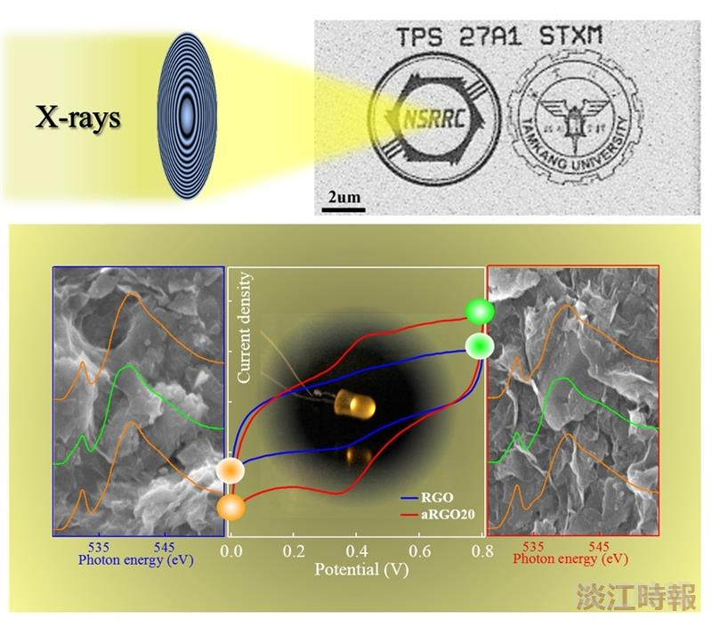
November, Professor Chung-Li Dong from the Department of Physics published his second research paper on the changes in atomic and electronic structures of extreme materials.

