Tamkang Times No.1198
General Education Micro-Program and Independent Learning Showcase: Students Present Diverse Themes

The Center for General Education and Core Curriculum hosted the "Knowledge Enhancement, Learning Upgrade: Tamkang General Education Micro-Program and Independent Learning Showcase" to enhance students' competencies in designing and executing learning plans from November 26 to 28. The showcase allowed students to present their course outcomes through an exhibition format. The opening ceremony took place on November 26 at 12:00 PM in the Black Swan Exhibition Hall, attended by Vice President for Administrative Affairs Chun-Hung Lin, Chief Secretary of the Board Wen-Chih Huang, Secretary-General Yu-Pei Ma, Chief Audit Executive Yen-Ling Lin, Dean of the College of International Affairs Cheng-Hao Pau, Dean of Academic Affairs Tzong-Ru Tsai, Dean of Library Sheue-Fang Sung, and over 100 faculty and students.

The ceremony was hosted by Director Shun-Jie Ji of the Center for General Education and Core Curriculum, with Assistant Professor Wei-Hong Weng leading students in an energetic opening performance titled "Drums and Gongs: Beiguan Music by College Students." In his remarks, Prof. Chun-Hung Lin commended the opportunities for active learning fostered by the students, as well as the dedication and innovative efforts of faculty in course guidance, which successfully sparked student interest and achieved better learning outcomes—one of the goals of the university’s development plan. Prof. Tzong-Ru Tsai highlighted that Tamkang's general education courses and interdisciplinary micro-programs are among the most diverse in the nation. He praised the innovative reforms of traditional curricula through micro-programs and their excellent results in fostering independent and cross-disciplinary learning. He encouraged the entire campus community to participate and invest more in these learning opportunities without compromising professional courses. Awards for the "Independent Learning Course Theme Competition" were then presented by Vice President Chun-Hung Lin and other administrators.

Student performances followed, including "Digital Music Composition: Variations of 'Twinkle, Twinkle, Little Star," directed by Professor Yung-Ying Gan; "Tamsui Field Theater: The Desolate Inn," directed by Associate Professor Hui-Yun Chen; "Dancing Keys: A Student Piano Sharing Session," directed by Professor Pei-Yee Lee; and "Echoing Soul," a collaborative cross-campus performance with National Taiwan University, directed by Associate Professor Wen-Chi Wu. The static poster exhibition featured 2 main themes: "Lessons Beyond the Classroom," showcasing outcomes of interdisciplinary independent learning from 10 courses and 3 narrative documentaries on multiculturalism and humanistic care; and "Local and Mobile Narratives," highlighting local narratives, mobile learning, and AI storytelling. Community colleges were also invited to participate, contributing 10 course themes.

A series of related activities included a special session on "European Cultural and Artistic Journeys through Film," a reflective forum titled "From Exploring Humanity to Discovering Place—A Two-Year Review of the Ministry of Education’s Narrative Innovation Curriculum Development Project," and a discussion on "Interdisciplinary General Education and Micro-Programs: From Independent Learning to Knowledge Integration," offering participants more ideas for cross-disciplinary independent learning.

Associate Professor Hui-Ru Li from the Department of Chinese, who participated in the exhibition titled "Tamsui Eight Views," explained how she guided students to discuss and select iconic landscapes in the Tamsui area, write essays in classical Chinese, and use AI-generated images to submit their final works. The goal was to encourage students to integrate humanities with technology, presenting unique perspectives of landscapes aided by technology and inspiring Chinese literature students to adopt modern narrative techniques.

Chun-Lun Yan, a sophomore in Transportation Management who participated in "The Desolate Inn" performance, said that the showcase validated his classroom learning efforts and gave him a better understanding of organizing exhibitions. "I hope more exhibitions like this will be held in the future, allowing more people to focus on the diverse learning and development opportunities provided by general education courses," he added.
2024/12/18

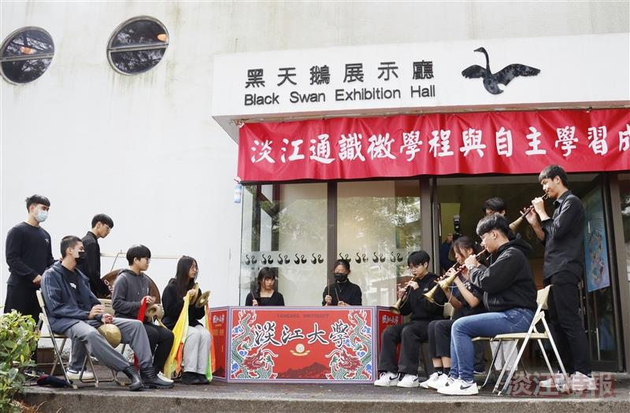
The students kicked off the event with a traditional opera music performance titled "Drums and Gongs: Beiguan Music by College Students."

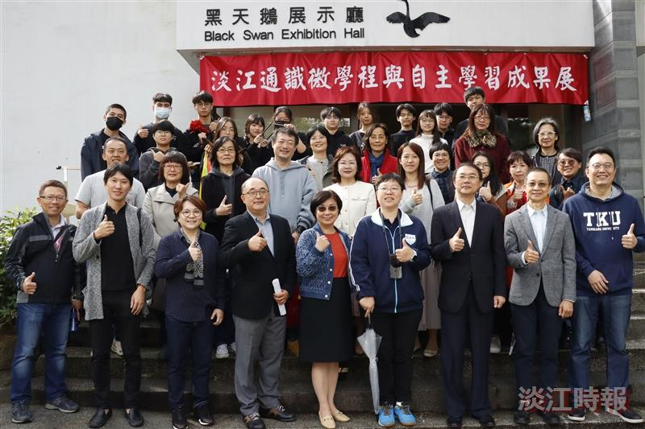
The Center for General Education and Core Curriculum held the opening ceremony of the "Knowledge Enhancement, Learning Upgrade: Tamkang General Education Micro-Program and Independent Learning Showcase" on November 26 at 12:00 PM.

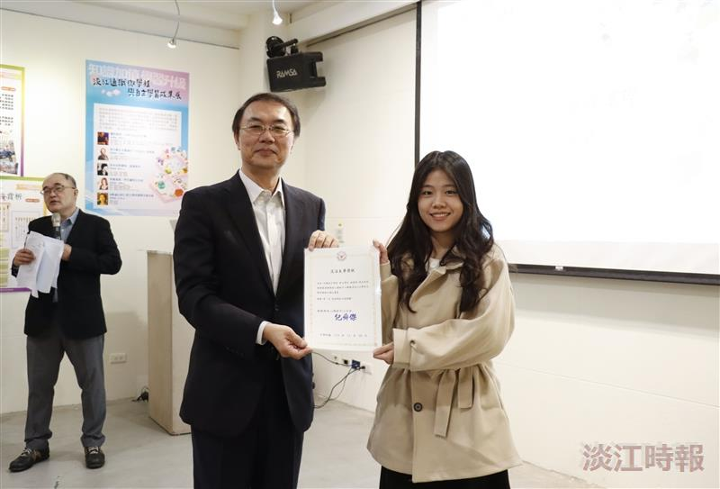
Vice President for Administrative Affairs Chun-Hung Lin presented the first-place certificate for the "Independent Learning Course Theme Competition" to Hsiao-Ni Lin, a senior in the English Department.

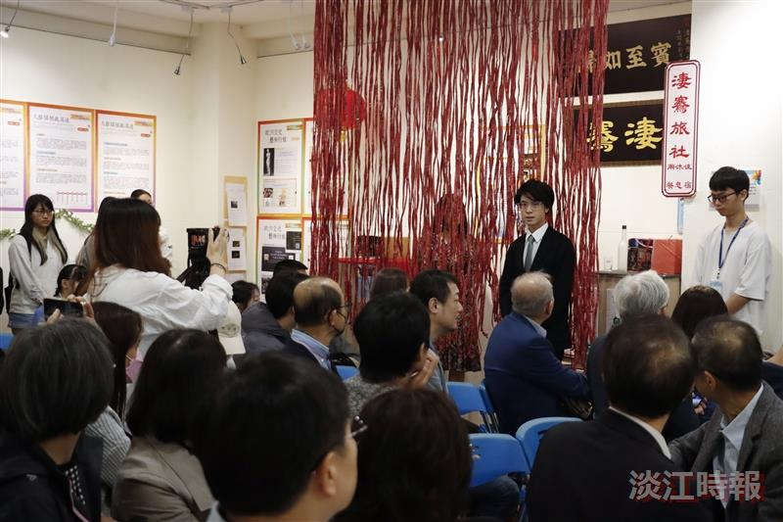
The students delivered a live theatrical performance of "The Desolate Inn" (《淒騫旅社》), captivating the audience with their vivid and engaging acting.

