Tamkang Times No.1198
【Tamkang Clement and Carrie Chair】Kazuo Asano Urges Higher Education to Cultivate Students' Observational and Listening Skills Beyond AI's Reach

"Understanding humanity itself is crucial. It’s not just about cold, hard academics but about embracing the warmth and spirit of human beings," stated Professor Kazuo Asano, Vice President of Heisei International University (HIU) in Japan. During the Tamkang Clement and Carrie Chair Lecture delivered on November 22 at 10:30 a.m. to the faculty and students of the Department of Global Political Economics at the College of International Affairs, Prof. Asano addressed the heated discussions surrounding AI. He emphasized that higher education should play a vital role in fostering students' observation and listening skills.

With the theme "Impact on Social Sciences and its Future Development in the Age of AI," Prof. Asano delivered a speech in Japanese after receiving the Tamkang Clement and Carrie Chair Trophy from Vice President for Academic Affairs, Prof. Hui-Huang Hsu. The lecture was held at the Chang Yeo Lan International Conference Hall of the Hsu Shou-Chlien International Conference Center. Prof. Asano announced, "We will conduct two translation games" — live translations between Chinese and English — to evaluate AI's capabilities in facilitating cross-linguistic communication.

He noted that he is not an AI expert; for the past 30 years, he has focused on studying Taiwan-Japan relations and Taiwanese politics. However, today he wanted to discuss the future development of AI and what we should do in this era. Prof. Asano emphasized that the advent and application of generative AI, such as ChatGPT, have profoundly impacted social sciences and daily life within just 2 years. AI can not only answer questions but also create novels, design advertisements, perform multilingual translations, and even provide strategies to address social issues like declining birthrates and aging populations. However, the potential risks associated with AI cannot be overlooked. These include deepfake technology, the spread of misinformation, copyright issues, cultural biases, and the use of AI for illegal activities, all of which are significant drawbacks associated with AI.

He went on to illustrate the dangers of AI-generated fake news by citing international incidents: rumors about the Ukrainian First Lady purchasing cars and luxury goods, cases of fake news being used to manipulate public opinion during elections in India, and a viral video claiming that Ukrainian forces would retreat from a certain city. He highlighted that while AI development brings numerous opportunities, it also presents significant challenges. "We need to find a balance to ensure that the advancement of AI technology does not negatively affect society," he stated.

In his concluding remarks, he stated, "From a Christian perspective, Adam and Eve being expelled from the Garden of Eden signifies that humans possess free will, and by exercising this right, they use imagination and creativity to become complete human beings." Asano believes that if AI entirely replaces human decision-making and creativity, the purpose of the universe's existence might disappear.

He cited the example of the beautiful calligraphy works featured in the Japanese NHK taiga drama The Life of Murasaki Shikibu. These works are not merely data or information but expressions of emotion and creativity—something that AI cannot surpass. He emphasized that the core of social sciences and humanities lies not only in data analysis but also in understanding the human spirit and well-being. "This is not only a requirement for students but also a reflection for us as educators."

Dean of the College of International Affairs, Professor Cheng-Hao Pao, remarked that when AI was first introduced to social science research, the minimum expectation was for AI to assist in understanding other languages. However, today's experimental results show that the accuracy of English translations has reached 90%, while Chinese translations remain somewhat poor. He commented, "We still have a long way to go. AI always requires constant improvement, and we cannot allow ourselves to be controlled by AI."

Chair of the Department of Global Politics and Economics, Assoc. Prof. Ying-Lung Chou also agreed with the speaker's perspective: "We hope that students use AI to assist their learning, not to replace it." He emphasized the importance of foundational knowledge, adding, "If we substitute learning with AI, it would be a terrifying scenario."

Professor Kazuo Asano, the Tamkang Clement and Carrie Chair invited by the Department of Global Politics and Economics and Vice President of Tamkang University's sister school, Heisei International University in Japan, visited on November 22 at 1:30 PM and 2:00 PM, accompanied by Dean of the College of International Affairs Cheng-Hao Pao, Department Chair Ying-Lung Chou, and Assistant Professor Hong-Xin Hsu. They paid visits to President Huan-Chao Keh and Chairperson Flora Chia-I Chang. President Keh and Chairperson Chang respectively presented Prof. Asano with a Panda trophy and a vase imprinted with calligraphy by Masters Chi-Mao Li and a painting by Master Ben-Hang Chang, featuring Tamkang campus scenery and the school anthem as commemorative gifts.

Tamkang University maintains frequent exchanges with HIU. Professor Kazuo Asano has visited our campus multiple times, participating in various academic and sports-related faculty and student exchange activities. He expressed gratitude for being invited as a Tamkang Clement and Carrie Chair professor and hopes to further strengthen the interaction between the two universities. He specifically welcomed efforts to introduce Tamkang University to the students of the 4 high schools affiliated with HIU, encouraging them to study in Taiwan after graduation. President Keh extended a warm welcome and appreciation to Professor Asano and mentioned that next year marks the 75th anniversary of Tamkang University. He sincerely invited him to visit again and join in the celebrations.

Chairperson Chang, who led an administrative delegation to visit HIU in 2002, invited Professor Asano to view and take a commemorative photo with the bronze sculpture Elegantly Toward Tomorrow, a surprise gift from then-Chairman Eitaro Sato. She also mentioned another piece gifted by Chairman Sato at the time, Traveler, which still stands in front of the Carrie Chang Fine Arts Center, warmly accompanying the Tamkang community. Professor Asano fondly recalled memories of that period and shared his experience of recently visiting our university's History Gallery, where he discovered many photos from his earlier visits to Tamkang, leaving him deeply touched. He also expressed gratitude for the arrangements made by the university, especially his impression of the Panda Suite in the Huei-Wen Hall. Chairperson Chang explained the origins of the Tamkang Clement and Carrie Chair, founded by Tamkang University's founder, Dr. Clement C.P. Chang, and his wife. She warmly welcomed Professor Asano to visit Tamkang regularly and jokingly remarked, "The next time you visit Tamkang, you’ll see your photo among the Tamkang Clement and Carrie Chair s displayed in the Tamkang History Gallery."
2024/12/18

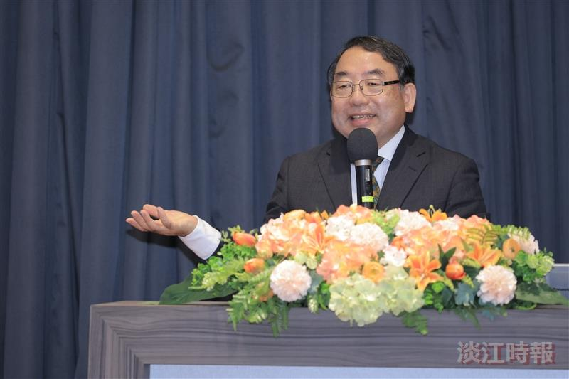
Professor Kazuo Asano, Vice President of Heisei International University in Japan.

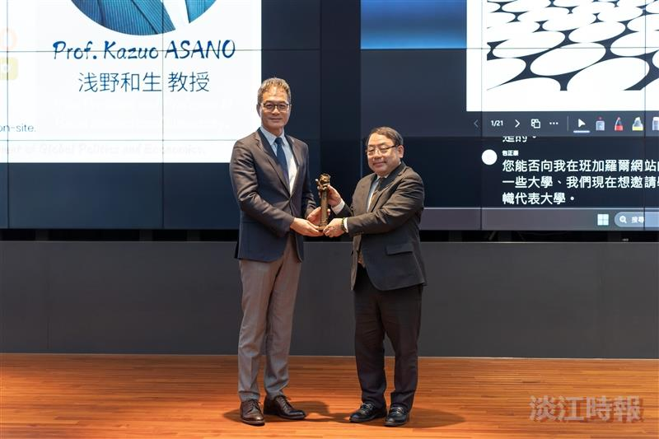
Professor Kazuo Asano, Vice President of Heisei International University in Japan (right), receives the Panda trophy from Academic Vice President Hui-Huang Hsu.

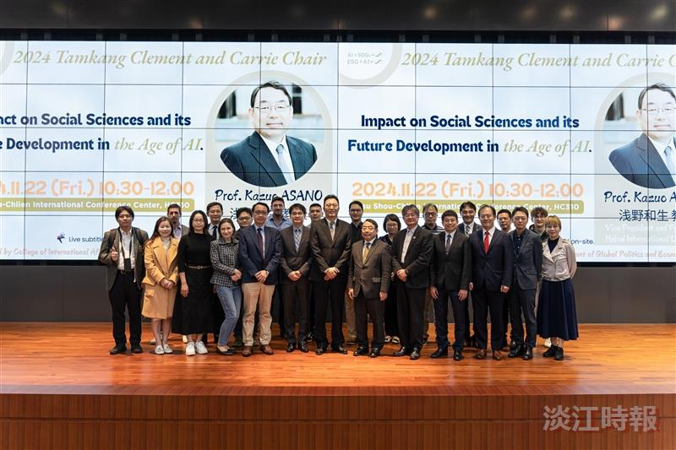
Faculty members of the International Affairs College take a group photo with Professor Kazuo Asano.

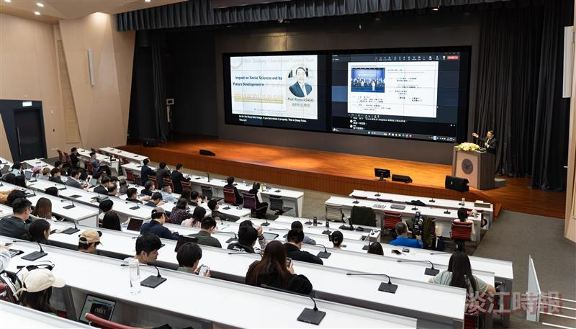
Professor Kazuo Asano shared a humanities scholar's perspective on AI with the faculty and students of the Department of Global Politics and Economics.

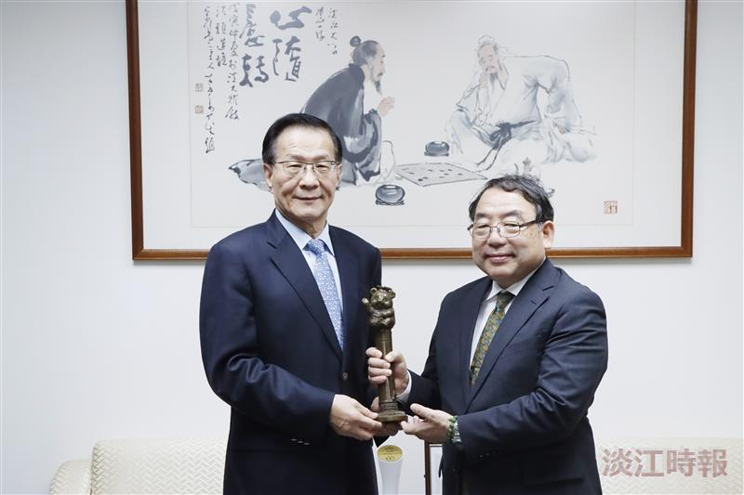
President Huan-Chao Keh (left) personally presented a Panda trophy to Professor Kazuo Asano, the Tamkang Clement and Carrie Chair invited by the Department of Global Politics and Economics.

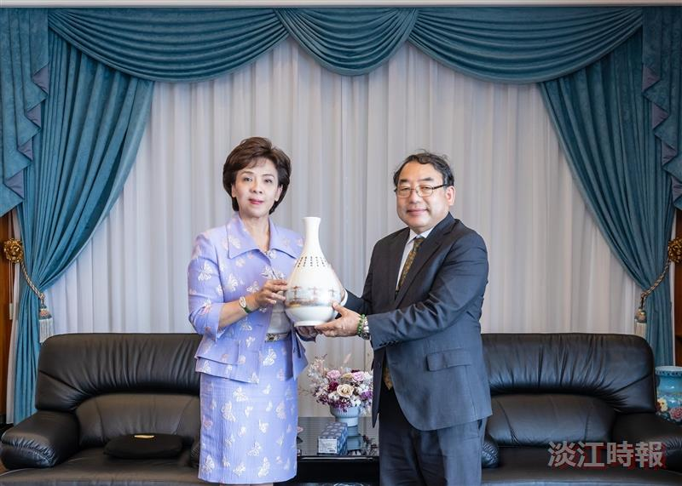
Chairperson Flora Chia-I Chang (left) personally presented a Tamkang University signature vase to Professor Kazuo Asano, the Tamkang Clement and Carrie Chair invited by the Department of Global Politics and Economics.

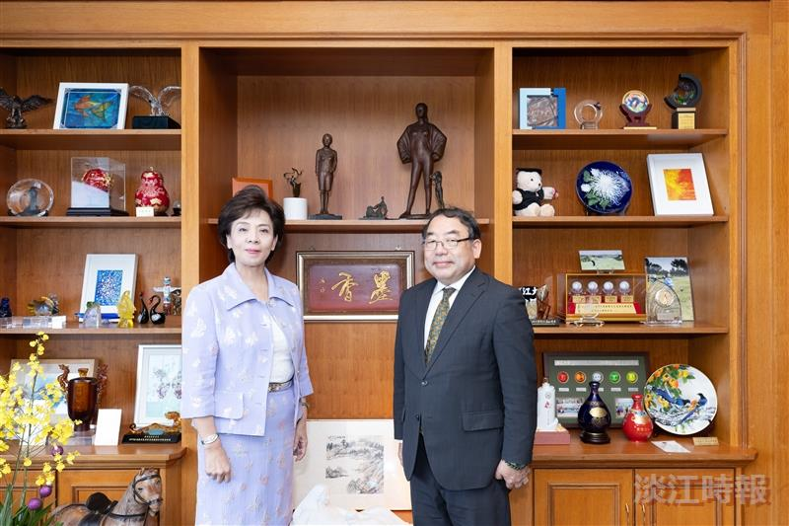
Chairperson Flora Chia-I Chang (left) and Kazuo Asano, the Tamkang Clement and Carrie Chair invited by the Department of Global Politics and Economics, took a group photo in front of the bronze sculpture "Elegantly Toward Tomorrow" (framed in the center-left), a special gift from Eitaro Sato, former chairman of Heisei International University, in 2002.

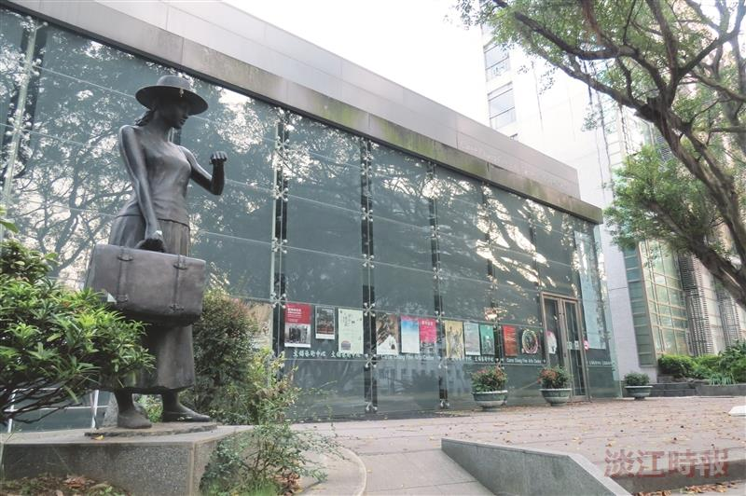
The bronze sculpture "Traveler" presented to Tamkang University in 2002 by Eitaro Sato, former Chairman of Heisei International University.

