Tamkang Times No.1196
"Tamkang Journal of Science and Engineering" and "Journal of Futures Studies" Win Airiti Taiwan Academic Communication Awards

Airiti held the 2023 Airiti Taiwan Academic Communication Awards on November 9 at the Chang Yung-Fa Foundation International Convention Center. The awards recognized top-ranked theses and their authors based on global download and citation frequency, aiming to raise awareness of these creators' academic contributions through the ceremony. Tamkang University's Tamkang Journal of Science and Engineering and the Department of Education and Futures Design's Journal of Futures Studies were awarded the "Most Diverse Journal" in the journal category. Dean of the College of Education and professor of the Department of Education and Futures Design, Prof. Kuo-Hua Chen, represented the department to accept the award. Additionally, alum Ya-Hui Chen from the Executive Master’s Program in Banking and Finance received the Best Communication Award in the Thesis Category for her work "The Impact of ESG and Financial Indicators on Stock Returns in Taiwan's Financial Industry." Yen-Hung Lin, a graduate of the AI Robotics Master’s Program in the Department of Electrical and Computer Engineering, also won the same award for his thesis, "Design of a ChatGPT-Assisted Learning System."

Prof. Chi-Wang Li, Editor-in-Chief of the Tamkang Journal of Science and Engineering and professor in the Department of Water Resources and Environmental Engineering, expressed gratitude for the recognition of the award, emphasizing that it reflects the dedicated efforts of the journal. In recent years, the journal has actively sought collaboration with international reviewers and authors, aiming to shorten the review process, reduce the acceptance rate, enhance readability, and increase scholars’ willingness to submit. These efforts are designed to gradually boost the journal's influence. Moving forward, the journal will continue working toward these goals to achieve the vision of a high-quality and sustainable publication.

Prof. Chen congratulated the Journal of Futures Studies for receiving the award, noting that the journal has been cited in research from as many as 119 countries. He expressed gratitude for the collective efforts of the editorial team and shared his hopes for the journal's continued progress toward SSCI recognition. The journal's Editor-in-Chief, Assoc. Prof. Anisah Abdullah from the Department of Education and Futures Design, offered her perspective as a scholar, practitioner, and editor, emphasizing that the Journal of Futures Studies is an influential academic publication. The journal is committed to advancing futures studies as an interdisciplinary field, reflecting the diversity and shared responsibility at the core of futurism. With its accessibility, academic rigor, and dedication to community engagement, the journal plays a crucial role in futures research. She expressed her aspiration for the journal to provide innovative ideas and approaches to address complex social, technological, and environmental challenges. As an "open-access" publication, it aims to benefit its global readership.

Yen-Hung Lin shared that the emergence of ChatGPT has significantly helped people organize data and provide information. His research focuses on applying ChatGPT to course learning for middle and high school students, aiming to integrate information technology into the curriculum to spark students’ interest in learning and help them address their challenges. He expressed gratitude to Assistant Professor Shu-Han Liao from the Department of Electrical and Computer Engineering at Tamkang University and Professor Chien-Hsing Chou from the National Taipei University of Education (NTUE) for their recommendations and assistance, as well as to his collaborators from NTUE. "We worked together to design the learning system, test how ChatGPT could provide appropriate responses to students, and identify suitable participants for writing tests. The feedback we received after the tests was positive, and the outcomes aligned perfectly with our expectations!" he said.
2024/12/10

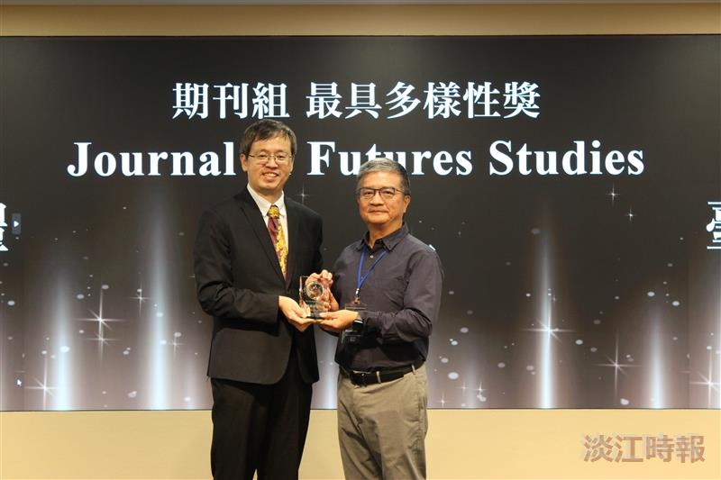
The Department of Education and Futures Design's journal, Journal of Futures Studies, received the "Most Diverse Journal Award" in the Journal Category of the "2023 Airiti Taiwan Academic Communication Awards." The award was accepted by the Dean of the College of Education, Prof. Kuo-Hua Chen (right), on behalf of the journal.

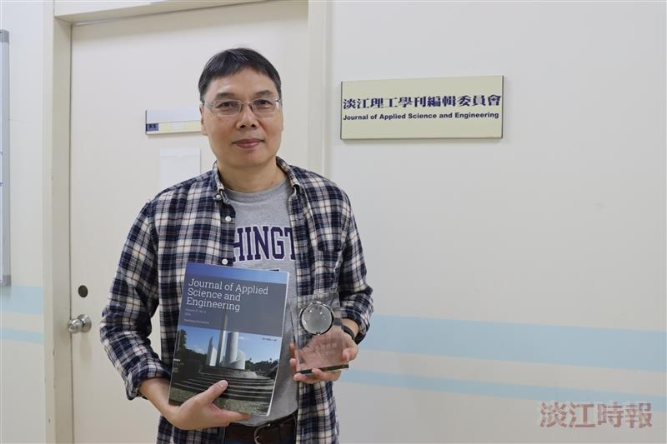
Prof. Chi-Wang Li, Editor-in-Chief of the Tamkang Journal of Science and Engineering and professor in the Department of Water Resources and Environmental Engineering, poses for a photo with the trophy and journal.

