Tamkang Times No.1196
Physics Department Achieves Another Milestone in International Academic Collaboration: 2 Papers Published in Top Physics and Chemistry Journals

Physics Department Chair, Professor Cheng-Hao Chuang led graduate students in publishing 2 journal papers in prominent international journals, namely "Atomic Insights into the Competitive Edge of Nanosheets Splitting Water" in the Journal of the American Chemical Society (JACS), which explains the competitive edge of nanosheets in water splitting from an atomic perspective, and "Operando X-ray and Mass Spectroscopy of Reduced Graphene Oxide (rGO)-Mediated Cobalt Catalysts for Boosting the Hydrogen Evolution Reaction" in PRX Energy, which discusses how reduced graphene oxide promotes cobalt catalysts in the hydrogen evolution reaction through operando X-ray and mass spectroscopy analysis. JACS has an impressive impact factor of 14.5, while PRX Energy is a new journal that began accepting submissions in 2022 and will announce its impact factor in 2025.

Professor Chuang explained that the first paper focuses on designing nanocrystalline IrOOH as the primary material, revealing its excellent catalyst utilization and predictable structure. The chemical stability of crystalline IrOOH surpasses that of its amorphous counterpart, enhancing its catalytic activity. By comparing findings with other literature, the study establishes a simple set of competitive rules that can predict the stability and reactivity of IrOOH based on atomic models. These rules aim to inspire future atomic design strategies for OER catalysts.

Prof. Chuang noted that JACS belongs to the highest-ranking (Q1) journals and is the most prestigious specialized journal among the many published by the American Chemical Society. Papers published in JACS represent the best achievements of research teams. As Tamkang University's laboratory encourages interdisciplinary research, recent efforts have focused on green energy materials and future hydrolysis applications. This paper's international team comprises experts in physics, chemistry, materials science, and computational science, and it represents a long-term collaboration with the international team at Germany's Max Planck Institute. Prof. Chuang contributed by utilizing synchrotron X-ray technology to investigate and address the catalytic reaction mechanisms. Over the course of this 4-year project, more than 7 high-impact-factor articles have been published, demonstrating significant research accomplishments. This collaboration serves as an excellent model for international academic exchange.

The second paper, with Carl Osby M. Mariano, a second-year student in the Doctoral Program in Applied Science of the College of Science, as the first author, was a collaborative effort involving Prof. Chuang, senior undergraduate Meng-Xun Tsai, and a domestic research team. Prof. Chuang explained that PRX Energy is the first journal under the American Physical Society (APS) dedicated exclusively to the field of energy materials. It is renowned for its stringent review process, selecting only groundbreaking and high-impact results, and is widely respected in the global physics community. The PRX journal has an impact factor exceeding 11.6, making it one of the Q1 journals in the field of physics. PRX Energy focuses specifically on energy-related topics within the domain of physics.

The paper highlights the application of a simplified electroplating concept to synthesize large-scale catalytic samples, achieving a 3.8-fold increase in hydrogen production efficiency while maintaining high material stability. Using X-ray analysis and theoretical calculations, the study clearly identifies intermediate states in the hydrolysis process, offering forward-looking material designs and groundbreaking physical discoveries. It addresses the unknown factors in catalytic materials' roles in water electrolysis reactions. With its low cost and ease of maintenance, this approach holds significant potential for applications in green and sustainable technologies.
2024/12/10

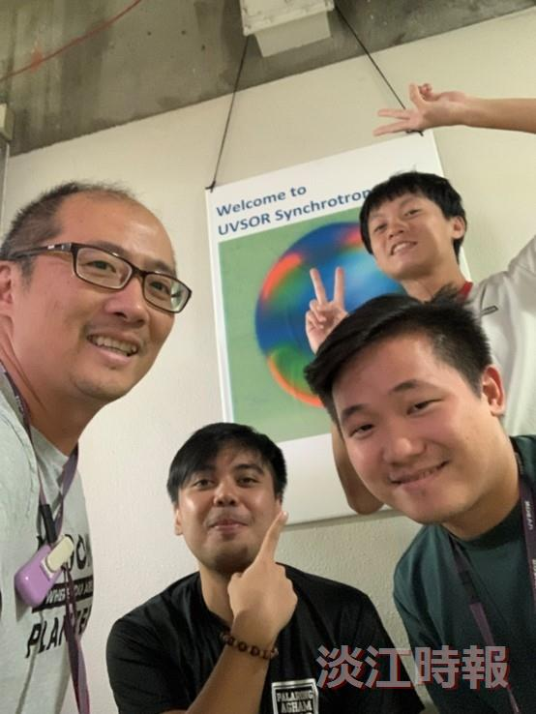
The Chair of the Department of Physics, Prof. Cheng-Hao Chuang (left), collaborated with second-year Ph.D. student Carl Osby M. Mariano from the Doctoral Program in Applied Sciences and senior undergraduate Meng-Xun Tsai on an academic paper, which was published in an international journal.

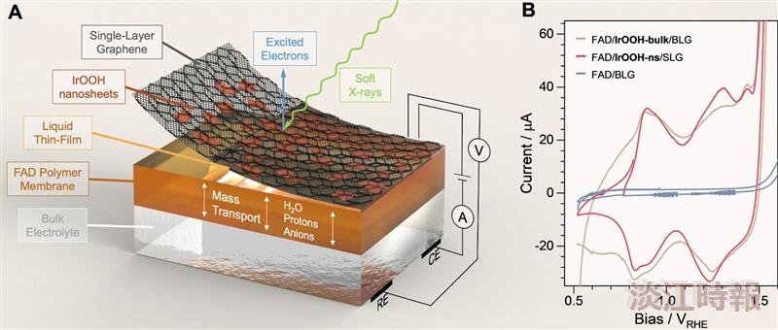
Prof. Cheng-Hao Chuang explained the fabrication of iridium oxide and graphene-layered materials, highlighting the unique catalytic interfacial reactions revealed through X-ray measurements. The findings were published in the internationally renowned journal JACS.

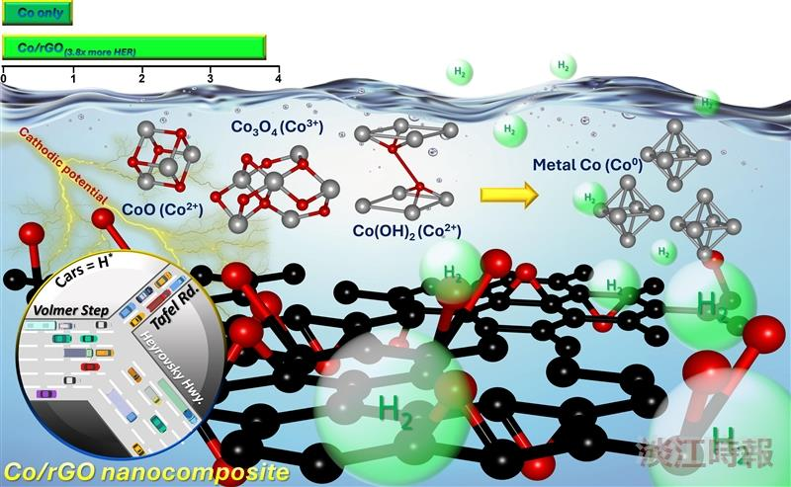
Prof. Cheng-Hao Chuang, along with students Carl Osby M. Mariano and Meng-Xun Tsai, published a collaborative paper in PRX Energy, featuring an illustration of the key principles.

