Tamkang Times No.1196
【Tamkang Clement and Carrie Chair】Prof. Ahsan Kareem Discusses Wind Engineering from a Historical Perspective

Professor Ahsan Kareem from the Department of Civil & Environmental Engineering & Earth Sciences at the University of Notre Dame, United States, was invited by the Department of Civil Engineering to deliver a Tamkang Clement and Carrie Chair Lecture on November 14 at 1:10 p.m. in the Chang Yeo Lan International Conference Hall of the Hsu Shou-Chlien International Conference Center. The lecture introduced the essence, intricacies, and applications of wind engineering under the title: "Wobbly Tall Deep and Long Span Structures: Historical Perspectives to Recent Advances and Beyond."

Before the lecture, Professor Emeritus Chi-Ming Cheng from the Department of Civil Engineering introduced the speaker. He reminisced about half a century ago when he pursued his doctoral degree at the University of Houston, where he was Prof. Kareem’s first Ph.D. student—a story reminiscent of a movie plot. Prof. Ahsan Kareem, an internationally renowned expert in aerodynamics, wave dynamics, and stochastic vibrations, not only has a solid foundation in probability and statistics but also possesses deep knowledge of fluid mechanics and structural mechanics. His interdisciplinary expertise enables him to excel in challenging research fields and contribute significantly to human society. From receiving his first award at the age of 39, the Presidential Young Investigator Award, Prof. Kareem has since garnered numerous prestigious honors in the field of international wind engineering, including the A.G. Davenport Medal (2007), the Robert H. Scanlan Medal (2005), and the Jack E. Cermak Medal (2002).

In his lecture, Prof. Ahsan Kareem provided a concise summary of the historical development of dynamics in high-rise buildings, deep-sea platforms, and long-span bridges. Starting with the premise that everything in the world is an oscillator with oscillatory characteristics, he seamlessly connected this concept to the swaying of tall buildings, deep-sea structures, and long-span bridges.

Prof. Ahsan Kareem noted that fluid motion equations are mathematically unsolvable, leading to reliance on wind tunnel physical modeling for high-rise buildings, long-span bridges, and offshore platforms. From early research at the UK National Physical Laboratory involving the World Trade Center towers, People realized that it is essential to simulate inflow conditions that reflect the atmospheric boundary layer rather than the uniform flow in wind tunnels. At that time, dynamic responses were evaluated using aeroelastic models with base rotations, while efforts were underway to develop faster methods for wind load assessment, leading to advancements in various force-balance techniques. In bridge aerodynamics, the role of turbulence in evaluating flutter speed has consistently been a focal point of attention.

Against this backdrop, he provided a historical overview of fundamental techniques for quantifying wind loads and their dynamic effects. These techniques include analytical methods, experiments, computational fluid dynamics (CFD), model- and data-driven simulation approaches, database-supported platforms, code- and standards-based procedures, and full-scale monitoring. These are applied to high-rise buildings, long-span bridges, and deepwater offshore platforms. He then outlined the development of CFD, covering topics from isolated buildings to urban landscapes, from mesoscale to microscale, physical information simulations, shape and optimization, the vulnerability of glass cladding under extreme winds, and the role of damping devices in mitigating structural motion.

After the lecture, Professor Jong-Dar Yau from the Department of Architecture raised a question about the application of artificial intelligence and machine learning in architecture. Prof. Kareem emphasized the importance of AI, stating that it can no longer be ignored. He suggested that every course should include some AI-related content to foster excellent advancements in engineering.

On the morning of November 13, at 10:30 and 11:00, Prof. Tamura and Prof. Kareem, accompanied by the Dean of the Colleges of Engineering, Artificial Innovative Intelligence, and Precision Healthcare, Professor Tzung-Hang Lee; Chair of the Department of Civil Engineering, Prof. Yung-Shan Hong; Director of the Wind Engineering Research Center, Prof. Jen-Mu Wang; and Professor Cheng-Hsin Chang, visited President Huan-Chao Keh and Chairperson Flora Chia-I Chang. President Keh and Chairperson Chang respectively presented Prof. Tamura and Prof. Kareem with Panda trophies and vases imprinted with calligraphy by Masters Chi-Mao Li and a painting by Master Ben-Hang Chang, featuring Tamkang campus scenery and the school anthem as commemorative gifts.

President Keh warmly welcomed the two Tamkang Clement and Carrie Chair professors and began by discussing the topics covered in their lectures. The speakers emphasized the importance of information literacy for university students today. President Keh shared Tamkang University's journey in promoting the concept of AI+SDGs=∞, explaining how both AI and sustainable development goals can be integrated across disciplines to enhance students' learning outcomes. He also highlighted that Tamkang University currently offers mandatory courses for freshmen in general education, including "AI and Programming Language" and "Exploring Sustainability", to help students build a strong foundation for interdisciplinary learning and boost their competitiveness. Chairperson Chang not only explained the origins of the Tamkang Clement and Carie Chair series, initiated by the university's founders, Dr. Clement C.P. Chang and his wife but also invited the speakers to view the construction progress of the Tamkang Bridge across the Tamsui River from the office. She shared updates on the project and suggested that the speakers plan trips to experience its scenic beauty when visiting Taiwan again.
2024/12/10

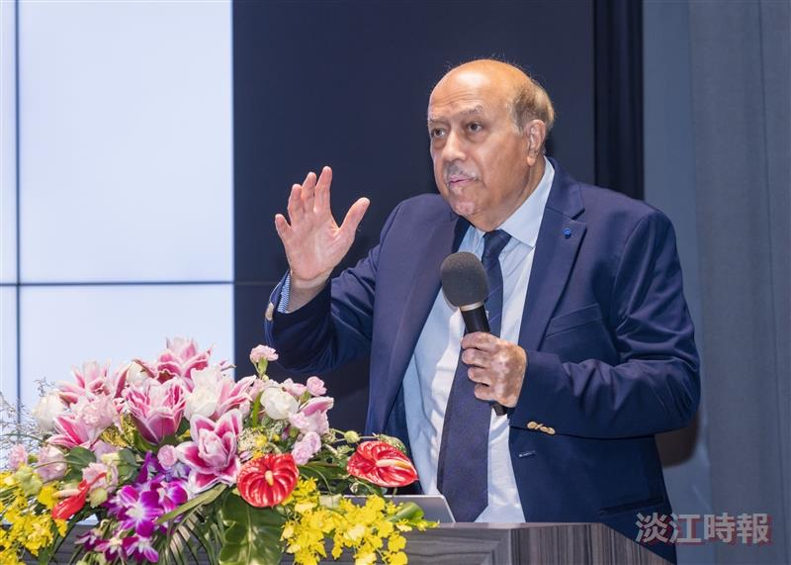
The Tamkang Clement and Carrie Chair, Professor Ahsan Kareem from the Department of Civil & Environmental Engineering & Earth Sciences at the University of Notre Dame, USA.

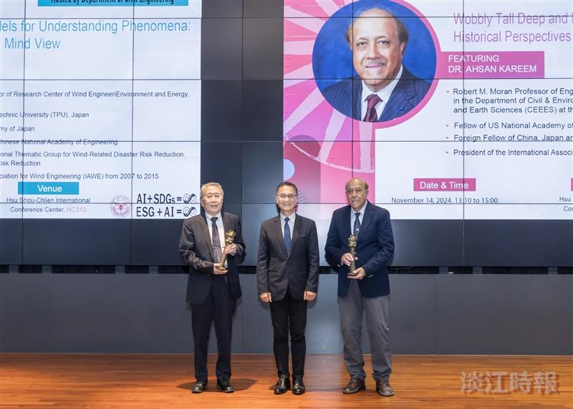
The Dean of the College of Engineering, Prof. Tzung-Hang Lee (center), presented the Panda trophies to Prof. Ahsan Kareem (right) and Prof. Yukio Tamura.

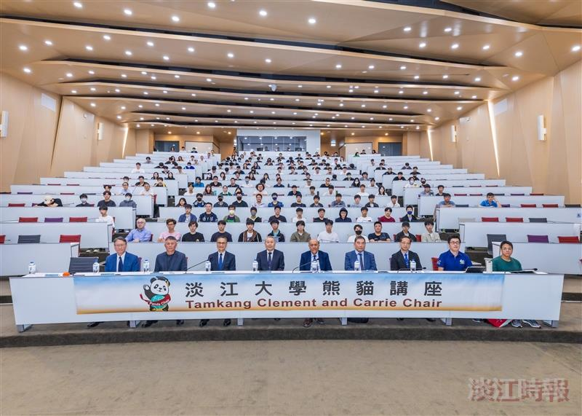
Prof. Ahsan Kareem, a professor in the Department of Civil & Environmental Engineering & Earth Sciences at the University of Notre Dame, USA, delivered a Tamkang Clement and Carrie Chair Lecture.

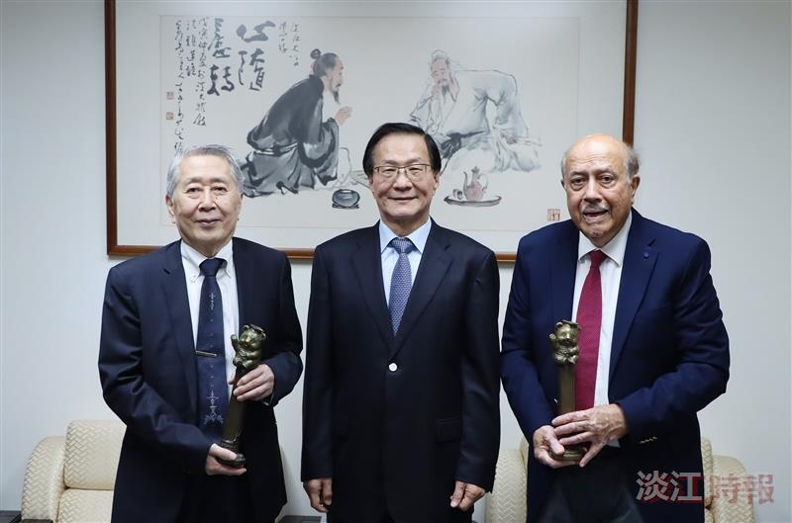
President Huan-Chao Keh (center) personally presented the Panda trophies to Prof. Yukio Tamura (left) and Prof. Ahsan Kareem (right), the Tamkang Clement and Carrie Chairs invited by the Department of Civil Engineering.

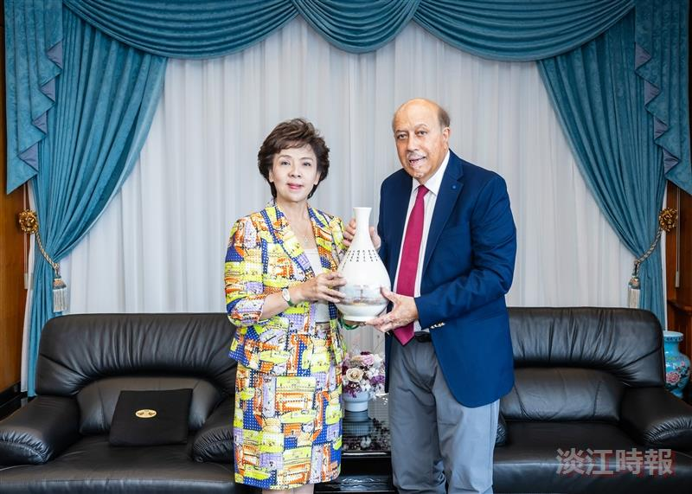
Chairperson Flora Chia-I Chang (left) personally presented a Tamkang-themed vase to Prof. Ahsan Kareem, the Tamkang Clement and Carrie Chair invited by the Department of Civil Engineering.

