Tamkang Times No.1196
Founder Chang and Yueh-O Kuo Honored with Special Recognition by Taiwan Basketball Hall of Fame

The Taiwan Basketball Hall of Fame Association recently announced the third batch of inductees. On November 2 at 3:00 PM, the induction ceremony was held at the Sports Administration Building of the Ministry of Education. Founder Dr. Clement C.P. Chang and retired professor Yueh-O Kuo from the Office of Physical Education were honored with the "Special Recognition" award for their contributions to Taiwan's basketball community. Kuo attended the event in person to receive the award for herself and Founder Chang.

Founder Chang, a passionate advocate for sports and basketball, previously served as the fourth chairman of the Chinese Taipei Basketball Association. In 1986, as team leader, he guided the national team to its first participation in the Women's Basketball World Cup held in Moscow, Soviet Union. Dr. Chang made significant contributions to the development of national basketball players, offering unwavering support for various competitions during his tenure as Minister of Transportation and Speaker of the Taipei City Council. He cared deeply about players' education and career development. Around 1961, he recruited many renowned players to study at Tamkang University, enabling key members of the Chinese Taipei national team to excel on the court and bring glory to the country. Additionally, he employed many basketball talents as faculty members, making Tamkang University a key cradle for women's basketball players, a legacy inseparable from Founder Chang's efforts.

Yueh-O Kuo, a pioneering member and former captain of the Cathay Life Women's Basketball Team, was honored for her outstanding contributions as a senior player. She was selected for the FIBA Women's Asian Cup 3 times and joined Tamkang University in 1970 as a faculty member. There, she served as coach and manager of the women’s basketball team, imparting her extensive experience gained from years of competition. Upon receiving the recognition, Kuo remarked, "I am deeply grateful to the Taiwan Basketball Hall of Fame Committee for this honor and to Tamkang University for providing such a comprehensive environment for sports education and competition. My over 50 years of service at the university have been the most fulfilling experience of my life."

The Taiwan Basketball Hall of Fame was established to honor players, coaches, referees, contributors, and teams that have significantly impacted Taiwan's basketball scene. Since 2022, the Hall of Fame has set high standards for induction. Candidates must be nominated by the "Nomination Committee" and approved by the "Selection Committee" before being recognized and celebrated as contributors to the basketball community.
2024/12/10

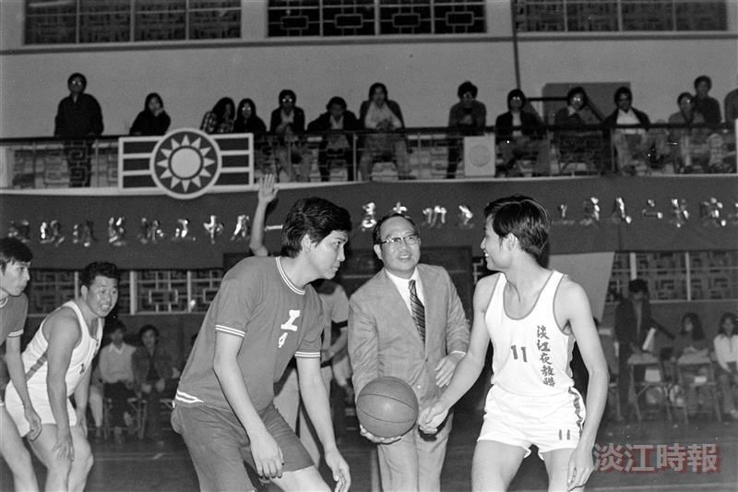
Founder Chang, a passionate supporter of basketball, inaugurated the faculty and staff basketball tournament at Tamkang University's Student Activity Center in 1975.

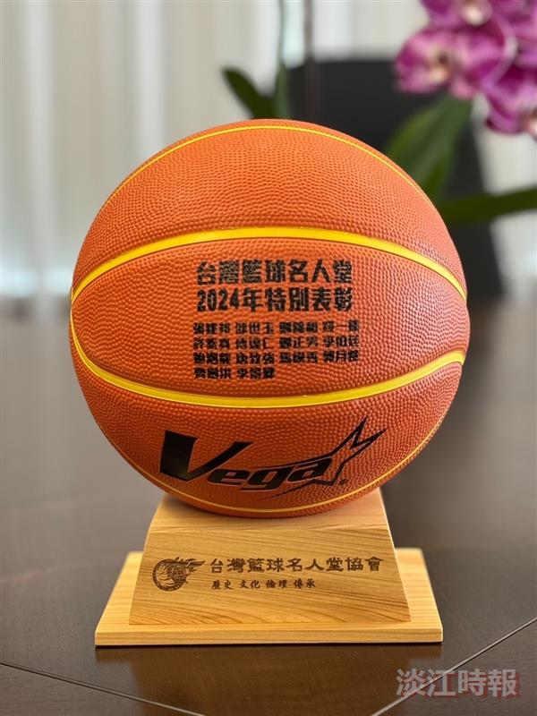
Taiwan Basketball Hall of Fame "2024 Special Recognition" trophy.

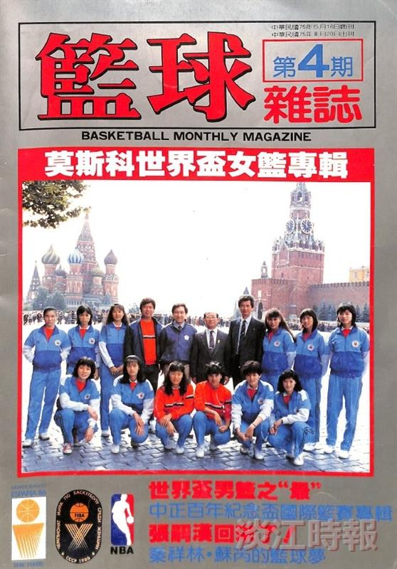
In 1986, Founder Chang led the national team to participate in the Women's Basketball World Cup held in Moscow, Soviet Union.

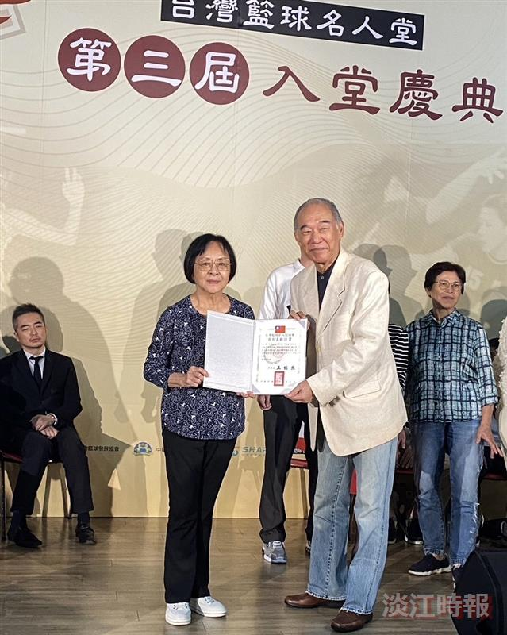
Retired Professor Yueh-O Kuo (left) from the Office of Physical Education received the "Special Recognition" honor, presented by Hsin-Liang Wang, Chairman of the Taiwan Basketball Hall of Fame Association.

