Tamkang Times No.1196
【Tamkang Clement and Carrie Chair】Prof. Monte Cassim: Academia is the Hope for Humanity's Future, Interdisciplinary Collaboration is Key

Wearing a shirt purchased during his visit to Taiwan more than a decade ago, Professor Monte Cassim, President of Akita International University (AIU), delivered a Tamkang Clement and Carrie Chair Lecture on November 4 at 1:00 PM in the Chang Yeo Lan International Conference Hall of the Hsu Shou-Chlien International Conference Center. During his speech, he invited Chairperson Flora Chia-I Chang, an old acquaintance seated in the audience and with whom he had once taken a commemorative photo, saying, "Could we use our language-oriented programs to collaborate across different disciplines? We might create an exciting modern society."

The lecture, titled "The Value of Sound Scholarship: Shaping the Future with Hope, Creativity, and Honor," was delivered in English. The Chang Yeo Lan International Conference Hall was filled with faculty and students from the Department of Japanese, with Chairperson Chang and the Dean of the College of Foreign Languages and Literatures, Professor Yi-Ti Lin, leading supervisors and faculty in attending the lecture. The session was opened, and the speaker was introduced by the Vice President for International Affairs, Professor Hsiao-Chuan Chen.

A scholar from Sri Lanka, he previously served as President of Ritsumeikan Asia Pacific University and President of Shizenkan University, a graduate school in Tokyo. He is one of the few foreigners to have held the position of university president in Japan. At the outset, Prof. Cassim declared, "Academia is the hope for humanity's future." In his lecture, he extensively addressed global issues such as climate warming, the loss of biodiversity and its connection to interspecies disease transmission, the Russia-Ukraine war, the U.S. presidential election, and the anticipated rise of robots surpassing human capabilities by 2040, which will compel humanity to learn how to coexist with machines. He frequently used examples from projects he personally participated in to illustrate his perspectives. He emphasized that the future world will be vastly different, and its challenges cannot be solved solely through technology and science. He advocated for interdisciplinary collaboration, bridging social sciences and the humanities. Expressing faith in the creativity of young people, he encouraged students to take risks, step out of their comfort zones, and explore different parts of the world. "Embark on a wonderful journey into the hearts and minds of people who are different from you," he urged.

Drawing from his own experience of transitioning from microbiology to a program in art and technology, and later shifting paths to become an architecture scholar, he illustrated his point. He explained that architecture encompasses various disciplines, including art, history, archaeology, materials science, physics, mathematics, dynamics, and calculus. "Through moving to architecture, I learned the value of expertise that transcends a single discipline," he remarked. He emphasized the importance of collaboration among experts, stating, "If you truly believe one discipline is the best for you, try working with people from other fields to organize your team."

Towards the end of his lecture, Prof. Monte Cassim shifted the focus from global issues back to Akita, where AIU is located, and explained how AIU has posed 8 questions to seek solutions and create new value. Using the example, "Can Akita's renewable energy help the region break free from dependence on Japan's three major metropolitan areas?" he expressed his belief that Akita does not need to rely solely on Tokyo, Nagoya, Osaka, or other major cities in Japan to generate wealth. Instead, it can collaborate with places like Taiwan, Sri Lanka, and Vietnam, "or anyone else for that matter. The current challenge lies in connecting local regions with global partners." Demonstrating his drive to enact world-changing initiatives, he extended an invitation for collaboration to the Chairperson present, envisioning it as part of the university's 75th-anniversary initiatives.

Associate Professor Tomita Akira, a Japanese faculty member of the Department of Japanese who attended the entire lecture and previously led students to Akita International University (AIU) for short-term language training, shared his thoughts in an interview. He remarked that AIU is renowned for its internationalization, with all courses conducted in English and a strong focus on global affairs.

Professor Akira Tomita noted that Monte Cassim emphasized the multifaceted development of liberal arts students during his lecture, aligning with AIU’s values. He expressed agreement with the president's perspective, stating that liberal arts students can offer a unique sense of humanistic care and thinking in a rapidly changing technological environment, which differs from the approach of STEM students. He added that collaboration in this area is worth exploring further.

On November 4, at 10:30 a.m. and 11:00 a.m., Prof. Monte Cassim, the Tamkang Clement and Carrie Chair invited by the Department of Japanese and President of Akita International University, was accompanied by the Vice President for International Affairs, Prof. Hsiao-Chuan Chen, the Dean of the College of Foreign Languages and Literatures, Prof. Yi-Ti Lin, and the Department Chair, Assoc. Prof. Pei-Ching Tsai to visit President Huan-Chao Keh and Chairperson Flora Chia-I Chang. President Keh and Chairperson Chang respectively presented Prof. Cassim with a Panda trophy and a vase imprinted with calligraphy by Masters Chi-Mao Li and a painting by Master Ben-Hang Chang, featuring Tamkang campus scenery and the school anthem as commemorative gifts.

Professor Monte Cassim, who previously served as President of Ritsumeikan Asia Pacific University (APU), warmly hosted Chairperson Chang during her tenure as President when she led an administrative delegation to visit to APU in 2009. During the meeting, President Keh and Chairperson Chang first extended a warm welcome and expressed their gratitude to Monte Cassim. They also explained the origins of the Tamkang Clement and Carrie Chair, established by Tamkang University’s founder, Dr. Clement C.P. Chang, and his wife. President Keh further extended a personal invitation to Prof. Monte Cassim to attend Tamkang University’s 75th-anniversary celebrations next year.

In terms of education, although international students make up only 30% of AIU's student body, its use of an all-English curriculum has facilitated exchanges with over 170 countries worldwide, showcasing a remarkable level of internationalization. The 2 universities currently enjoy frequent exchanges; in addition to the 5 Tamkang students currently participating in an exchange program at AIU, the Department of Japanese organizes annual winter break visits for faculty and students to AIU for study and cultural exchange.
2024/12/10

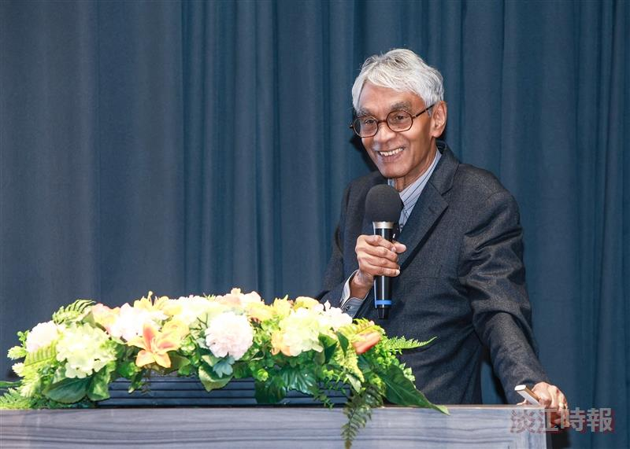
Prof. Monte Cassim, President of Akita International University, Japan.

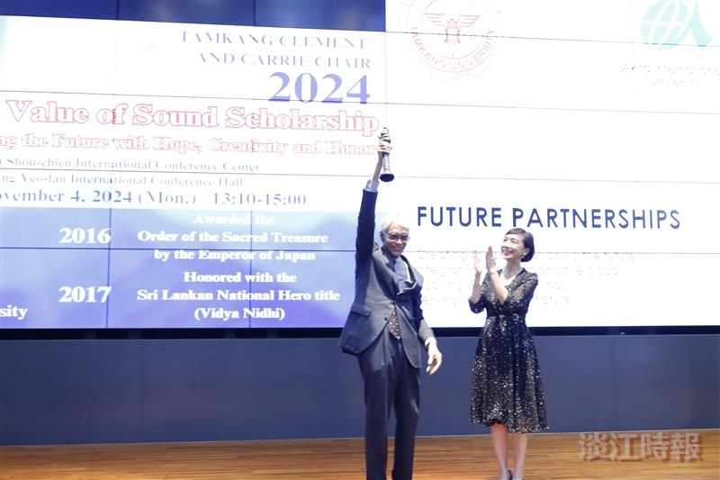
Prof. Monte Cassim, President of Akita International University (first from left), received the Panda trophy from the Vice President for International Affairs, Prof. Hsiao-Chuan Chen, and proudly raised the trophy to the applause of faculty and students.

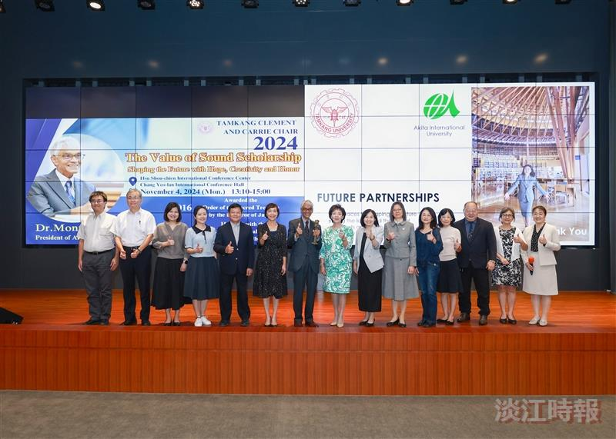
After his lecture, Prof. Monte Cassim, President of Akita International University (seventh from the left), posed for a group photo with participating faculty members.

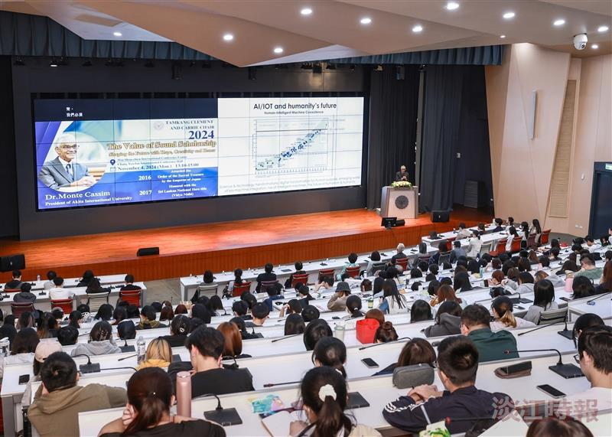
Prof. Monte Cassim, President of Akita International University, delivered a Tamkang Clement and Carrie Chair Lecture on November 4 at 1:00 p.m. in the Chang Yeo Lan International Conference Hall of the Hsu Shou-Chlien International Conference Center.

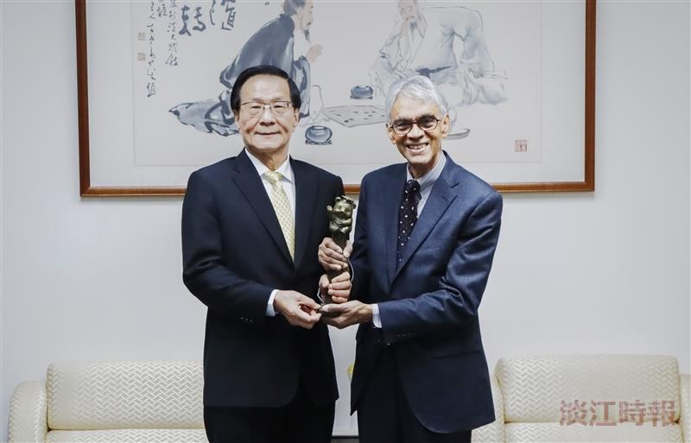
President Huan-Chao Keh (left) personally presented the Panda trophy to Prof. Monte Cassim, the Tamkang Clement and Carrie Chair invited by the Department of Japanese.

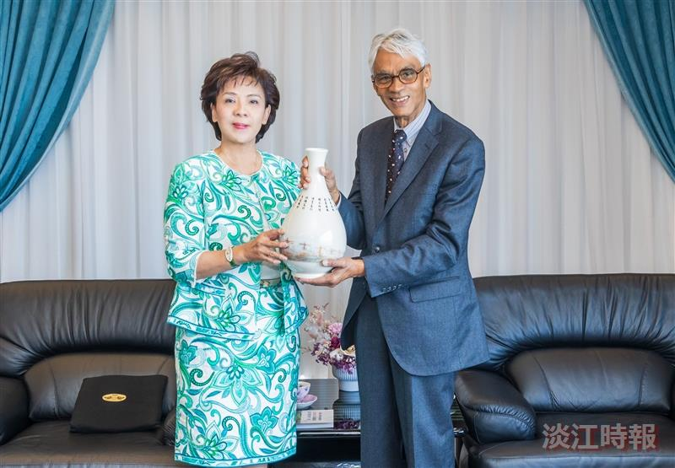
Chairperson Flora Chia-I Chang (left) personally presented a signature Tamkang vase to Prof. Monte Cassim, the Tamkang Clement and Carrie Chair invited by the Department of Japanese.

