Tamkang Times No.1194
Teaching and Administrative Innovation Seminar: Brainstorming AI Integration in Education

The 2024 Academic Year Teaching and Administrative Innovation Seminar was held on October 26 at 9 a.m. in the Chang Yeo Lan International Conference Hall of the Hsu Shou-Chlien International Conference Center under the theme "AI Integration in Education: Innovation and Practice." Over 300 participants, including President Huan-Chao Keh, Chairperson Flora Chia-I Chang, the university's 3 vice presidents, first- and second-level supervisors, secretaries, and faculty members, attended the event.

Chairperson Flora Chia-I Chang first commended Tamkang University for keeping pace with AI advancements and aligning with global trends. She referenced the Organisation for Economic Co-operation and Development (OECD) and its four educational scenarios for the next 20 years, the World Economic Forum's (WEF) "Future Schools 2020: Defining New Learning Models for the Fourth Industrial Revolution," and Education 4.0's three key areas and action recommendations as references for curriculum planning. Lastly, she highlighted the Executive Yuan's "2024 National Talent Competitiveness Leap Policy," particularly Strategy 1, which focuses on cultivating "green-collar" and cross-disciplinary digital humanities talents, aligning with the university's development goals. She encouraged continued progress toward the visions of "AI + SDGs =∞" and "ESG + AI =∞."

President Huan-Chao Keh noted that since 2019, the university has pursued a "dual-track transformation," culminating in the current "AI + SDGs =∞" vision, which he deemed a step in the right direction. While the seminar's theme focused on AI, he emphasized its inseparability from sustainability, with digital transformation serving as the foundation for dual-track transformation. He pointed out that most administrative staff already grasp the concepts of MS3AP and apply them to their work, but faculty involvement remains limited. He hoped the seminar would encourage teachers to understand basic AI models and incorporate them into their specialized teaching to improve student learning outcomes.

The first keynote presentation, delivered by Dean of Academic Affairs Tzung-Ru Tsai, was titled "Empowering Professional Development with AI – Leading a New Horizon in Teaching." He explained that in the AI era, teachers must apply AI optimization (AIO) in classrooms, redesign curricula, and explore ways to integrate AI technologies into specialized fields to enhance student competitiveness. With guidance from Tamkang University’s Office of Information Services, numerous related courses and workshops have been launched recently. Starting in the 2025 academic year, the university plans to fully integrate AI into its curriculum. Professor Tsai also emphasized the importance of adhering to AI ethics guidelines to avoid legal risks and announced the establishment of an AI Ethics Teaching Resource Center and related courses to help faculty and students develop AI literacy.

The second keynote, presented by Dean Tzung-Hang Lee of the Colleges of Engineering, Artificial Innovative Intelligence, and Precision Healthcare, was titled "The Era of AI Brilliance: Role Transitions in the Multiverse." Using ChatGPT’s summarization, inference, conversion, and expansion functions as examples, he described generative AI as a multi-functional "expert advisory team." He stressed the need for continuous learning, integration, and innovation in this AI-driven multiverse. Teachers who effectively utilize AI technologies in their curricula can foster students' critical thinking, communication, and problem-solving skills and cultivate talents with scientific knowledge, humanistic literacy, and a sense of sustainability and social responsibility.

The third session, titled "Our Distance from AI," featured the following presentations: Dean Huei-Chun Chi of the College of Liberal Arts: "Where is AI? A Digital Adventure in the College of Liberal Arts;" Dean Tzenge-Lien Shih of the College of Science: "Integrating AI into Research and Teaching;" Dean Li-Ren Yang of the College of Business and Management: "Innovative Applications of AI in Business and Management Education;" Dean Yi-Ti Lin of the College of Foreign Languages and Literatures: "Enhancing Language Learning with AI Empowerment and Cross-Disciplinary Applications;" Dean Cheng-Hao Pao of the College of International Affairs: "Leveraging Generative AI in Social Science Education – Opportunities and Challenges;" Dean Kuo-Hua Chen of the College of Education: "AI Empowerment in Professional Advancement – From Instructional Design to Educational Innovation;" Dean I-Cheng Chen of Physical Education: "Holistic Health Trends in AI Technology – Creating Value in Physical Education;" Director Shun-Jie Ji of the General Education Core Curriculum Center: "AI and General Education – Omnipresent and Boundless."

In the afternoon, Vice President for Academic Affairs Hui-Huang Hsu, Vice President for Administrative Affairs Chun-Hung Lin, and Vice President for International Affairs Hsiao-Chuan Chen facilitated group discussions involving faculty and administrative supervisors from various departments. The sessions included presentations by distinguished professors, such as Professor Chih-Yung Chang from the Department of Computer Science, Professor Ben-Hang Chang from the Department of Chinese, Professor XingChen C.C. Lin from the Department of History, Professor Ku-Jun Lin from the Department of Accounting, and Associate Professor Chih-Hung Chung from the Department of Educational Technology, who shared their experiences integrating AI into their respective fields. The discussions covered several subtopics, including AI applications in science education, AI-assisted engineering education, AI and pedagogy, The integration of AI into humanities and social sciences teaching and student learning, AI applications in business education, The role of AI in arts and sports education, AI innovations in international affairs education, AI applications in foreign language teaching, and AI integration into EMI courses. Each vice president presented the outcomes of these discussions in a summary report.

During the final general discussion, Professor Su-Ling Fan from the Department of Civil Engineering suggested providing more practical software resources to support teaching, a recommendation acknowledged by President Keh. In his closing remarks, President Keh reiterated the importance of integrating AI into teaching, urging departments to invest more resources and effort. He hoped that AI integration would yield more innovative and effective learning outcomes, modeled after initiatives like teaching practice research and USR projects.

Chairperson Chang affirmed the seminar’s content but stressed the importance of applying the PDCA (Plan-Do-Check-Action) model to assess and refine teaching outcomes. She encouraged feedback collection through midterm and end-of-term evaluations to fine-tune AI-curriculum integration. She applauded the university's early adoption of "AI + SDGs =∞" but emphasized, "Starting early requires doing it even better," urging continuous improvement to achieve greater success.

The seminar, organized by the Office of Quality Assurance and Audit, featured a specially designed virtual host, whose engaging appearance and clear articulation impressed attendees. Chairperson Chang jokingly suggested introducing an AI spokesperson for next year’s event.
2024/11/26

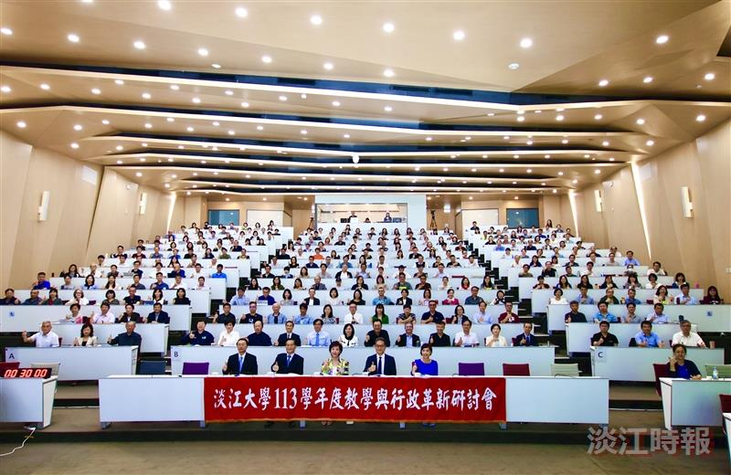
The 2024 Academic Year Seminar on Teaching and Administrative Innovation was held at the Chueh-Sheng International Conference Hall with the theme "AI Integration in Education: Innovation and Practice."

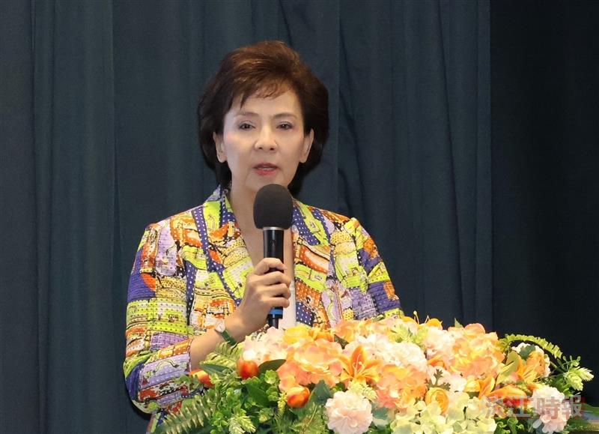
Chairperson Flora Chia-I Chang delivered the opening remarks.

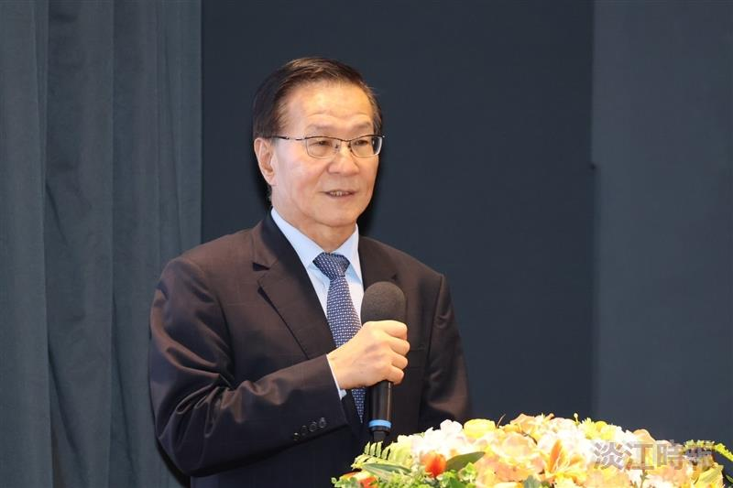
President Huan-Chao Keh delivered the opening remarks.

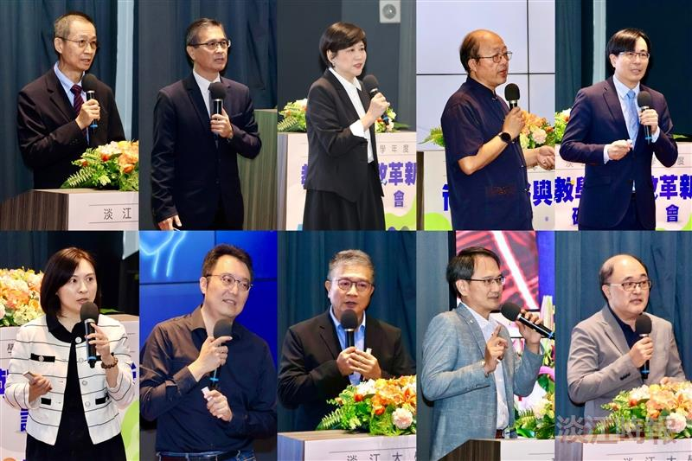
The keynote presentations were delivered by (from top left to bottom right): Dean of Academic Affairs Tzong-Ru Tsai, Dean of the Colleges of Engineering, Artificial Innovative Intelligence, and Precision Healthcare Tzung-Hang Lee, Dean of the College of Liberal Arts Huei-Chun Chi, Dean of the College of Science Tzenge-Lien Shih, Dean of the College of Business and Management Li-Ren Yang, Dean of the College of Foreign Languages and Literatures Yi-Ti Lin, Dean of the College of International Affairs Cheng-Hao Pao, Dean of the College of Education Kuo-Hua Chen, Dean of Physical Education I-Cheng Chen, and Director of the General Education Core Curriculum Center Shun-Jie Ji.

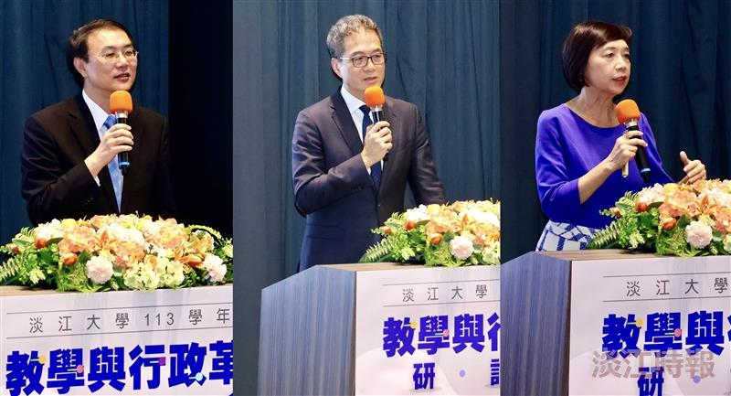
The group discussions were concluded with summary reports delivered by (from left) Vice President for Administration Chun-Hung Lin, Vice President for Academic Affairs Hui-Huang Hsu, and Vice President for International Affairs Hsiao-Chuan Chen.

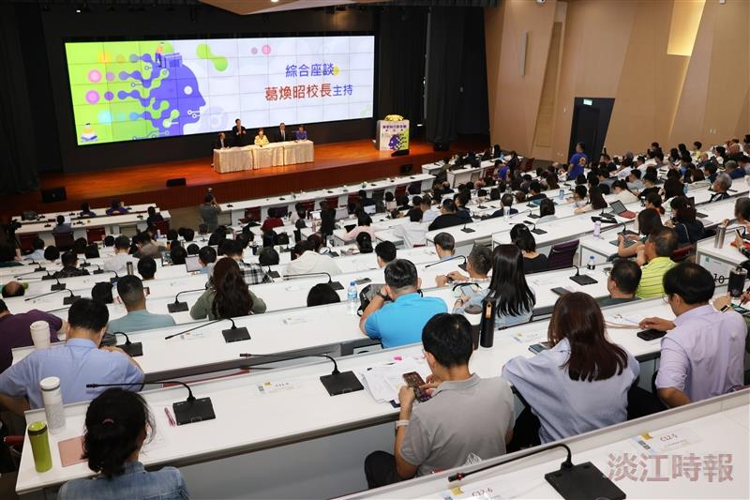
The general session was chaired by President Keh (second from left on stage).

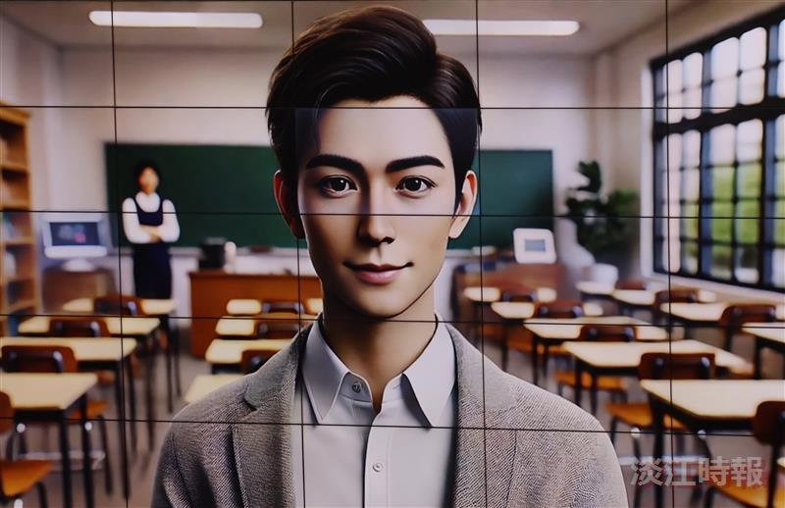
The virtual host of this seminar.

