Tamkang Times No.1192
Kumamoto Chamber of Commerce & Industry in Japan Holds 2nd Recruitment Drive at Tamkang University

For the second time, prominent companies from the Kumamoto region in Japan came to Tamkang University to recruit talent. The Kumamoto Chamber of Commerce & Industry, a union of companies in the region, sent Shinji Hamamoto, Representative Director of Fumidas, and Akihito Kawada, Assistant General Manager of General Affairs, to Taiwan to introduce the internship recruitment system of Japanese companies. On October 17, they hosted a Japanese corporate culture lecture, "Exploring Kumamoto: A Comprehensive Guide from Culture to Career," and held discussions with the Japanese Department to kick off a series of recruitment activities for internships with Kumamoto companies later this month.

This marks the second joint internship briefing by the Japanese Department and the Kumamoto Chamber of Commerce, following a similar event in May with 8 major Kumamoto companies and Tokyo Water Co., Ltd. Japanese Department Chair Pei-Ching Tsai noted that the students selected for internships in Japan last year have graduated. Due to their excellent performance, one student secured a position at Kumamoto KDS Driving School in September, while 3 others received formal job offers from the Tsuruya Department Store Co., Ltd. During Japan's hiring season, they will join the company with other new Japanese hires in April.

Associate Professor Yu-Ching Liao, responsible for organizing internships in Kumamoto region, explained that last year the Japanese Department offered a “Japanese Corporate Culture” lecture to prepare students before their internships. This year’s recruitment plan is split into 2 phases: the first involved 2 workshops on Japanese workplace culture, and the second was an internship briefing and selection event on October 28 featuring 5 companies: Shinsan Jutaku Co., Ltd., Kumamoto Daido Seika Co., Ltd., Aoyagi, Adel・Cars Co., Ltd., and Tsuruya Department Store Co., Ltd. Internal selections were held, with recommended students progressing to the interviews.

At the briefing, Shinji Hamamoto discussed the significance of working and interning in Japan and Kumamoto, internship structures, and job prospects. Senior students who participated in summer training also shared their internship experiences, making the Q&A lively as attendees eagerly asked questions. The lecture aimed to prepare students considering internships or employment in Kumamoto by helping them with mental preparation and career planning.

Following the lecture, the Kumamoto Chamber of Commerce and the Japanese Department held a planning meeting for future industry-academia collaborations. Kawada explained that Tamkang Japanese students are highly sought after due to their outstanding performance, prompting plans to hold large-scale joint recruitment events each May and November. They aim to offer two-week summer internships, providing students greater exposure to different companies, bridging the gap from internship to employment, and enhancing career development opportunities.

While the primary attendees were third- and fourth-year students, several first- and second-year students also joined. First-year student Hung-En Chen shared that attending the lecture was highly rewarding, stating, “Even though I’m not making decisions right now, attending helps me plan my university years and consider my future career path.”
2024/11/20

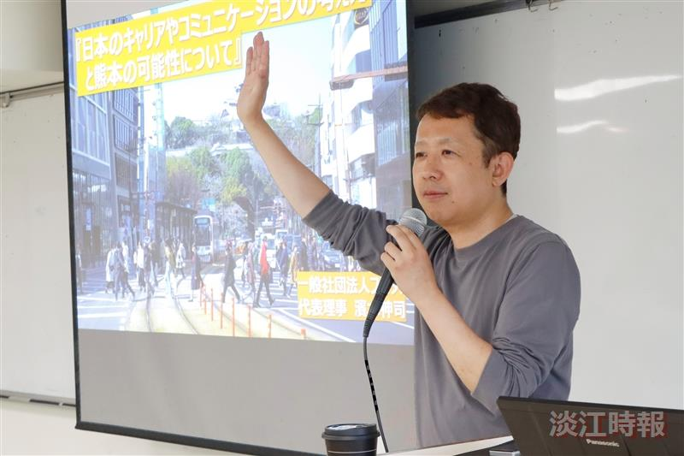
Shinji Hamamoto, Representative Director of Fumidas, personally visited Taiwan on behalf of the Kumamoto Chamber of Commerce & Industry to explain the internship recruitment system of Japanese companies at Tamkang University.

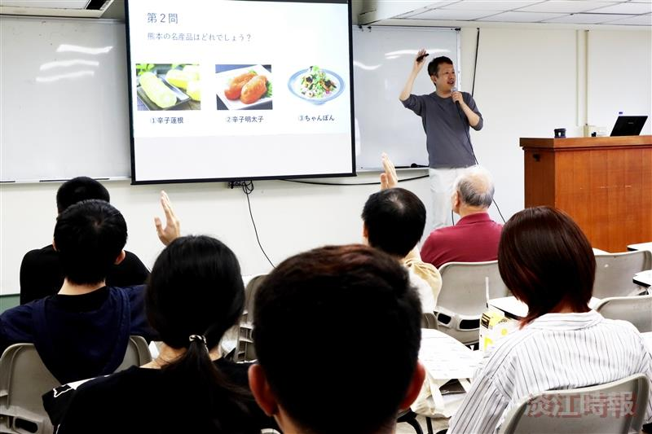
Shinji Hamamoto used a Q&A session to enhance students' understanding of Kumamoto.

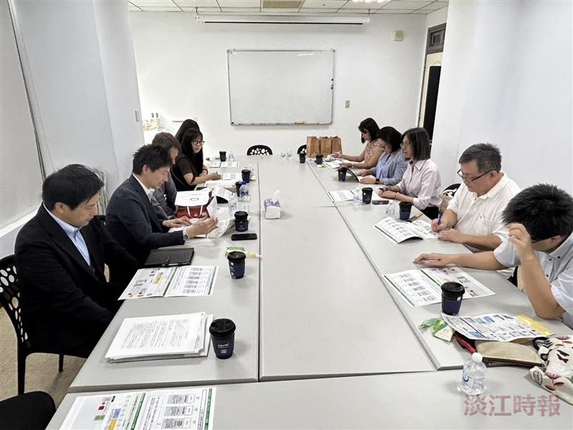
The Kumamoto Chamber of Commerce & Industry sent Shinji Hamamoto, Representative Director of Fumidas, and Akihito Kawada, Assistant General Manager of General Affairs, to Taiwan to explain the internship recruitment system for companies in the Kumamoto region. They also held a planning meeting with the Japanese Department to discuss future industry-academia collaboration.

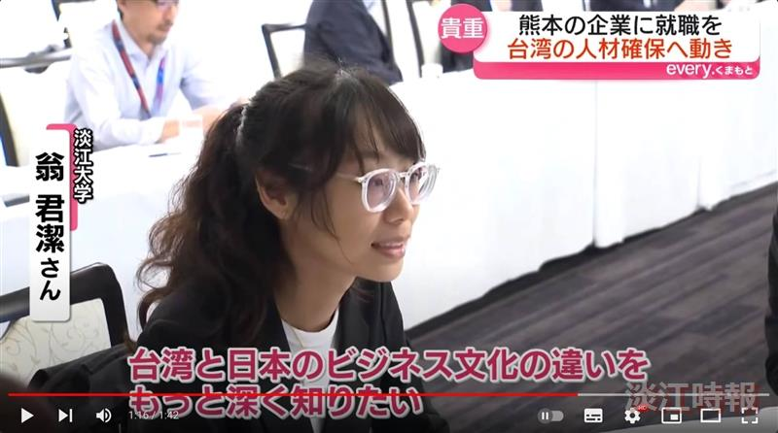
In July, Japan's KTT News reported on Kumamoto companies offering internship opportunities to Taiwanese students. In an interview, Tamkang University's Japanese Department student, Chun-Chieh Weng, expressed hopes to learn about the differences between Japanese and Taiwanese workplace cultures through the internship and looks forward to exploring various companies in Kumamoto.

