Tamkang Times No.1192
Architecture Students Win Silver and Bronze in Tainan's "Best Corner Design" for Creative Community Building

2 student teams from Tamkang University’s Department of Architecture achieved silver and bronze awards in the "2024 Tainan Corner Creative Building Project" (「2024年臺南築角創意營造計畫」)organized by the Urban Development Bureau of Tainan City Government. The teams designed a rest pavilion for the Gongguan community in Zuozhen and an entryway installation for the Zhuwei community in Yujing, showcasing a vibrant community presence. Awards will be presented at the project’s results presentation ceremony, where each team and community unit will receive prize money and certificates.

This year marks the 14th edition of "Tainan Corner," a nationally recognized design-build competition for college students. Over 50 students from universities across Taiwan participated, working with local communities to transform idle spaces through creative planning and design from July to August.

The silver award-winning project, "Let’s Rest Together Pavilion" (「作伙來歇腳亭」), was created by students Hong-Lin Huang, Jia-Qian Lan, Kai-Sheng Tsai, and Wan-Tzu Tseng. They designed a cozy bus stop area for the Gongguan community, incorporating progressive spatial experiences, with sunlight casting shadows through woven bamboo for a forest-like visual. The team expressed gratitude for the jury's recognition, the support from Gongguan community members, and guidance from their mentors and the Bureau of Urban Development. Hong-Lin Huang reflected on the valuable practical knowledge gained from mentors, noting, "I especially resonated with the saying, ‘It’s easy to draw a straight line on paper, but making one in construction is extremely challenging,’" experiencing the emotional impact of turning ideas into reality.

The bronze-winning team, "Neighborly Gathering" (「鄰聚里」), designed a unique wooden arched entrance for the Zhuwei community in Yujing. The team members, including Shi-Xian Lai, Mi-Shuan Tsai, Fang-Chieh Chen, Shao-En Tseng, Meng-Che Liou, and Hao Yu Bai, nicknamed themselves "Corner Beasts" (「築角獸」). Mi-Shuan Tsai shared how 4 months of planning, revisions, and construction refined the design, overcoming weather and practical challenges. "The project not only created a park pavilion but also recorded our teamwork and stories," she added.

Watching the students collaborate with communities, from clearing weeds to planting grass and carrying materials under the sun, the bronze award’s guiding professor, Associate Professor Yi-Chih Huang, shared in a post on the department's social media, "Seeing these ‘fledglings’ fly solo on their first build, tanned and working hard, I feel a mix of pride and empathy!" Assistant Professor Liang-Ping Yen, the Silver Award's guiding instructor, praised the students for overcoming challenges with a positive attitude and completing the project with determination—a most commendable quality.
2024/11/19

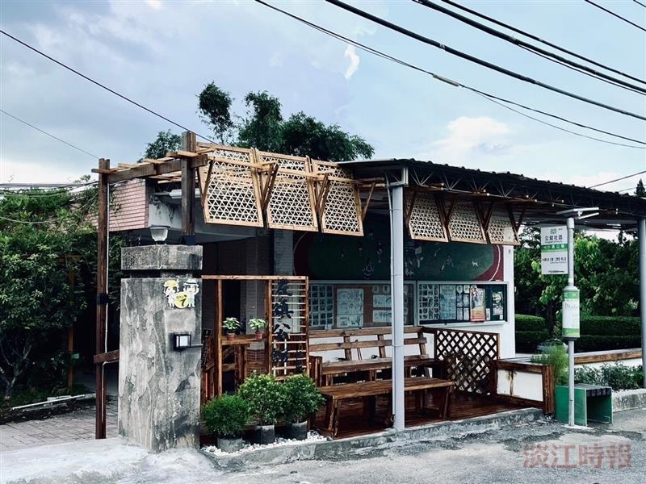
Silver Award Project: "Let's Rest Together Pavilion" (「作伙來歇腳亭」) creating a cozy waiting area for the Gongguan community in Zuozhen.

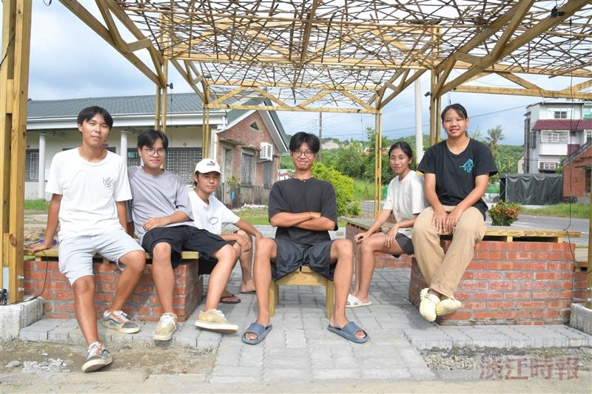
Bronze Award "Neighborly Gathering" (「鄰聚里」) team members pose for a commemorative photo with their project. From left: Meng-Che Liou, Shi-Xian Lai, Hao Yu Bai, Shao-En Tseng, Mi-Shuan Tsai, and Fang-Chieh Chen.

