Tamkang Times No.1192
Li-Shih Hsieh and Biaoxin Fang Win Gold in Documentary Competition at the 1st Tuying Art Festival

On October 8, the Taoyuan Indigenous Peoples Development Foundation held the "2024 Tuying Art Exhibition and Awards Ceremony." Tamkang University’s Information and Communication juniors Li-Shih Hsieh and Biaoxin Fang won the Gold Award in the Documentary category, with a prize of NT$120,000, for their work Stories of Kusu, which captures everyday life among Indigenous communities in the Fuxing District of Taoyuan City. This year’s competition attracted over 280 entries, with total prize money reaching NT$750,000.

In the early stages of filming, Li-Shih Hsieh and Biaoxin Fang conducted field research on Indigenous culture, preparing interview outlines and exploring Fuxing District to document the area's historical and cultural richness. They were particularly surprised to discover the beautiful landscapes of Taoyuan's Dongyanshan, where Indigenous culture is deeply woven with historical traces, enriching their filming experience. Li-Shih Hsieh expressed gratitude for the extensive effort put into the documentary, thanking Assistant Professor Ming-Yi Tsai from the Mass Communication Department for his guidance and recommendation. “Winning the Gold Award was an unexpected honor, and it has given us more direction for future projects. The Atayal people's genuine daily life and culture left a lasting impact on us as filmmakers. We are grateful to the community members for allowing us to walk in step with their way of life.”

Biaoxin Fang also noted that through the filming process, he learned that preserving culture differs from promoting it, with each effort presenting its challenges. This realization motivated them to share this place and story with a broader audience.

Through this competition, the Taoyuan Indigenous Peoples Development Foundation aims to discover more Indigenous talent and bring deeper, more comprehensive cultural interpretations to society. The Director Amuy Muwakay of the Department of Indigenous Affairs, Taoyuan City, expressed hope that the power of art and culture will amplify the voices of Indigenous communities and broaden the reach of their culture, creating more opportunities for cultural integration and inspiring original business ventures.
2024/11/19

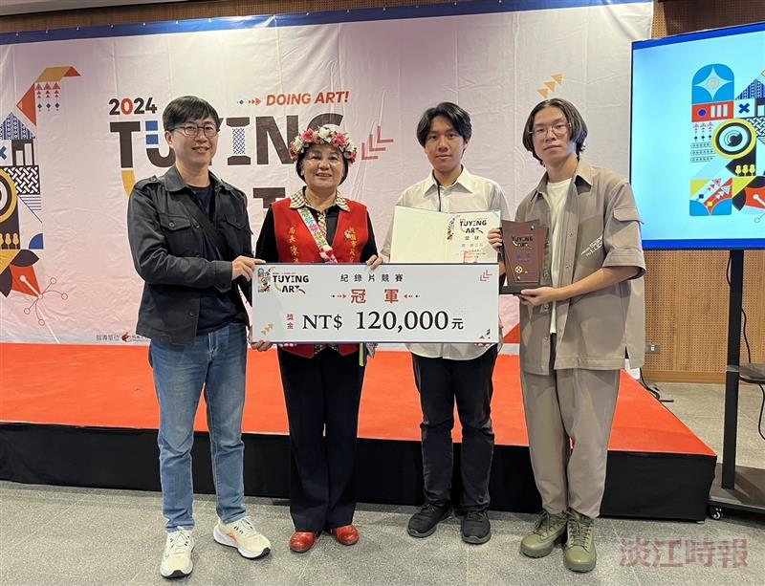
At the 1st Tuying Art Exhibition and Awards Ceremony, Assistant Professor Ming-Yi Tsai from the Mass Communication Department (first from the left) guided junior Digital Communication students Li-Shih Hsieh and Biaoxin Fang (second and first from the right) in documenting daily life in the Fuxing District of Taoyuan City, earning them the Gold Award in the Documentary category. Amuy Muwakay, Director of the Department of Indigenous Affairs, Taoyuan City, presented the award.

