Tamkang Times No.1192
Tamkang University’s Employee Learning Program Recognized with 7 Awards for Outstanding Performance

Tamkang University encourages paid learning for faculty and staff, receiving Recognition for the Seventh Time with the Ministry of Education’s 2024 Annual "Central Government Employee Learning Program Promotion Award" for Excellence. The award ceremony was held at 10:00 a.m. on October 12 at the National Taiwan Science Education Center, with Executive Vice President Chun-Hung Lin representing Tamkang University to receive the award from Deputy Minister of Education Teng-Chiao Lin.

Professor Chun-Hung Lin explained that Tamkang University prioritizes lifelong learning and diverse development for faculty and staff. In recent years, Tamkang has introduced various AI learning courses to help staff enhance their information skills, allowing them to apply new knowledge and improve efficiency, creating a win-win work environment. “The university provides benefits and a supportive environment to foster a happy and fulfilling campus for faculty, staff, and students, promoting growth together with the university.”

To encourage lifelong learning and career development, the government has established the "Central Government Employee Learning Program Promotion Award," designed to motivate organizations to strengthen employee learning systems, enhance individual skills, and boost organizational competitiveness. Tamkang has previously applied for this award 6 times, each time receiving recognition, including Special Distinction in 2015 and 2018 and Excellence in 2013, 2014, 2016, and 2017.

In 2023, Tamkang achieved notable results, with 12,473 instances of employee participation in learning programs, totaling 188,267 hours of paid learning time, averaging 144 hours per employee, and earning 142 certifications. The university has also established various learning policies, encouraging faculty and staff to pursue professional development, participate in overseas training, and receive resources and subsidies to improve teaching quality. Regular training courses, seminars, and workshops are held, with feedback and satisfaction surveys used to refine offerings, ensuring the university continues to provide essential learning programs for employees.
2024/11/19

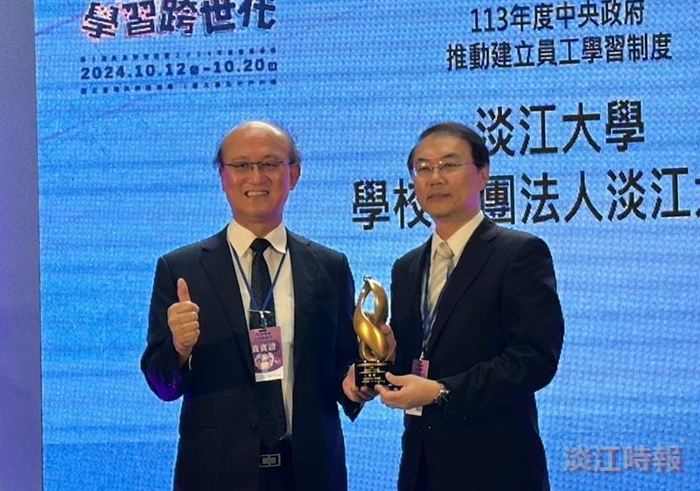
Tamkang University was honored with the 2024 “Central Government Employee Learning Program Promotion Award” for Excellence. Executive Vice President Chun-Hung Lin (right) represented the university in receiving the award from Deputy Minister of Education Teng-Chiao Lin (left).

