Tamkang Times No.1192
President Keh Leads Delegation to Australia to Strengthen Exchanges with 3 Sister Universities

To strengthen academic exchanges with Australian partner universities and check on the well-being and academic progress of Tamkang University students participating in junior abroad, exchange, and dual-degree programs, President Huan-Chao Keh recently led a delegation to visit 3 sister institutions: Western Sydney University (WSU), the University of Queensland (UQ), and Queensland University of Technology (QUT). The delegation included the Vice President for International Affairs, Professor Hsiao-Chuan Chen, Dean of the Colleges of Engineering, Artificial Innovative Intelligence, and Precision Healthcare, Professor Tzung-Hang Lee, Dean of the College of Business, Professor Li-Ren Yang, and Head of the International Cross-Strait Exchange Section under the Office of International and Cross-Strait Affairs, Ms. Hsinyin AC Chu. They engaged in discussions to deepen cooperation and shared perspectives on advancing collaboration.

President Keh highlighted that these partner universities rank highly in global university rankings, with WSU notably achieving the top position in the THE World University Impact Rankings. Internationalization is a core educational principle at Tamkang, and fostering strong relationships with partner universities while expanding dual-degree and exchange opportunities is essential for broadening students’ global perspectives and learning environments. Additionally, showcasing Tamkang’s connections with prestigious international universities can attract students interested in studying abroad through exchange or dual-degree programs. President Keh described the trip as fruitful, noting achievements in strengthening dual-degree collaborations, expanding exchange spots, and encouraging students to seize opportunities for international learning, which would also enhance their post-graduation competitiveness.

Upon arrival in Sydney on October 6, the delegation met with 10 students from the Department of International Tourism Management studying at the International College of Management, Sydney (ICMS), to discuss their local academic and living experiences. President Keh encouraged students to make the most of their time abroad. The students expressed their gratitude with thank-you cards. On October 8, the delegation visited Director Cheng-Wei Wu of the Taipei Economic and Cultural Office in Sydney (TECO in Sydney). President Keh shared Tamkang’s internationalization achievements and its educational vision, “AI+SDGs=∞.” Director Wu praised Tamkang’s success in education and recruitment and invited Tamkang students to participate in events organized by the office, offering further support for students studying in Australia.

On the afternoon of October 8, the delegation visited WSU, marking the first stop in their tour of Australian sister universities. Tamkang University and WSU established their partnership in 2018, with exchange programs as well as customized short courses in environmental sustainability. The visit began with a tea gathering with 2 Tamkang exchange students and a formal meeting hosted by WSU President Professor George Williams AO. Key WSU faculty members, including Associate Dean of Business Professor Stella Huiying Wu, Associate Dean of the School of Humanities Associate Professor Ruying Q, and Director of International Affairs Ms. Jo Byng, participated in the discussions.

The meeting focused on strengthening ties between the universities and exploring future collaboration opportunities. Tamkang introduced dual-degree options like the 2+2 program and the 1+1 dual master's degree, along with new specialized programs offering scholarships and internship stipends, allowing students to study in Taiwan while working in industry to advance their careers. WSU highlighted its academic strengths and proposed a 1+1 master’s program structure with one year of coursework and one year of research. The universities also discussed potential collaborations in the humanities and education, particularly in linguistics and English training. The visit concluded with the signing of a renewed academic exchange and student exchange agreement between the two universities. President Keh expressed gratitude for the warm reception and sincerely invited Professor George Williams AO to attend Tamkang University’s 75th-anniversary celebrations in 2025. He also invited Professor Williams to be a speaker at the President’s Forum, where he could share insights from WSU’s experience as the world leader in the THE World University Impact Rankings.

The delegation flew to Brisbane on October 9 and visited UQ on October 10. Tamkang University and UQ established their partnership in 2007, with exchange programs including junior-abroad and dual-degree options. Since 2008, Tamkang has been recommending junior-abroad students to UQ, with 3 students currently enrolled and a total of 69 students having participated in the program. In terms of dual-degree programs, options include bachelor’s and master’s dual degrees from the College of Engineering and master’s dual degrees from the College of Business and Management. Since 2008, Tamkang has sent 67 students to UQ for dual-degree studies, with 53 students successfully obtaining dual degrees.

The itinerary included a campus tour, a student gathering, and discussions between the two universities, along with a meeting with UQ President Professor Deborah Terry AC. 8 Tamkang students currently at UQ attended the gathering, including 3 third-year Computer Science students, one dual-degree Computer Science master’s student, 3 Business and Management dual-degree master’s students, and 1 Civil Engineering dual-degree bachelor’s and master’s student. The students shared their experiences of studying and living at UQ. The discussions focused on consolidating existing cooperation and exploring expanded exchange opportunities across more departments to benefit a broader range of students. Since 2012, Tamkang has also sent 39 faculty members to UQ for English-medium instruction training. However, this program has been temporarily halted post-pandemic; the possibility of resuming it was also discussed. At noon, UQ Vice President for International Affairs, Mr. Brett Lovegrove, hosted a lunch for the delegation, after which they met with President Professor Deborah Terry AC, extending an invitation for her to participate in Tamkang’s 75th-anniversary celebrations in 2025.

On October 11, the delegation visited QUT, a partner university since 2007 with exchange programs including student exchange, junior-abroad, and dual-degree options. Since 2014, Tamkang has been sending students to QUT for exchanges, with one student currently enrolled and a total of 11 students participating to date. For the junior-abroad program, which began in 2011, 6 Tamkang students are currently studying at QUT, with 18 students having participated in total. In dual-degree programs, options include bachelor’s dual degrees in the Department of Information and Communication, as well as master’s dual degrees in the College of Business and the Department of Computer Science. Since 2015, 50 Tamkang students have pursued dual degrees at QUT, with 44 successfully obtaining them.

Professor Margaret Sheil AO, the President of QUT, hosted the delegation, leading discussions and arranging a campus tour, college exchanges, and a student tea gathering. In their discussions, both university presidents shared updates on their institutions. Professor Sheil highlighted QUT's plan to establish Australia’s first Indigenous Studies Academy in 2025, its corporate immersion international collaboration with MIT, and its industry-academic alliance with BMW, emphasizing QUT’s focus on practical, industry-linked education, as reflected in its motto: "the university for the real world." President Keh discussed Tamkang’s recent achievements in global university rankings, successes in robotics competitions, and its Indigenous Student Resource Center, expressing hopes for further collaboration in these areas. He also extended an invitation to QUT to join Tamkang’s 75th-anniversary celebration. Faculty members from both universities continued discussions on bachelor’s and master’s dual-degree cooperation, with Vice President for International Affairs, Prof. Hsiao-Chuan Chen, securing one additional exchange spot for the 2025 academic year. During the student tea gathering, students shared their learning experiences and discussed topics like credit transfer and grading. QUT’s international affairs staff hosted a lunch for the Tamkang delegation, concluding the successful series of visits to Australian partner universities.
2024/11/19

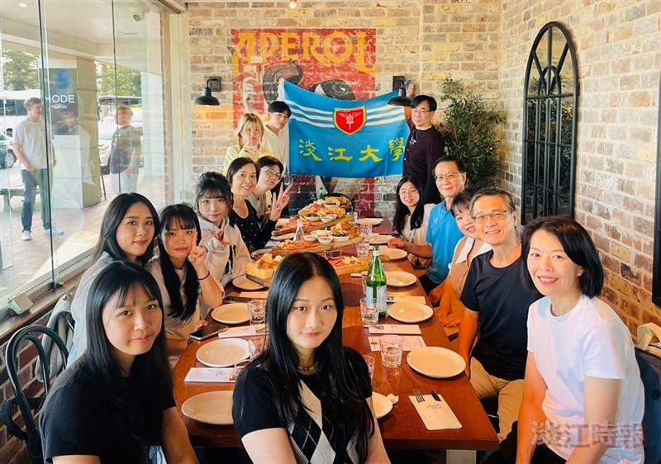
President Keh (fourth from right) and his delegation had dinner with Tamkang University third-year students studying abroad at the International College of Management, Sydney.

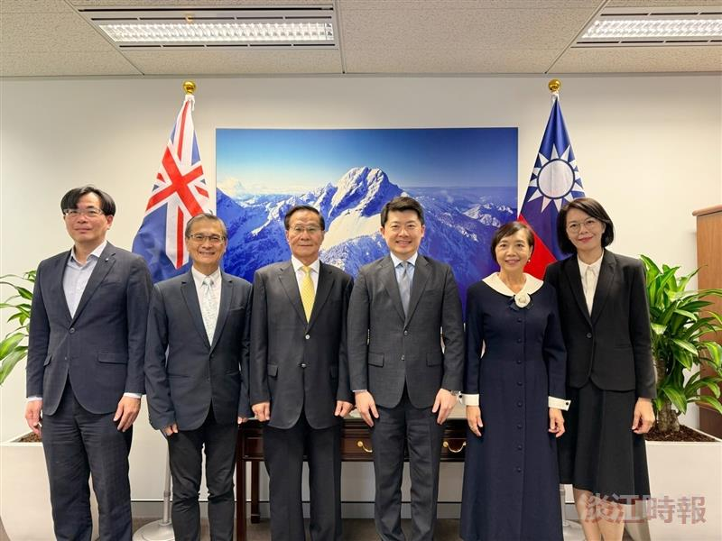
President Keh (third from left) and the delegation met with Director Cheng-Wei Wu (fourth from left) of the Taipei Economic and Cultural Office in Sydney.

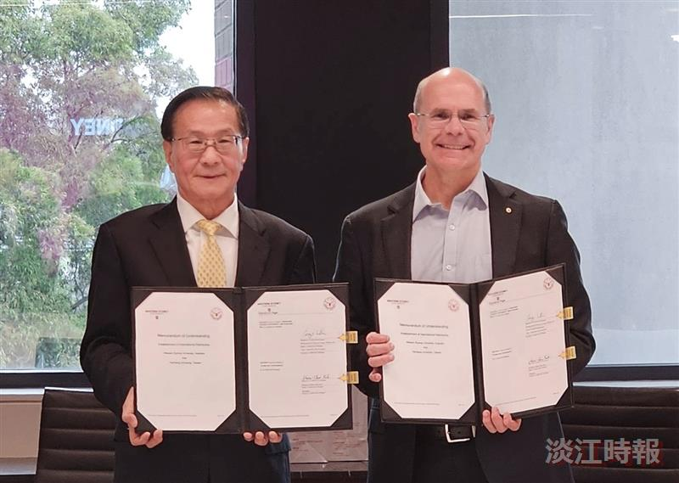
Tamkang University renewed its academic exchange and student exchange agreement with Western Sydney University, signed by President Keh (left) and Western Sydney University President, Professor George Williams AO.

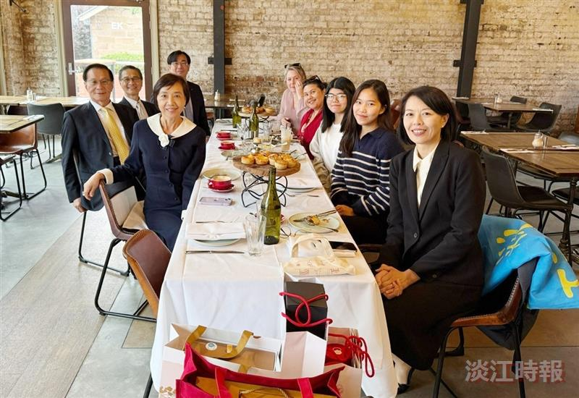
President Keh (second from left) and the delegation held a tea gathering with Tamkang University exchange students at Western Sydney University.

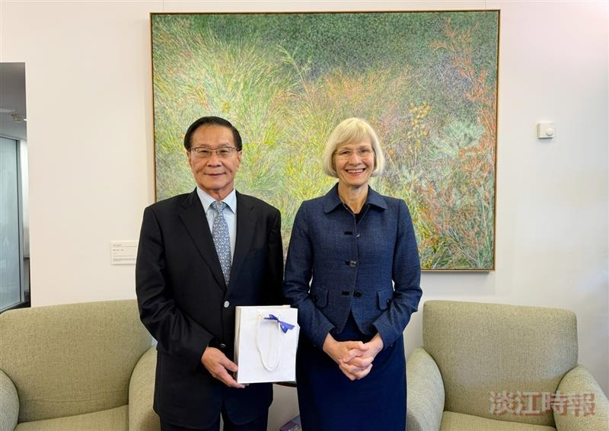
President Keh (left) and his delegation met with the President of the University of Queensland, Professor Deborah Terry AC.

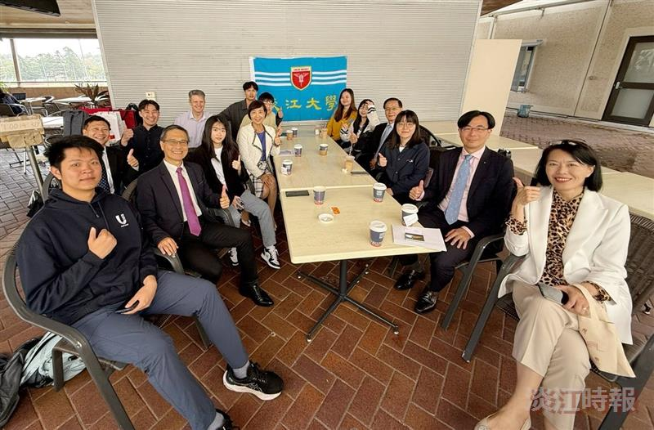
President Keh and the delegation held a tea gathering with Tamkang University students studying at the University of Queensland.

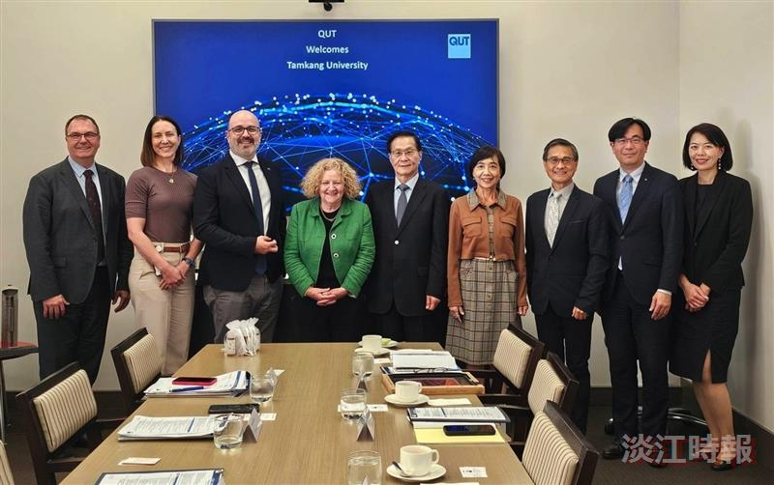
President Keh (5th from left) and the delegation visited the Queensland University of Technology, where the President of QUT, Professor Margaret Sheil AO (4th from left), hosted and presided over the meeting.

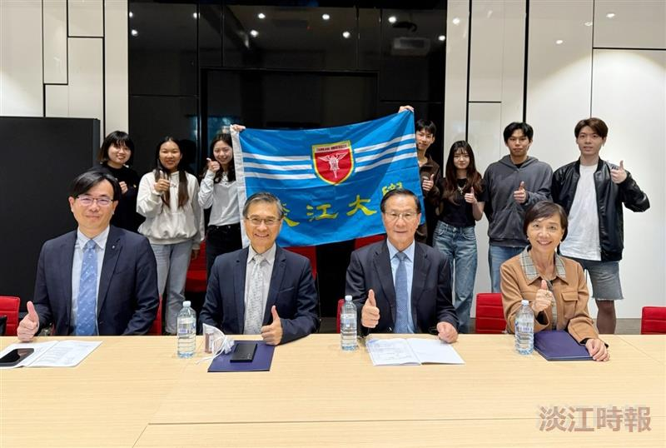
President Keh (front row, second from right) and the delegation held a tea gathering with students from Tamkang University currently studying at Queensland University of Technology.

