Tamkang Times No.1190
Holistic Education Center Hosts High Table Welcome Dinner: 260 Faculty and Students Celebrate Together

The "High Table Dinner" organized by the Center for Holistic Education for its new members, including first-year students from the all-English classes in the Department of Computer Science and Information Engineering, the Department of English, the Department of International Tourism Management, and the Department of Global Politics and Economics, was grandly held on October 1 at 5:45 p.m. in the Student Activity Center. Vice President for Academic Affairs and Director of the Holistic Education Center, Professor Hui-Huang Hsu, dined with the attending faculty and first-year students, with over 260 participants joining the event.

Despite the approaching Typhoon Sandur, the event proceeded as planned, with enthusiasm remaining high among faculty and students. Participating faculty members included Vice President for Administrative Affairs, Professor Chun-Hung Lin, Vice President for International Affairs, Professor Hsiao-Chuan Chen, Dean of the College of International Studies and Executive Secretary of the Center, as well as convener of the Holistic Development Curriculum Group, Professor Cheng-Hao Pao, Dean of Student Affairs and convener of the Residential Learning Activities Group, Professor Shi-Jung Wu, Dean of International Affairs and convener of the Overseas Counseling Group, Professor Chien-Mu Yeh, Dean of the College of Engineering, Professor Tzung-Hang Lee, Dean of the College of Foreign Languages and Literatures, Professor Yi-Ti Lin, and Dean of Academic Affairs, Professor Tzong-Ru Tsai.

After Professor Hui-Huang Hsu led the faculty and students in a toast, saying, "Cheers!" the dinner officially began. In his opening remarks, he introduced the Holistic Education Program, saying, "Since its inception at the Lanyang Campus in 2005, the program emphasizes communication, flexibility, and global vision, with key features including all-English instruction, full residential learning, and mandatory third-year overseas internships or studies, making it a unique international program." He encouraged all students to participate actively in activities and interact with professors and peers to learn about different cultural backgrounds and broaden their horizons. He added, "This dinner also symbolizes the beginning of adulthood, where responsibility will accompany each student's growth. I hope that in 4 years, everyone will confidently pursue their futures across the world."

The High Table Dinner continued the tradition of the Lanyang Campus, modeled after Oxford and Cambridge Universities in the UK, fostering social and academic exchanges between students and professors. Accordingly, the main table was arranged with department representatives dining with faculty, and teachers were seated at the students' tables as well, bringing faculty and students closer together and allowing first-year students to get to know each other better.

Before the dinner, Assistant Professor Wei-Ting Wang from the Department of English provided a lecture on table manners, covering the historical background of the High Table tradition, dress code, seating etiquette, and the proper use of utensils. This was intended to help the Holistic Education students who will study abroad in their third year become more comfortable with foreign social and academic environments. Ya-Wen Chang, an assistant at the Holistic Education Center, noted that although many students felt nervous about the formal dress requirement before the event, thanks to the promotion, everyone showed up in proper attire on the event day. Sheng-Hung Chiang, a first-year student from the Department of Global Politics and Economics, eagerly anticipating the event, found it fascinating to see his classmates in formal attire and described it as a unique experience.

Han-Ting Chen, a representative from the Department of International Tourism Management, was seated at the main table across from the Dean of International Affairs. He remarked that the conversation provided valuable learning tips and brought him closer to the faculty. Yen-Hsiang Chen, a fourth-year student from the Department of English, shared that after years of canceled events due to the pandemic, he missed last year’s High Table Dinner at the Tamsui Campus while on exchange abroad. This year, he was thrilled to participate finally, enjoying the dinner with faculty and fellow students and cherishing the precious memories it created during his university life.
2024/11/05

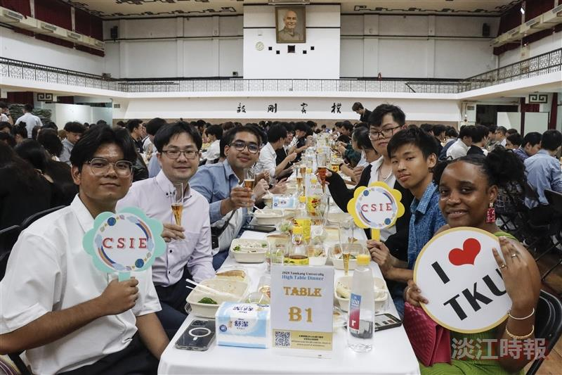
The Holistic Education Center held a High Table Dinner, bringing together faculty and students for a joyful gathering.

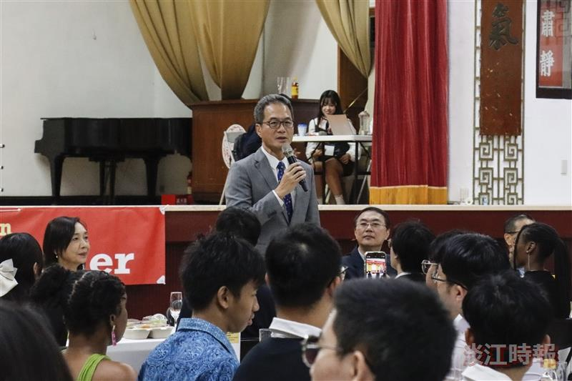
The Holistic Education Center held a High Table Dinner, presided over by the Vice President and Director of the Holistic Education Center, Professor Hui-Huang Hsu.

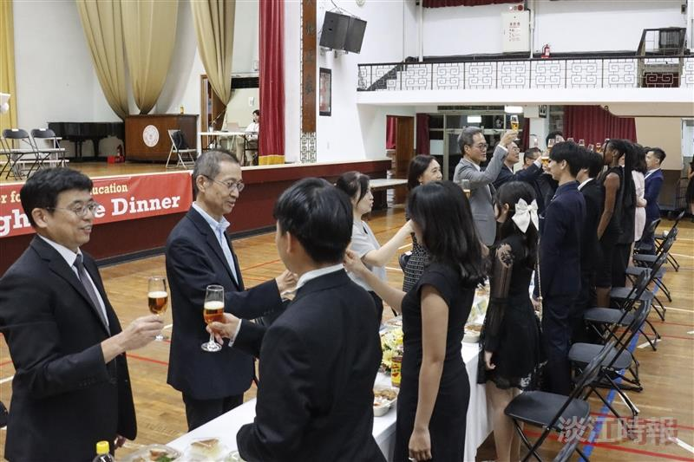
Professors led the toast to celebrate the start of the new academic year.

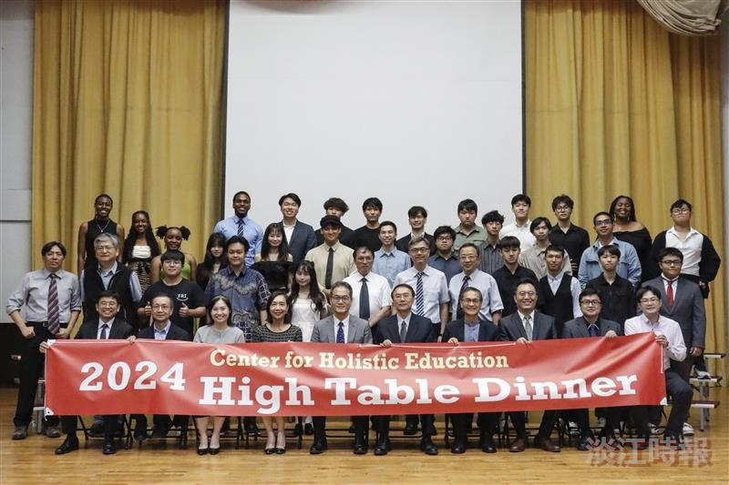
After the High Table Dinner hosted by the Holistic Education Center, professors and students took group photos in turns.

