Tamkang Times No.1190
Summer Service Teams Gather for Exchange: Experience Joy and Share Love

The Extracurricular Activities Guidance Section held the "Summer Service Team Sharing Session: Experience Joy and Share Love" on September 26 at 6:30 p.m. in classoom B713. 6 service teams happily presented the results of their efforts, with nearly 70 participants attending the event. Section Chief Te-Cheng Cheng presented service certificates, expressing that the experiences the teams went through, from preparation to the completion of their missions, were unforgettable. He thanked everyone for maintaining their enthusiasm throughout the process.

The event began with a preview video of the service teams, followed by a lottery to determine the order of presentations. The Seed Tutoring Club focused on international cultural exchange, helping children understand global cultures and sustainability concepts while fostering team cooperation and responsiveness among the volunteers. The "Economic Explorer" International Volunteer Team from the Department of Economics, which previously served in Cambodia, traveled to Switzerland this year to explore water resource knowledge, learning from local research institutions with the hope of applying it in Cambodia in the future.

The Photography Club not only learned photography skills and conducted field interviews but also explored the issue of homelessness. They observed many existing societal problems and hoped to encourage the public to approach these issues with understanding and empathy, avoiding stereotypes and prejudice. The Rover Scout Group combined scouting education with activities centered on discipline and teamwork, along with water and land activities in Green Island, helping children understand environmental conservation while also strengthening the bonds among peers through service.

The Fencing Club introduced elementary school children with no prior experience to the beauty of fencing, including physical games, team competitions, and professional training. The volunteers worked together to solve all challenges and used the event to promote the sport of fencing. The Cambodia Service Learning Team from the Extracurricular Activities Guidance Section focused on digital learning and Chinese language teaching. The 7 volunteers were responsible for designing nearly 2 weeks of lesson plans and activities, emphasizing that "service is about seeing your value in meeting the needs of others, taking initiative, and learning from each other."

The event concluded with a video of encouragement and reflections from the team leaders, bringing the sharing session to a satisfying close. Hua-Lian Lei, a member of the Fencing Club and a second-year student in Public Administration, remarked, "Seeing the service teams tirelessly travel to various regions, remote islands, and even overseas to provide service, from brainstorming to gathering a group of people together, planting the seeds of the SDGs everywhere, was truly moving. I hope these activities will continue to be passed on.
2024/11/05

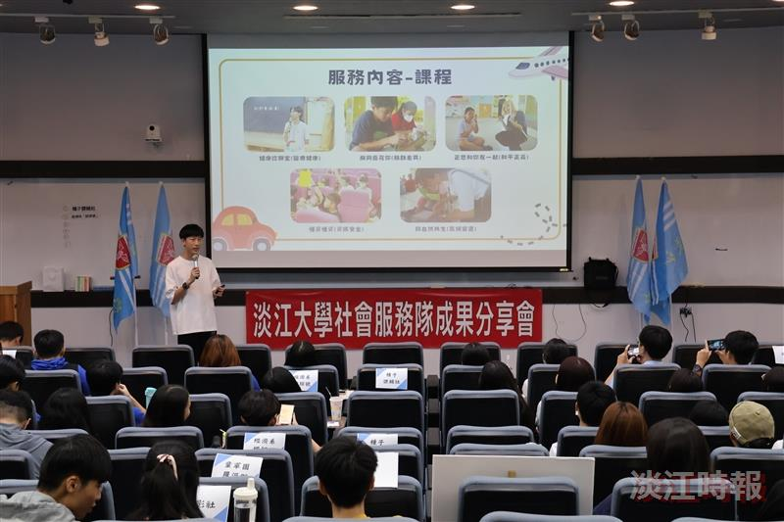
The Extracurricular Activities Guidance Section held a Summer Service Team Sharing Session on September 26, with 6 service teams presenting their experiences.

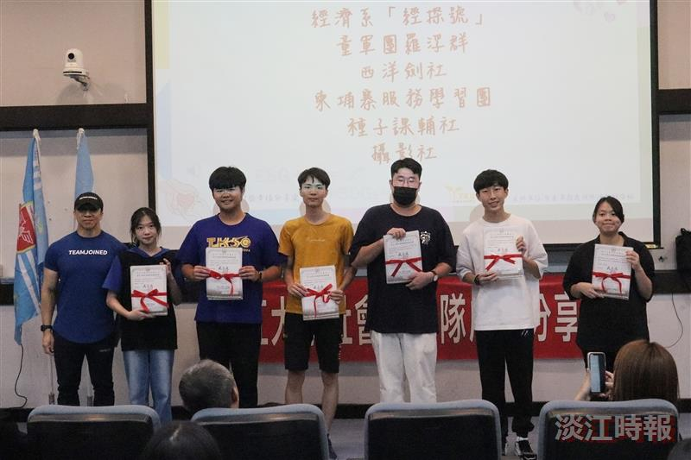
The Extracurricular Activities Guidance Section held the “Summer Service Team Sharing Session,” during which service certificates were awarded.

