Tamkang Times No.1190
Sustainability Reporting and Value Communication Conference: Faculty, Staff, and Students Collaborate to Create Diverse Value

Tamkang University's medium- and long-term goals for sustainable development guided by AI+SDGs=∞and ESG+AI=∞, aim to become a glocalized, cloud-smart, and sustainable future resilient university city. On the afternoon of September 25, the Center for Sustainable Development and Social Innovation (SDSI) hosted the "2024 Tamkang University Sustainability Reporting and Value Communication Conference" at the Hsu Shou Chlien International Conference Center. The event was presided over by the Vice President for Academic Affairs and Center Director, Professor Hui-Huang Hsu, and attended by the Vice President for International Affairs, Professor Hsiao-Chuan Chen, as well as first-level supervisors. The conference featured the release of the Sustainability Report, the Social Responsibility Annual Report, and the Carbon Inventory Report, showcasing Tamkang University's achievements in promoting sustainable development in 2023.

The event highlighted Tamkang's efforts in 3 key areas: USR Annual Report, Sustainability Reporting, and Talent Empowerment. The 2023 Tamkang University Sustainability Report documents the university's value creation process in sustainable development through talent cultivation, teaching innovation, administrative reform, campus sustainability, resource sharing, local revitalization, think tank advisory, collaborative alliances, social impact, and value communication. Special attention was given to the fact that the report was compiled by sustainability managers from various university departments, with students co-authoring the final report, showcasing a collaborative effort between faculty, staff, and students. The 2023 Tamkang University Sustainability Empowerment Implementation Report records the growth process of student editors involved in the report, describing how they progressed together through the hands-on sustainability empowerment program, ultimately becoming sustainability leaders in their own right.

The 2023 Tamkang University Social Responsibility Annual Report shared the achievements of 5 teams that participated in Phase III of the Ministry of Education's USR (University Social Responsibility) project. With support from the administration and coordination from SDSI, these teams integrated sustainable development goals into their unique projects, enhancing students' abilities in social engagement, interdisciplinary skills, information technology, and humanistic care. The report also showcased the university’s efforts in strengthening local communication, service, and connections. It also highlighted the winning projects from the first "Tamkang University Social Practice Service Excellence Award," including focus cases from domestic and international contexts. These efforts are expected to energize faculty and students as they move toward the next phase of USR, incorporating it into the university’s sustainable development strategy and expanding its impact.

Moreover, the release of the Carbon Inventory report, the Net-Zero Blueprint, and the TCFD (Task Force on Climate-related Financial Disclosures) explains how the university is actively working towards its goal of a Net-Zero Campus by the 100th Anniversary. This includes initiatives such as greenhouse gas inventories, waste reduction, procurement of high-efficiency or energy-saving products, the establishment of a sustainable energy management platform, the promotion of zero-carbon education and green transportation, increased research in related fields, and alignment with international carbon credit trends. These efforts and the development of green talent have been recognized and awarded.

Professor Hsu mentioned that since 2021, Tamkang University has been compiling and publishing its sustainability reports, with results moving from "achieving presence" to "achieving quality" to "achieving meaningfulness." The 2023 Sustainability Report, in particular, represents a collaborative effort between faculty, staff, and students, from identifying and disclosing key issues to addressing the concerns of 10 major stakeholders. For our university, these reports serve as valuable references for promoting related initiatives and provide a clear direction for future efforts. "The most important mission of a university is talent cultivation. We are pleased to see students grow through participation in various activities, and we will continue to carefully address key issues of concern to major stakeholders and make necessary adjustments as we move toward the goal of a sustainable campus.”
2024/11/05

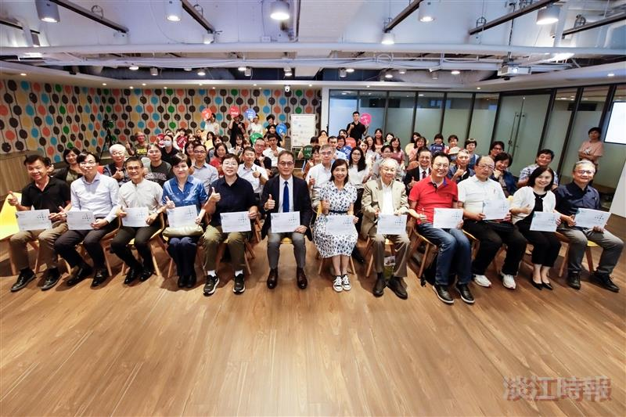
The 2024 Tamkang University Sustainability Reporting and Value Communication Conference showcases Tamkang University's achievements in promoting sustainable development in 2023.

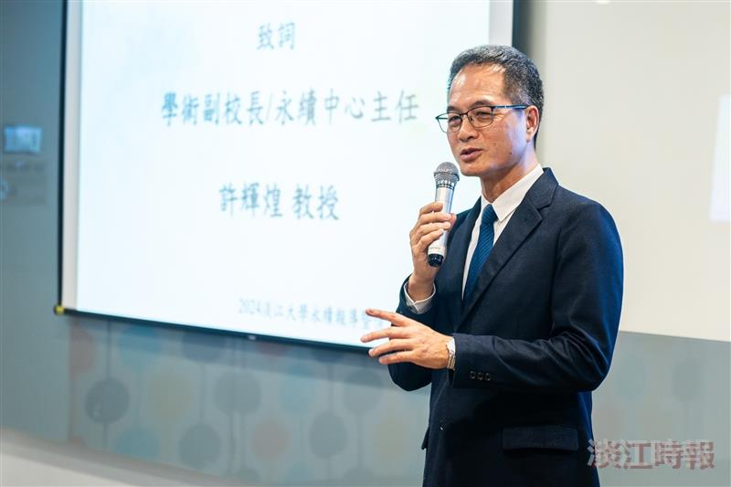
Vice President for Academic Affairs and Director of the Center for Sustainable Development and Social Innovation, Professor Hui-Huang Hsu, delivered the opening remarks, introducing Tamkang University's 2023 sustainability achievements.

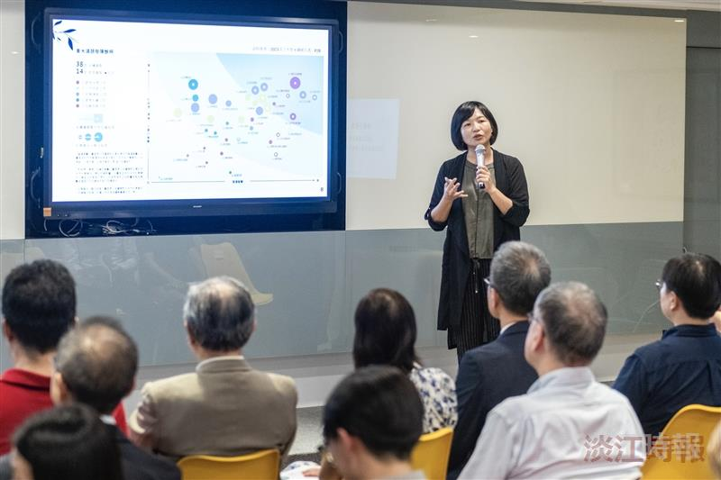
Professor Min-Fen Tu from the Department of Business Administration shared the process of compiling the 2023 Sustainability Report.

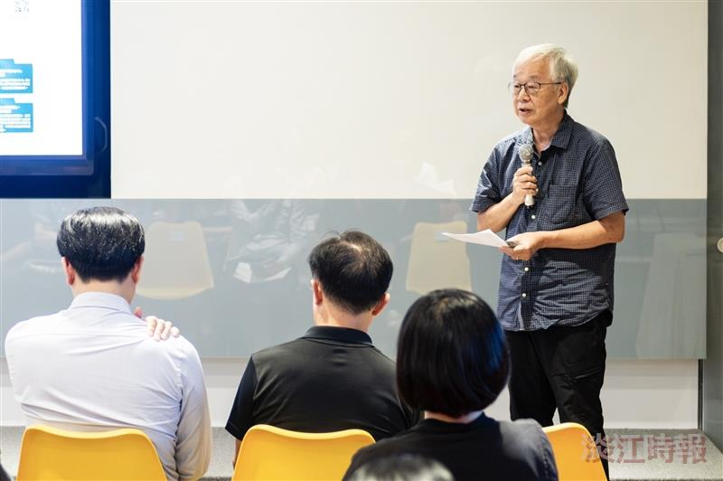
Professor Jui-Mao Huang from the Department of Architecture explained the contents of the 2023 Social Responsibility Annual Report and shared his experience in its implementation.

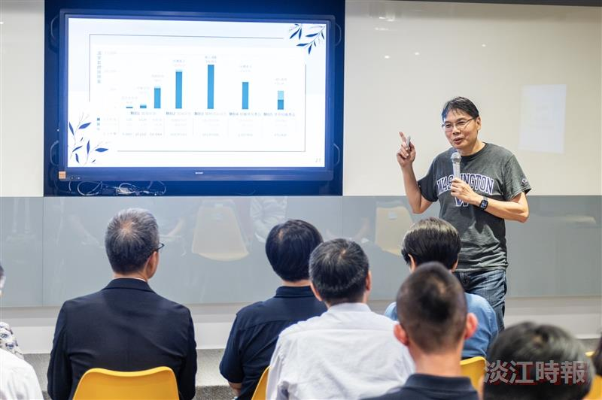
Professor Chi-Wang Li, Head of the Net-Zero Carbon Emissions Promotion Section at the Center for Sustainable Development and Social Innovation, reported on Tamkang University's recent achievements in advancing a net-zero campus.

