Tamkang Times No.1190
Tamkang University Accredited as Futures Studies Institution, WFSF Sends Letter of Congratulations

The World Futures Studies Federation (WFSF) sent a letter to Dean Kuo-Hua Chen of the College of Education on September 23, informing and congratulating the College's undergraduate and master's programs in the Department of Education and Futures Design for passing the organization (WFSF Program Accreditation Council)’s accreditation and announcing plans for a certificate presentation.

Professor Kuo-Hua Chen noted that this recognition follows previous honors received by Tamkang University, including the “Best Educational Institution for Contributions to Global Futures Studies” award from the WFSF in 1999 and the “Outstanding Achievement Award for Promoting Futures Studies” presented to former President and current Chairperson Flora Chia-I Chang by the Hawaii Research Center for Futures Studies (HRCFS) in 2016. This latest accreditation from the WFSF represents the third pillar of a “Futures Studies Golden Triangle,” making it a fitting tribute to the university’s 75th anniversary.

The letter was signed by WFSF President Erik F. Øverland, who praised Tamkang University’s outstanding achievements in futures research and foresight education, affirming its global leadership position in the field. He emphasized that the accreditation process followed rigorous procedures and standards to ensure the highest quality of international futures education, supported by comprehensive review measures and conducted according to the best global accreditation practices.

The WFSF is a global NGO that consultative partner to UNESCO and the United Nations, with members from over 60 countries, including scholars, researchers, practitioners, students, and institutions involved in futures studies. Currently, only 3 institutions worldwide have received WFSF accreditation for futures studies programs: the Master's Program in Foresight at the University of Houston, Turku University in Finland, and Stellenbosch University in South Africa. The accreditation is valid for 5 years, with a review conducted every 5 years.
2024/11/05

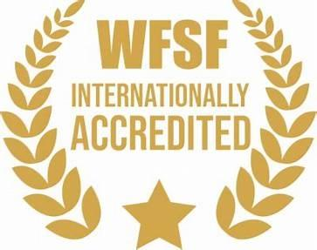
WFSF Accredited Foresight Programme Logo

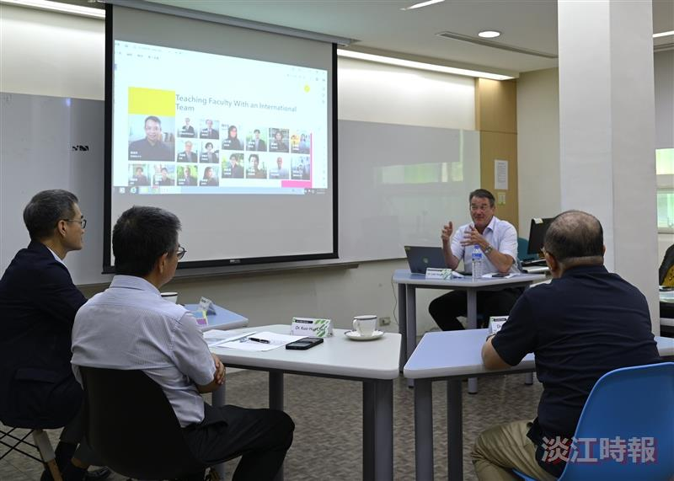
Dr. Luke Van der Laan, Chair of the Accreditation Committee for Futures Studies at the WFSF, responsible for certifying international research and teaching institutions, visited the College of Education this April to conduct the institutional accreditation.

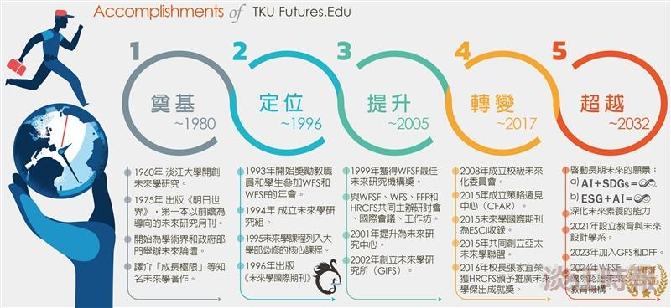
Timeline of the Development of Futures Studies at Tamkang University

