Tamkang Times No.1188
A.P. Chia-Jwu Tai's In-Depth Visit to Rome: Engages in Religious Art Exchange with Ambassador to the Holy See

Associate Professor Chia-Jwu Tai from the General Education and Core Curriculum Center recently led a team on an in-depth study tour to Italy, visiting several Roman churches to explore their artistic works. On September 5, the group visited H.E. Matthew S.M. Lee, Taiwan's Ambassador to the Holy See, to share their insights from the tour and discuss European art history. The conversation was lively, and A.P. Tai was especially pleased to meet alumni of Tamkang University abroad, including Minister Jun-Rong Huang and Counsellor Chia-Wei Li.

During the exchange, they shared views and personal experiences on the connection between religion and art. A.P. Tai highlighted that the evolution of European art history is deeply tied to the development of the Church. She noted that church art encompasses architecture, religion, history, and artistic creation, praising Rome as the "Eternal City," with over 900 churches, describing the city as "a rich history of art in itself." Both sides agreed that artistic experiences enrich personal growth and travel experiences. Mr. Lee added that many professionals in politics and business have a strong interest in the arts, and if Taiwanese academia could offer more information and courses on this subject, it would likely generate significant interest.

A.P. Tai specializes in visual arts creation and analysis, Western art history, the Renaissance, and Christian art, with a deep understanding of Catholic and Christian church art. In her teaching, she encourages students to gain a deeper understanding of the course content through hands-on experiences, often planning on-site sketching sessions where students can leave the classroom and experience the beauty of architectural art while enjoying the creative process. She previously published On High: A Millennium of Italian Church Art (「至高之處：義大利教堂藝術的千年光輝」), and through this study tour, she hopes to bring back firsthand knowledge to share with her students, enriching their learning with new insights and inspiration. She also plans to compile the results of her tour into a book that will introduce Roman church art, covering architecture, religion, history, and artistic creation, helping more people appreciate the beauty of art.
2024/10/15

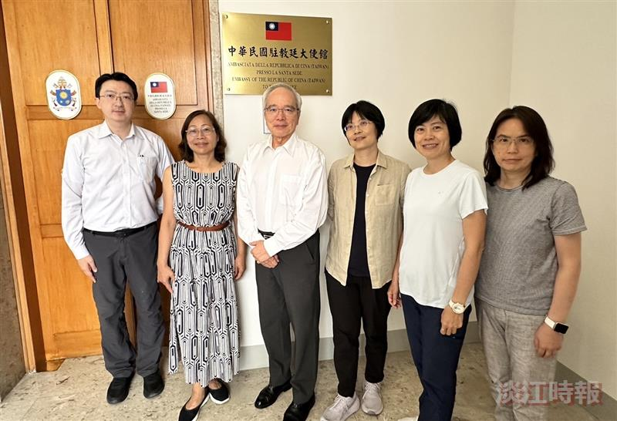
A.P. Chia-Jwu Tai (third from the right) visited the Ambassador to the Holy See, H.E. Matthew S.M. Lee (fourth from the right).

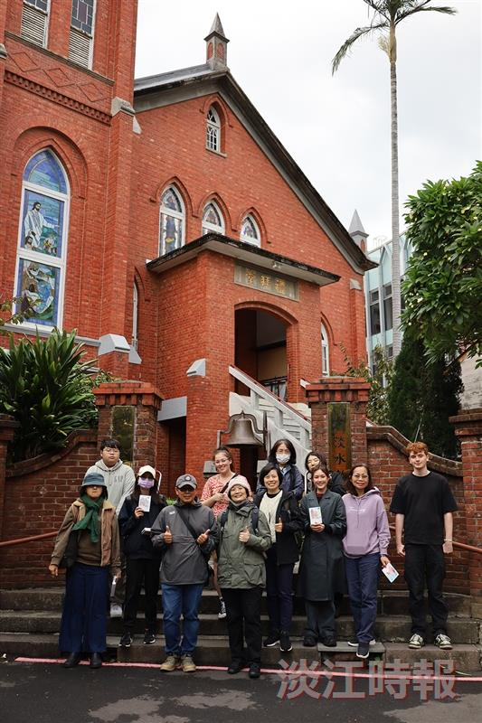
A.P. Chia-Jwu Tai (front row, fourth from the left) arranged an on-site sketching session in class, guiding students to experience art and discover the joy of creation.

