Tamkang Times No.1188
Prof. Chih-Hsin Chen and Prof. Yang-Han Lee Co-develop Real-time Semiconductor Manufacturing Monitoring System: Tamkang University Secures First 5.4 Million NTD Grant from NSTC Germination Program

Professor Chih-Hsin Chen, Chair of the Department of Chemistry, has achieved remarkable research success. Following the receipt of the 2020 NSTC Future Technology Award, multiple invention patents in Taiwan, and the Gold Medal at the 2023 Taiwan Innotech Expo, he secured a grant of NT$5.4 million this August from the NSTC 2024 2nd batch Germination Program for his project "Real-time Monitoring System for Gaseous Molecular Contaminants in Semiconductor Manufacturing Processes." This is the first project from Tamkang University to receive funding under this program. The team developed a flexible, cost-effective, real-time monitoring system tailored to semiconductor manufacturing processes. They also invited Professor Yang-Han Lee from the Department of Electrical and Computer Engineering as a co-principal investigator and plan to establish a startup next year, using innovative trace gas detection technology to open new markets and offer cutting-edge solutions for the semiconductor industry.

Prof. Chen explained that the project aims to detect potential gaseous molecular contaminants in the highly precise semiconductor manufacturing process. Using exclusive paper-based sensing technology and multi-dimensional color analysis, the system can instantly and accurately detect the concentration of gaseous molecules, enabling preventive measures to improve the yield and profitability of semiconductor processes. Prof. Chen pointed out that the semiconductor industry is a critical development sector in Taiwan, but existing technologies rely on large, expensive, and immobile instruments, which make it difficult to respond flexibly to the unique gases used in manufacturing processes. "Our detection system is lightweight, flexible, mobile, and suitable for various environments, reducing equipment costs compared to large instruments. It can integrate and detect multiple specific gases in semiconductor processes anytime and anywhere, effectively improving detection accuracy and offering significant market expansion potential."

The NSTC Germination Program grant encourages collaboration between academia, industry, and research institutions, aligning with government policies promoting industrial innovation. The grant supports promising research outcomes in moving toward commercialization and business development. It also connects resources from the Ministry of Education, NSTC, Ministry of Economic Affairs, National Development Council, and Financial Supervisory Commission, supporting national industrial sustainability and economic progress. With a smile, Prof. Chen said securing the grant was no easy feat, as most recipients are from national universities, medical universities, or medical institutions. "Our team worked tirelessly for three years, continuously refining our project direction until our application was finally approved, making us a nurtured team of the NSTC Research and Entrepreneurship Program Office."

The project’s research team includes 2 alumni from Tamkang University. Dr. Zhi-Wei Huang, a PhD graduate in chemistry, is responsible for advanced technology development, and Dr. Zong-Yang He, a PhD graduate in applied science from the College of Science, oversees commercial development strategies. The team plans to continue applying for government grants and subsidies, and they hope to raise funds to quickly establish a startup to promote this innovative technology.
2024/10/16

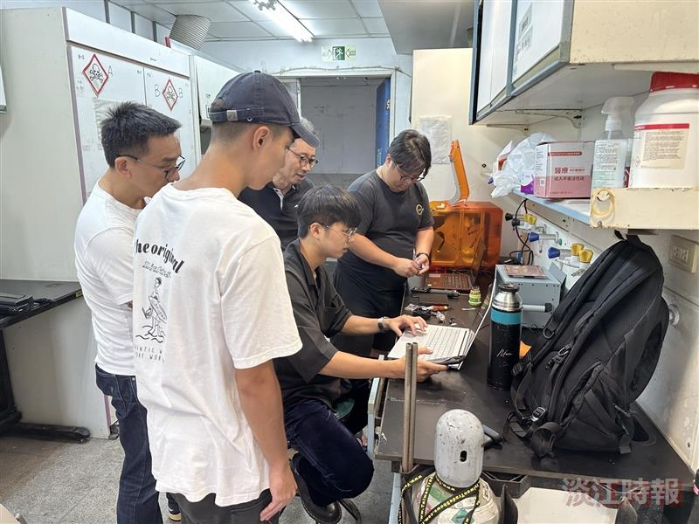
Team members discuss integrating the monitoring system with the image capture system.

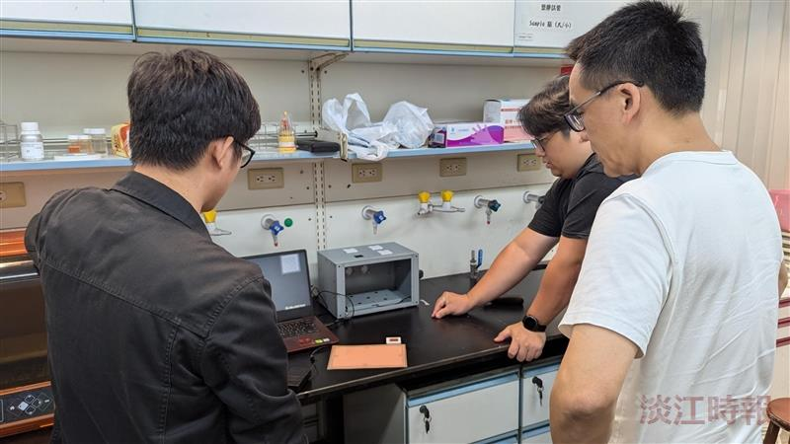
The research team conducts testing on the real-time monitoring system.

