Tamkang Times No.1188
Outstanding Educational Performance Recognized: Tamkang University Honored with the Asian Network for Quality Excellence in Quality Practice Award

Tamkang University's educational quality is recognized with a world-class award! Recommended by the Chinese Society for Quality (CSQ), our university has passed the evaluation of the 2024 23rd Excellence in Quality Practice Award (ARE-QP) from the Asia Network for Quality (ANQ). The Chief Audit Executive of Tamkang, Prof. Yen-Ling Lin, represented the university and traveled to Keio University in Japan on September 18 to receive the award from the conference chair, Professor Shu Yamada, during the ANQ Annual Conference.

The award aims to recognize organizations that demonstrate excellence in quality management and practices, promoting the development of the quality movement in Asia. The selection process involves nominations from member organizations in each country, with 1-2 organizations excelling in quality promotion activities and achieving outstanding accomplishments. After passing the preliminary selection, candidates must present their reports at the ANQ Annual Conference, where results are announced and awards are presented. CSQ serves as the member organization for Taiwan. Tamkang University, having previously won the society's 2023 Benchmark Award for Excellence in Operational Quality, was nominated for its exceptional educational quality. After passing the preliminary selection, Prof. Yen-Ling Lin delivered an English presentation at the annual conference, earning recognition alongside 6 other organizations from 3 countries.

President Huan-Chao Keh emphasized that quality is a hallmark and pride of Tamkang University, with Total Quality Management (TQM) being a key part of the university's organizational culture and the DNA of Tamkang's people. The university has long promoted TQM and, in recent years, has embraced the vision of AI+SDGs=∞ for institutional development, actively advancing digital and net-zero transformations. These efforts have enhanced teaching and research capabilities, providing students with an improved environment for learning and innovation. Additionally, Tamkang University has set new records for approved Teaching Practice Research Programs and undergraduate research projects funded by the National Science and Technology Council. Tamkang has also received the National Sustainable Development Award from the Executive Yuan and the Gold Award for Energy Conservation from the Ministry of Economic Affairs. The president encouraged faculty, staff, and students to continue their efforts in building Tamkang into a resilient university city that is both locally engaged and globally connected, with smart cloud technologies and sustainable futures.
2024/10/15

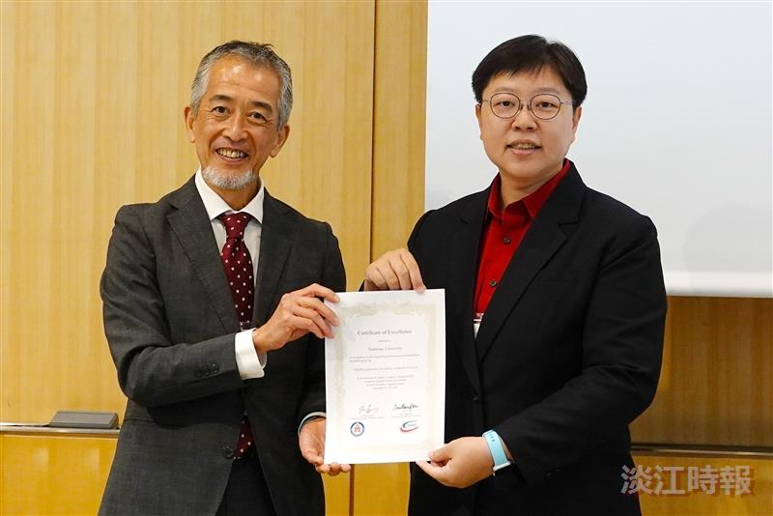
Tamkang University has been honored with the 2024 Excellence in Quality Practice Award by the Asian Network for Quality. The award was received on behalf of the university by Chief Audit Executive Yen-Ling Lin (right), presented by the conference chairperson, Shu Yamada.

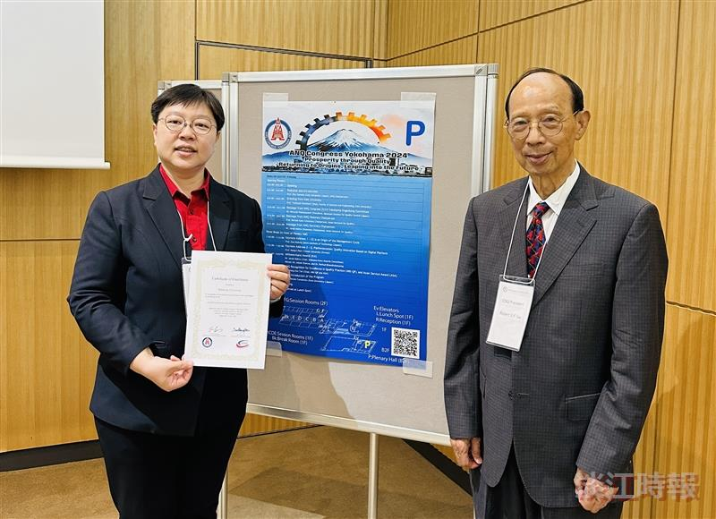
Prof. Yen-Ling Lin (left) poses for a photo with Rui-Yan Lu (right), Chairman of the Chinese Society for Quality.

