Tamkang Times No.1187
Professor Ku-Jun Lin Experiences the Appeal of AI-Integrated Teaching During Summer EMI Teacher Training in the U.S.

Professor Ku-Jun Lin from the Department of Accounting was selected to join 21 higher education faculty members from various fields across Taiwan to participate in the "EMI (English as a Medium of Instruction) Higher Education Training," co-organized by the National Taiwan Normal University entrusted by the Ministry of Education and the University of Texas at Austin (UT Austin) in the United States. During the two-week in-person course, Dr. Lin experienced the appeal of integrating "generative AI" into teaching and enthusiastically remarked, "This aligns perfectly with Tamkang University's AI + SDGs = ∞ development strategy."

Dr. Lin shared that one of the most noteworthy topics in the training was how to incorporate “generative AI” into courses, where it plays a pivotal role in teaching and learning. For example, ChatGPT can simplify complex accounting and financial statement notes that are difficult to understand, summarizing and translating them into content that is accessible to students of various English proficiency levels. This not only enhances the readability of the material but also fosters motivation for students to read and learn. Dr. Lin believes that effectively using such tools enables students from various disciplines to manage their time more efficiently by focusing on critical thinking and judgment. This approach not only helps overcome the initial understanding challenges in all-English-taught classes but also equips students with practical skills for their future career development. He remarked, "This perfectly aligns with our university's AI + SDGs = ∞ development initiative." He suggested that faculty integrate the university's TKU Copilot platform into teaching. Not only would this help build the university’s reputation, but if it could become an exclusive generative AI tool for all faculty and students, it would further empower them.

The training program was well-organized, with courses including Holistic Course Design, Generative AI, Reading and Writing, Oral Communication, Observation, and various workshops. It was customized by the Director of the Texas English Language Center and 6 professional EMI trainers. Before the trip, a survey was conducted to understand each teacher’s academic field and challenges in EMI teaching. A seven-day online course in Taiwan initiated topic analysis and group discussions, helping participants become familiar with each other and reduce cultural shock before traveling to the U.S. Once there, participants were divided into small groups for teaching, with a 1:10 teacher-student ratio, allowing for ample discussion and interaction, maintaining differentiated EMI teaching quality.

Additionally, the focus on "student-centered learning" was a key element of the training. Dr. Lin found it highly beneficial, whether through class activities designed to encourage group discussions and student participation or promoting teachers’ attention to student diversity. He also appreciated the focus on addressing students' individual needs to improve their language proficiency and offering remedial EMI instruction. Dr. Lin thanked the university’s EMI Promotion Center and National Taiwan Normal University's Bilingual Education Office for their support. He hopes to apply what he learned from this experience to enhance EMI courses and promote them on campus to benefit many students.

Furthermore, Dr. Lin noted that the training program treated him as a student, arranging for him to stay in university dorms and allowing him to use his student ID to access all facilities and public transportation throughout the city, including buses and trains. He also gained access to the university's library resources, databases, and academic journals for a year, significantly expanding his research resources, which he found very valuable.
2024/10/06

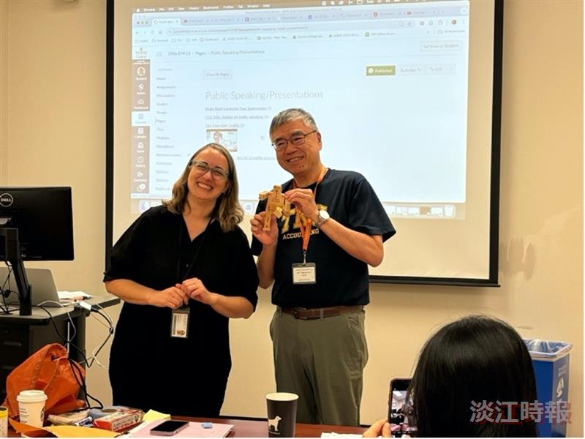
After completing the Oral Communication course, Dr. Ku-Jun Lin (right) received a small gift — a wooden robot from the University of Texas Business School.

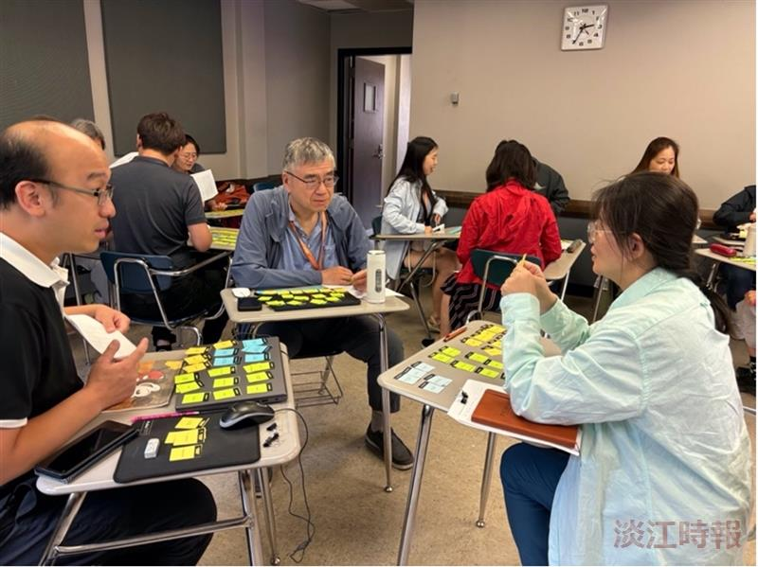
A glimpse of the workshop (flashcard) activity.

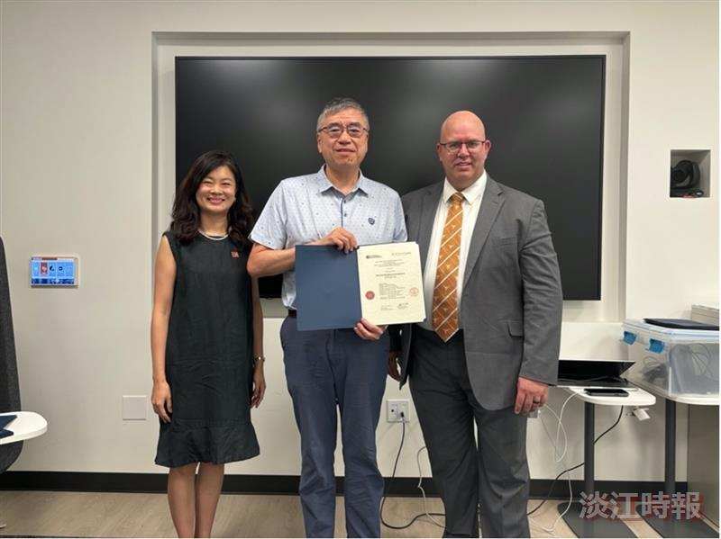
Dr. Ku-Jun Lin receives his certificate of completion.

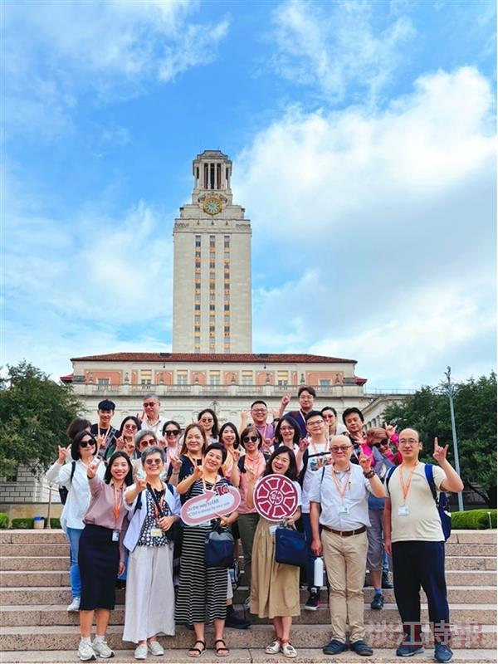
A group photo of all the participating teachers.

