Tamkang Times No.1187
TKU Achieves Significant Research Results in Taiwan-Netherlands Photon Quantum Computing Alliance: Year of Innovation and Cultural Exchange Promoted Strongly

In 2024, marking 400 years of Taiwan-Netherlands exchanges, the Netherlands Office Taipei (NLOT) is hosting the Taiwan-Netherlands Year of Innovation and Culture. On the homepage of the NLOT official website, special mention is made of the Taiwan-Netherlands "Photon Quantum Computing Alliance," a collaboration between Tamkang University's Assistant Professor Jun-Yi Wu from the Department of Physics and Executive Director of the Advanced Quantum Computing Research Center, and the University of Twente (UT) in the Netherlands. This alliance has been selected as a key promotion project, highlighting that Tamkang University's quantum computing research has become a sought-after partner on the international stage.

Dr. Wu pointed out that since June last year (2023), with funding from the National Science and Technology Council (NSTC) and the Netherlands Organization for Scientific Research (NWO), the "Taiwan-Netherlands Photon Quantum Computing Alliance" was officially launched. He and Dr. Jelmer Renema, a professor from UT, are the respective leaders of the alliance for Taiwan and the Netherlands. Over the next 4 years, they aim to accelerate the development of optical quantum computing technology, advancing the field toward universal optical quantum computing. Over the past year, the first phase of their collaboration on the “Multi-Photon Bell Test Verification Experiment” is nearing completion, and they are currently collecting and analyzing data. In the future, they will further design more efficient theories and experiments for optical quantum computing verification.

In the Taiwan-Netherlands Optical Quantum Computing Alliance, Tamkang University and the University of Twente have formed a close research partnership with Leiden University (LEI), National Tsing Hua University (NTHU), and National Central University (NCU) to tackle the complex challenges of optical quantum computing. Dr. Jun-Yi Wu pointed out that by strengthening the collaboration between the two sides, the alliance aims to develop high-quality key components for optical quantum computers, particularly in the preparation of optical qubits. The ultimate goal is to use innovative photonic quantum chips to build optical quantum computer components, provide stable solutions for the miniaturization and efficiency of future optical quantum technology, and ultimately create next-generation quantum computers' core architecture.

The alliance has entered its second year this year. In June this year, team members held the annual alliance meeting at Leiden University in the Netherlands. Each team shared significant technical advancements in various key components of optical quantum computing. Tamkang University introduced theories for photon state verification, highlighting progress in ensuring the accuracy and consistency of quantum states. NTHU and NCU reported on their progress in developing stable and efficient photon sources, while the UT presented advancements in photonic processors that facilitate complex quantum computations. LEI detailed improvements in single-photon detectors.

Dr. Wu stated that next year's alliance meeting will be held in Taiwan. All teams eagerly anticipate the technological developments in key components of photon quantum computing. He also mentioned that Tamkang University’s faculty and students will play a significant role in future photon quantum research. Students interested in this field are encouraged to join the Advanced Quantum Computing Research Center to enhance their interdisciplinary computing and quantum knowledge.
2024/10/06

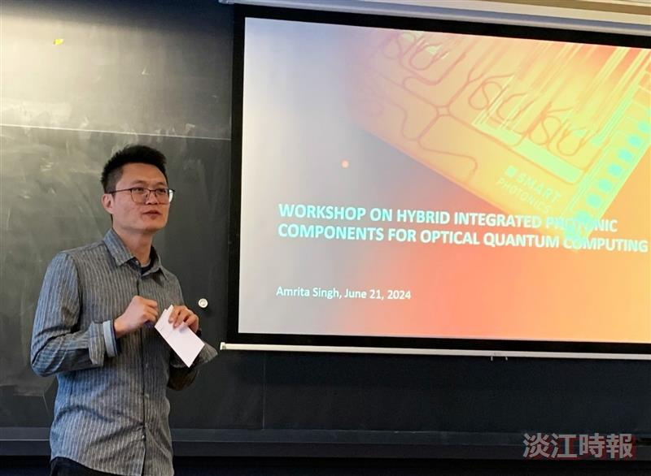
In the Taiwan-Netherlands Photon Quantum Computing Alliance, the alliance's lead from Tamkang University, Assistant Professor Jun-Yi Wu of the Department of Physics, presented significant research achievements at the annual meeting.

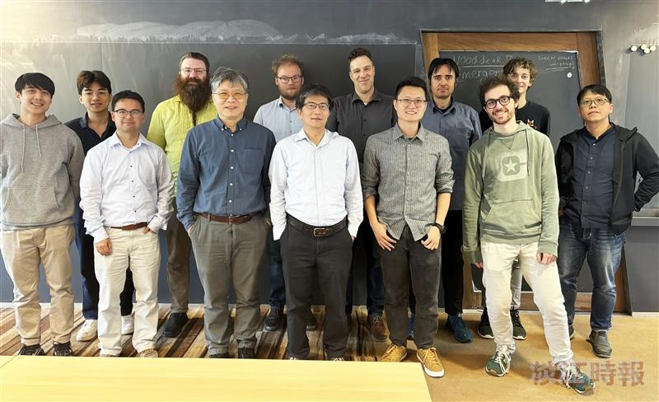
In the Taiwan-Netherlands Photon Quantum Computing Alliance, the alliance's lead from our university, Assistant Professor Jun-Yi Wu of the Department of Physics (front row, third from the right), posed for a group photo with the participating scholars during the annual meeting between both parties.

