Tamkang Times No.1187
e-Calligraphy Experience: A New Departure Activity at Taoyuan Airport Terminal 2

The “e-Calligraphy System” takes off at Taoyuan Airport Terminal 2! The "e-Calligraphy Experience: The Art of Writing with Technology, Showcasing the Beauty of Words," co-hosted by Tamkang University’s Carrie Chang Fine Arts Center and Tasa Meng Duty-Free Shop, launched on September 4th near Gate D5 in the departure area of Terminal 2 at Taoyuan International Airport. In addition to introducing e-Calligraphy, passengers can use iPads on-site to experience the "e-Calligraphy System," practicing with 4 built-in calligraphy templates and writing messages that reflect their travel sentiments and well-wishes. Participants can save their work by scanning a QR code or taking a screenshot, allowing them to enjoy the elegance of e-Calligraphy during their waiting time before departure.

Carrie Chang Fine Arts Center Director Ben-Hang Chang further explained that, in addition to the e-Calligraphy experience, the waiting area features an exhibition of artworks created with the e-Calligraphy system. "You can scan them with your phone and take them with you," he said. He also announced that e-Calligraphy artworks and Tamkang University’s dual-track e-Calligraphy research achievements will be exhibited from November 1 until early February next year at the Terminal 2 Performance Center and Art Gallery, and in February 2025 at the Taiwan Cultural Center in Tokyo, Japan. Through these experiences and upcoming exhibitions, more people will have the opportunity to discover this convenient writing tool, while sharing Tamkang University’s achievements in promoting dual-track development.

Sponsored by an alumnus of the accounting department Chin-Tsai Chen, chairman of WIN Semiconductors, the "Tamkang e-Calligraphy Dual-Track Development and Research Project," a collaboration between the Carrie Chang Fine Arts Center and the College of Engineering, is still ongoing. One of the features, "Air Writing" (空靈揮毫), uses AI detection and image recognition technology to allow users to wave their hands and have their invisible writing appear on a screen. The technology is now well-developed and continues to be optimized. Another feature, "Masterful Calligraphy Creation” (書作玉成), uses AI to allow users to choose different calligraphy fonts and template sizes. The system automatically generates a calligraphy layout after inputting the title, content, and signature. The “dynamic generation” function can simulate the writing process based on different poems and characters, allowing users to quickly start with calligraphy and experience the charm of this art form.

Ben-Hang Chang has also been teaching the " Creative Application of e-Pen" course in the College of Liberal Arts for several years. The year-long course familiarizes students with the e-Calligraphy system in the first semester and focuses on AI-assisted creative work in the second semester. Each year, the Carrie Chang Fine Arts Center holds an e-Calligraphy competition on campus, and in 2023, it launched the first "AI-Generated Calligraphy Art Contest." These competitions allow students to showcase their e-Calligraphy skills, and the annual exhibition presents their work to the public, offering insight into this convenient and elegant digital tool.

In recent years, Tamkang University has actively promoted the interdisciplinary integration of AI and SDGs. Starting this academic year, Ben-Hang Chang is offering a new course, "Cross-Disciplinary Innovative Applications of AI Technology and Humanities," in the College of Liberal Arts. Drawing on the success of the e-Calligraphy experience, the course invites professionals from various fields to share the practical applications of AI technology and humanities, encouraging students to enroll and gain new knowledge and inspiration.

Aside from promoting e-Calligraphy, Ben-Hang Chang continues to create works in the field of traditional calligraphy. His recent exhibition, "Coming with Inspiration – Ben-Hang Chang Calligraphy Exhibition," showcased nearly 50 works at the Ju Yi Antique Art Gallery (居意古美術) in Taipei, running until September 25th.
2024/10/06

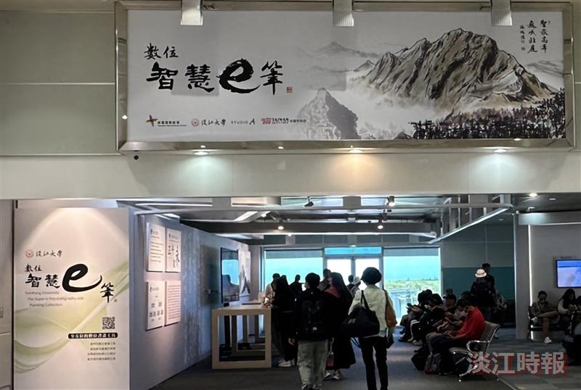
Starting from September 4th, the e-Calligraphy experience in the departure area of Taoyuan Airport Terminal 2 has attracted many travelers, who stop to admire the works and participate in the experience.

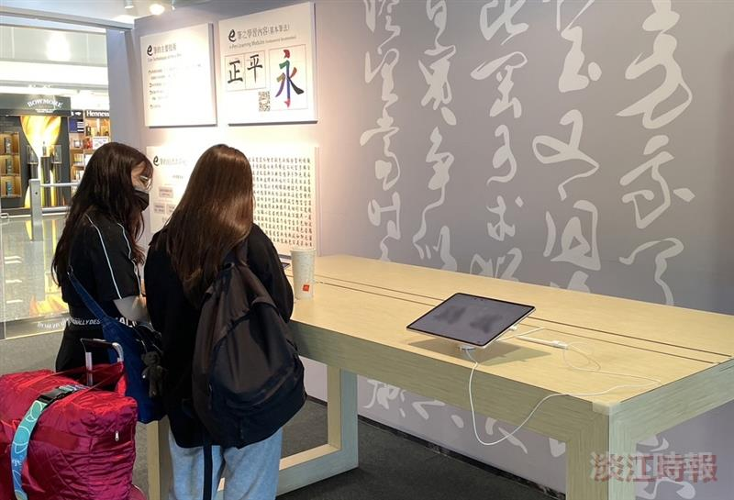
Starting from September 4th, the e-Calligraphy experience has been available at Taoyuan Airport Terminal 2, where waiting passengers can use the onsite equipment to try e-Calligraphy.

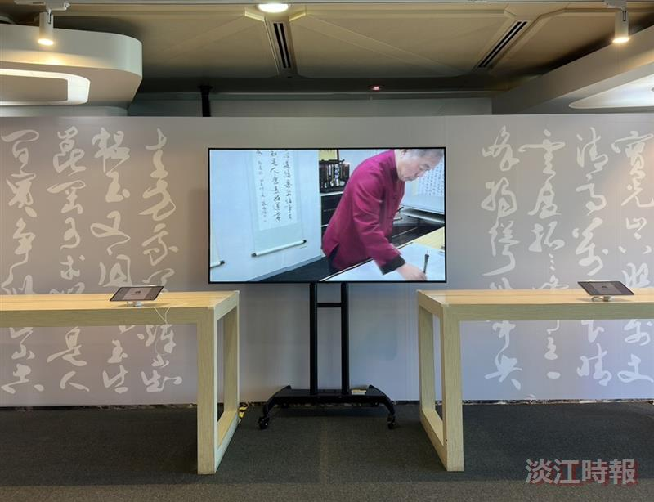
The e-Calligraphy experience area is equipped with iPads, allowing passengers to try e-Calligraphy on-site and watch promotional videos for the activity.

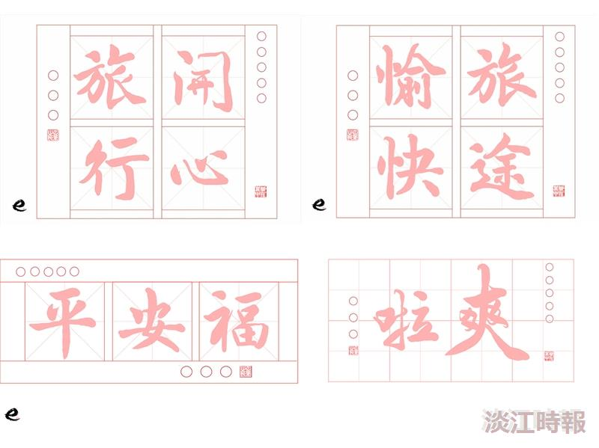
The e-Calligraphy experience allows participants to use the iPads provided on-site to practice 4 built-in calligraphy templates.

