Tamkang Times No.1186
The Symposium of Leaders in Student's Association of Tamkang University: President Keh Encourages Using AI to Enhance Club Management Efficiency

“The Symposium of Leaders in Student's Association of Tamkang University is crucial to Tamkang’s culture. Since its inception in 1966, the Symposium of Leaders in Student's Association of Tamkang University has adhered to the mission of “doing our best to create a vision,” embodying the spirit of passing on knowledge and ensuring that club experiences are sustainably preserved.” President Huan-Chao Keh, who has attended the opening ceremony for over 30 consecutive years, encouraged students to participate in various club activities to develop the soft skills needed by enterprises. He urged clubs to keep up with the times while passing on their experiences and organizing activities to align with Tamkang University’s core development goal, “AI+SDGs=∞,” to implement sustainable development and enhance club management efficiency through AI.

One of the distinguishing features of Tamkang University is its wide variety of student club activities. The main goal of the Symposium of Leaders in Student's Association of Tamkang University is to ensure that newly appointed club leaders can quickly get up to speed, become familiar with club operations, and lead members in enjoying club life. The Extracurricular Activities Guidance Section recently held “the Symposium of Leaders in Student's Association of Tamkang University” and “Club Leadership Training” on the Tamsui Campus to assist new club leaders and officers in understanding the operational processes of their clubs. A total of 228 participants attended.

This year, the symposium focused on 4 main themes: training courses, ceremonial rituals, reflection and feedback, and interactions and exchanges. These elements were designed to help newly appointed club leaders develop their management skills and engage with other club members for mutual learning and exchange. The seminar also included sessions led by professional instructors on topics such as “Event Planning,” “Communication and Expression,” and “Stress Management” to reinforce a positive mindset among participants. During the “Legacy Evening,” club leaders lit small candles symbolizing the passing of the torch within their clubs. They wrote down their club goals, which were placed in a wishing bottle, hoping to create a new legend of Five-Tiger Hill together.

The symposium was themed “Ginger Leads: The Trials for Club Runners.” For the first time, the course design allowed for flexible selection. In addition to mandatory courses like “Time Management,” “Leadership Mindset,” and “Event Planning and Preparation,” a variety of courses related to school club administrative processes were also offered. This allowed relevant positions or suitable leaders to choose and learn what was most appropriate for them, helping new leaders acquire the necessary skills to handle various club affairs and unexpected situations and positioning them to excel in their club roles.

Before the closing ceremony, Dean of Student Affairs Shih-Jung Wu delivered a talk titled “AI Applications and Sustainable Development in Clubs,” he discussed the importance of AI, SDGS, and how they can be applied to club management. He provided numerous examples to showcase a range of AI applications, aiming to enhance the technological proficiency of club leaders. During the session, participants were guided to brainstorm club activities and plan SDGs organized by clubs.

Ying-Cheng Chen, the first leader of the Psychology Research Club and a sophomore in Business Administration, stated, “The Symposium of Leaders in Student's Association of Tamkang University” is a large-scale event with over a hundred participants, which holds great significance for the leaders of newly established clubs. During the five-day and four-night event, participants could engage with members from different types of clubs, gaining valuable insights. In particular, the symposium allowed teams to form their clubs, where everyone actively discussed how to build a successful club. "By simulating various situations within a team, club leaders could gain valuable experience, which they can take back and apply to their clubs.

Yu-Che Chou, president of the Public Administration Department Student Association and a second-year student, shared his experience after participating in the symposium. He realized that the path to becoming a successful club leader is still long, as every step, from managing the club to applying for events, requires serious learning. "We are all seeds planted as club leaders, and I hope we can fully absorb the training, work through challenges with the officers, and grow strong to become outstanding club members!"
2024/09/10

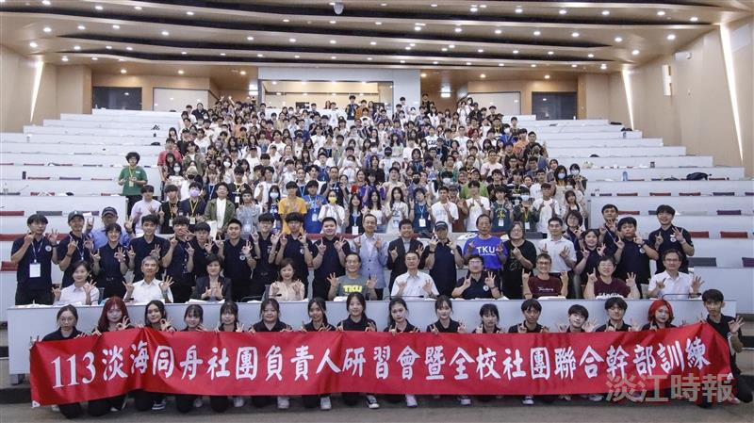
The opening ceremony was held at the Chang Yeo Lan Hall of the Hsu Shou-Chlien International Conference Center, where everyone happily took group photos.

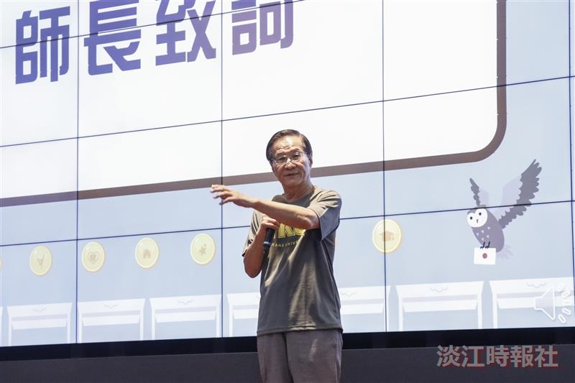
The opening ceremony of the Symposium of Leaders in Student's Association of Tamkang University invited President Huan-Chao Keh to deliver a speech.

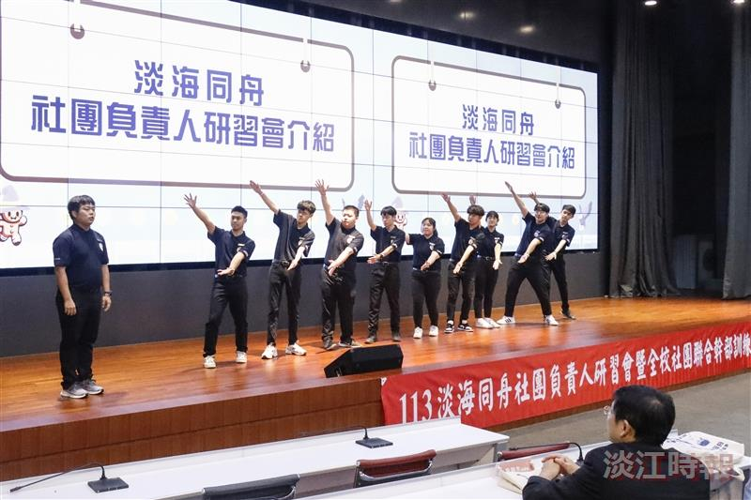
The Symposium of Leaders in Student's Association of Tamkang University staff were introduced during the opening ceremony.

