Tamkang Times No.1186
Hung-Chung Hsueh, Chi-Cheng Lee, Yung-Ting Lee's Cross-University Collaboration Published on the Cover of ACS Materials Letters

Physics Department Professor Hung-Chung Hsueh and Associate Professor Chi-Cheng Lee, along with Tamkang University's Chemistry Department alumnus Yung-Ting Lee, collaborated with scholars from National Taipei University of Technology, National Yang Ming Chiao Tung University, National Cheng Kung University, National Chung Hsing University, and the University of Tokyo to complete the academic paper titled "Revealing the Charge Density Wave Caused by Peierls Instability in Two-Dimensional NbSe2." This paper was featured on the cover of the internationally renowned journal ACS Materials Letters, published by the American Chemical Society. ACS Materials Letters is considered a top-tier journal in the field of materials science, with a 5-year impact factor of 10.2, ranking in the top 12% in the multidisciplinary materials science category.

Professor Hsueh stated, "The paper focuses on revealing the phenomenon of charge density waves (CDW) caused by Peierls instability in two-dimensional NbSe2 material, which expands our understanding of CDW. This research holds significant importance in the field of materials science as it challenges conventional views and offers novel observations and theoretical support." Understanding the mechanism behind the formation of CDW through this study can facilitate the development of new electronic devices. "Particularly in applications involving superconductors and low-dimensional materials, it could play a crucial role in quantum computing and high-performance electronic devices."

The scholars involved in this research represent a truly interdisciplinary collaboration, including Tamkang University's Associate Professor Chi-Cheng Lee from the Physics Department, Assistant Professor Po-Tuan Chen from the National Taipei University of Technology, Distinguished Professor and Director of the Key Materials Program at the Academy of Semiconductor and Sustainable Manufacturing at National Cheng Kung University, Dr. Chin Shan Lue, Associate Professors from the Department of Electrophysics at National Yang Ming Chiao Tung University, Dr. Chien-Te Wu and Dr. Chun-Liang Lin, Associate Professor Chien-Cheng Kuo from National Sun Yat-sen University, Professor Ming-Chiang Chung from National Chung Hsing University, and Professor Taisuke Ozaki from the Institute for Solid State Physics at the University of Tokyo. Dr. Chi-Cheng Li is also one of the corresponding authors of this paper.

Dr. Hung-Chung Hsueh, who serves as both a board member of the Physical Society of Taiwan and the Dean of Research and Development at Tamkang University, has managed to focus on research despite his busy administrative duties. He hopes to encourage young faculty members in Taiwan to engage in research and collaborate with scholars from different fields, contributing their expertise and experimental facilities. Combining experimental and theoretical interdisciplinary research, particularly in the intersecting areas of materials science, physics, and chemistry, can help discover more new materials with unique properties.

Dr. Yung-Ting Lee is currently a Project Assistant Professor in the Department of Vehicle Engineering at the National Taipei University of Technology. He was recognized as an Outstanding Young Alumnus by Tamkang University in 2008. He expressed his deep gratitude to his master's and doctoral thesis advisor, Professor Jyh-Shing Lin, and the faculty at his alma mater for their years of guidance and support. He plans to research the superconducting properties of two-dimensional materials made from "Transition Metal Dichalcogenides" and the extension and development of related first-principles methods.
2024/09/10

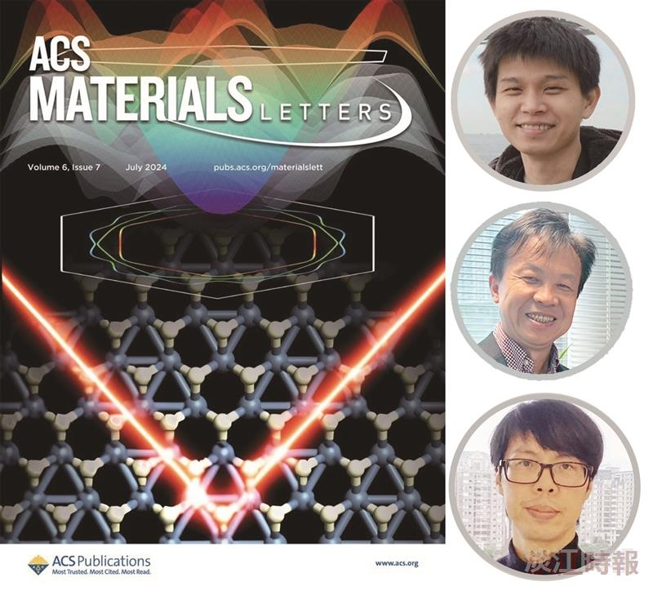
Tamkang University's Chemistry Department alumnus, Assistant Professor Yung-Ting Lee from the National Taipei University of Technology (top right), along with our Physics Department professors Hung-Chung Hsueh and Associate Professor Chi-Cheng Lee, co-authored an academic paper that was featured on the cover of the internationally renowned American journal ACS Materials Letters.

