Tamkang Times No.1186
【Freshman Tips】Tamkang University Scholarships: Over 200 Types of Scholarships Totaling More Than 200 Million NTD Annually to Support Students' Learning

To encourage diligent learning and assist students with various academic achievements and financial difficulties in successfully pursuing and completing higher education, Tamkang University has specially established the "Tamkang University Scholarships-Simplicity, Truthfulness, Firmness, and Perseverance." With an annual total exceeding 200 million NTD, over 200 types of scholarships are offered, ensuring that students can study without financial worries. Under the cultivation of the Three Circles and Five Disciplines curriculum, students are guided toward the goal of spiritual excellence.

<br />

#### Chang Yeo Lan Scholarship - The Highest Single Scholarship in Taiwan: New Students Can Receive 200,000 NTD

Currently, the "Chang Yeo Lan Scholarship" holds the highest total amount for a single scholarship among all universities in Taiwan. It was established in 2020 through a donation of 120 million NTD by Hang-Chien Hsu, an alumnus of the Department of Management Sciences. Since September 2021, this scholarship has benefited Tamkang University freshmen, with 592 students receiving scholarships ranging from 20,000 to 200,000 NTD. Recipients have expressed that this scholarship provides not only substantial financial support but also serves as an intangible source of encouragement.

<br />

Manda, an international student from the Department of Business Administration, shared, "I had always wanted to study in Taiwan since high school, but due to financial pressures, I once considered giving up. By chance, I got to know a teacher who graduated from Tamkang University, and through them, I gradually learned more about Tamkang. I am very fortunate to be able to study here and receive the Chang Yeo Lan Scholarship, which has allowed me to enjoy a warm and fulfilling university life."

<br />

#### Shao-Hsin Wang Donates 24.12 Million NTD Over 3 Years to Support Outstanding and Underprivileged Students

Shao-Hsin Wang, Chairman of SINBON Electronics and an alumnus of the Department of Mathematics, has been making substantial donations annually since 2020. These donations provide various scholarships and financial aid to economically disadvantaged students, those with excellent academic performance, outstanding research achievements, internships, and competition participants. His support aims to help current students focus on their studies without the need to juggle multiple part-time jobs, a struggle he faced during his own education that left him with little time to further his studies. To date, a total of 2,679 students have benefited from scholarships amounting to over 24.12 million NTD.

<br />

Tamkang University offers various internal and external scholarships and financial aid programs. To help students quickly find options that match their qualifications and to prevent those in urgent need from missing opportunities due to a lack of information, we have established the "Tamkang University Scholarships-Simplicity, Truthfulness, Firmness, and Perseverance," aligning with our school motto and corresponding to the 4 stages of education to increase visibility. At the start of their studies, students can access over 50 scholarships, including the Chang Yeo Lan Scholarship and Shao-Hsin Wang Scholarship, which are among the most prestigious in the nation. In their sophomore, junior, and senior years, as well as in graduate school, multiple scholarships continue to be available, ensuring that students can focus on their studies while rewarding their outstanding achievements. This support helps students become highly competitive professionals after graduation. For more information, please visit the Tamkang University Scholarships webpage (URL: https://scholarship.in.tku.edu.tw/ ).
2024/09/10

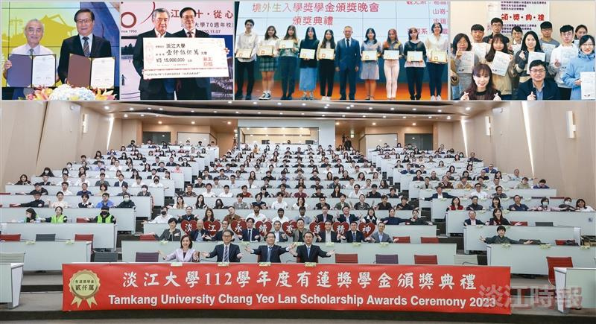
Tamkang University has established the "Tamkang University Scholarships-Simplicity, Truthfulness, Firmness, and Perseverance," with a total annual amount exceeding 200 million NTD, ensuring that students can pursue their studies without financial concerns.

