Tamkang Times No.1186
Net-Zero and Digital Dual Transformation: Tamkang University's SDG 7 Ranks in 2024 Times Global Top 100

In the "2024 Impact Rankings" released by the UK’s Times Higher Education (THE) on June 13, Tamkang University ranked 53rd globally in SDG7 "Affordable and Clean Energy," making it the top-ranked private university in Taiwan. The achievement of entering the global top 100 in SDG7 is a result of our university's recent efforts to pursue the dual transformation towards "Net-Zero" and "Digital" under the strategic development goal of "AI + SDGs = ∞".

This year, a total of 2,125 universities from 125 countries were included in the evaluation, with only 1,963 universities making the rankings. In the SDG7 "Affordable and Clean Energy" category, Tamkang University continued its success from last year, ranking second nationwide and first among private universities, second only to National Cheng Kung University.

Tamkang University's leading position in SDG7, "Affordable and Clean Energy," is attributed to our dual transformation strategy focusing on "Net-Zero" and "Digital." The key achievements are as follows: First, in 2022, we were awarded the Ministry of Economic Affairs (MOEA)'s Energy Saving Benchmark Gold Award and selected as a demonstration unit for 2023. We established the "Tamkang University Microsoft Digital Empowerment Center," leveraging smart technology and digital transformation to accelerate the implementation of the UN's Sustainable Development Goals. Additionally, we signed an MOU with Far EasTone Telecommunications for a "5G Metaverse Net-Zero Carbon Campus," marking the first industry-academia collaboration in Taiwan between a telecom operator and a university focusing on the metaverse and net-zero carbon emissions. After registering the trademark "AI + SDGs = ∞" with the Industrial Development Bureau, MOEA, we collaborated with Microsoft Taiwan and FarEasTone to establish the "Net-Zero Transformation Alliance," assisting SMEs in achieving dual transformations in digitalization and net-zero emissions.

Regarding actual energy-saving measures, the "Sustainable Cloud" initiative, in collaboration with FarEasTone Telecommunications and Microsoft, is an innovative effort that has led to significant energy-saving results. The EUI (Energy Use Intensity) decreased from 116.52 kWh/m²•yr in 2015 to 97.64 kWh/m²•yr in 2022, saving approximately 4.21 million kWh of electricity. Since July 2021, Tamkang University has installed a total of 1,636 solar photovoltaic panels, generating 1,107,240 kWh of electricity by August 31, 2023, and reducing carbon emissions by 562,690 kgCO2e.

Additionally, Tamkang University has actively assisted the community in understanding the importance of energy efficiency and clean energy, leading to actions promoting renewable energy adoption. We have supported and signed the "Talloires Declaration" and collaborated with universities to initiate the formation of the "Taiwan Green University Alliance," where President Huan-Chao Keh serves as a supervisor. Through SDGs environmental sustainability workshops, we have engaged with local communities and elementary schools to help them understand the importance of energy efficiency and clean energy. We have also provided long-term suggestions to the government for formulating clean energy policies and developing energy-saving technologies.

Furthermore, after Tamkang University obtained the qualification as an "Industrial Decarbonization Guidance Unit" from the Industrial Development Bureau, MOEA, the Champion Incubation Center has been actively conducting business diagnostics, including carbon inventory, carbon management, and carbon reduction guidance. This includes supporting startups applying low-carbon economies or technologies, assisting resident companies in applying for government projects, offering information on loans and startup funds, and developing environmental software application plans. The center also offers courses to guide startups in fundraising and marketing and facilitates industry-academia collaborations with our university’s faculty.
2024/09/10

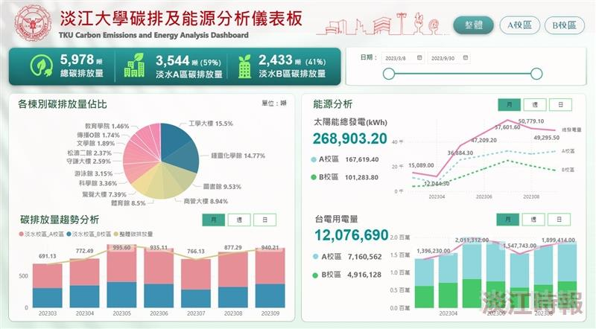
TKU Carbon Emissions and Energy Analysis Dashboard

