Tamkang Times No.1185
Leadership Transition of Club Leaders: Joining Hands to Continue Tamkang Spirit

To assist clubs in smoothly completing their leadership transitions, the Extracurricular Activities Guidance Section held the "2023 Academic Year Club Leadership Transition Series" on June 1 at the Student Activity Center. Successful senior members shared their experiences, continuing the Tamkang spirit and fostering a common understanding between outgoing and incoming leaders on club management. Over 130 people participated in the event.

In his speech, Dean of Student Affairs, Dr. Shih-Jung Wu, stated, "Serving as a club leader is a rare learning experience that helps you mature. It enhances your ability to think and plan comprehensively when managing affairs. The transition of club leadership is a crucial process for the sustainability of the clubs. Everyone here is a legend of the Five-Tiger Hill, and I hope the new club leaders will continue to strive and pass on this legacy."

The event was divided into 3 sessions. The morning session, "Heritage and Start," was led by Chao-Wei Lin, a lecturer from the Chinese Recreation Guidance Association. He facilitated interactive exchanges between outgoing and incoming leaders, promoting emotional connection and enhancing mutual understanding and trust. The afternoon session, "Connection and Heart Continuation," involved experience sharing by current leaders to help their successors understand the importance of heritage, recognize what needs to be passed down, and preserve the club's unique characteristics, aiming for better continuous development and growth.

The "Heritage and Heart Transmission" Handover Evening Gala was the event's climax. It began with the current club leaders handing over photos of club activities pieced together during the event to their successors, symbolizing the passing of the heritage. Next, in a ritual ceremony, each club advisor presented plaques and honor certificates to the outgoing leaders, expressing gratitude for their contributions over the past year. Dr. Shih-Jung Wu then awarded certificates to the Tan Hai Tong Zhou volunteers. Finally, everyone happily posed for a group photo, marking a successful conclusion to the series of activities.

Hao-Cheng Hsu, the current president of the Anime Club and a third-year student from the Department of Diplomacy and International Relations, shared, "I am grateful for the support of all the officers. Thank you all for being willing to accompany me through this year; I wouldn't be who I am today without you. I hope the new leaders will guide the club to even greater achievements and continue to promote team spirit. Just go for it!"

Cheng-Chin Yang, who is about to take over as president of the Seeding Study Guidance Service Club and is a first-year public administration student, stated that the most memorable part of the event was reflecting on and discussing the future vision and plans of the club with the current leaders. Through this, he gained a deeper understanding of the club's unique culture and enhanced mutual exchange. Taking on the significant responsibility of the president, he hopes to lead everyone forward, experience the joy of service, and cultivate team motivation.
2024/07/02

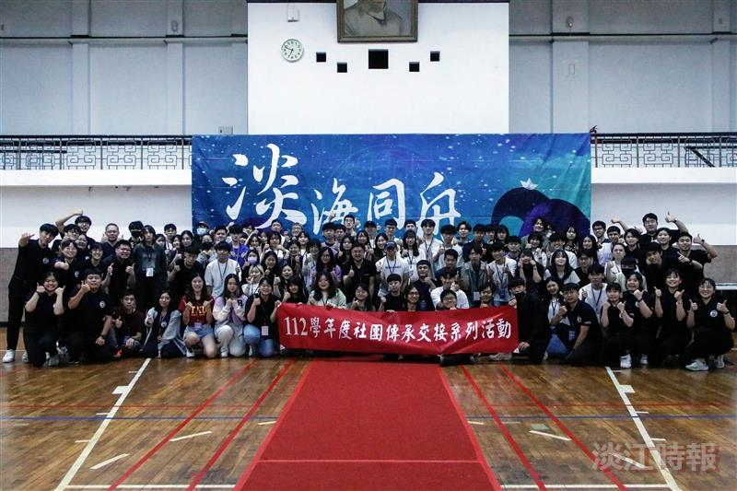
The Extracurricular Activities Guidance Section held the "Club Leadership Transition Series" on June 1, where everyone happily posed for a group photo.

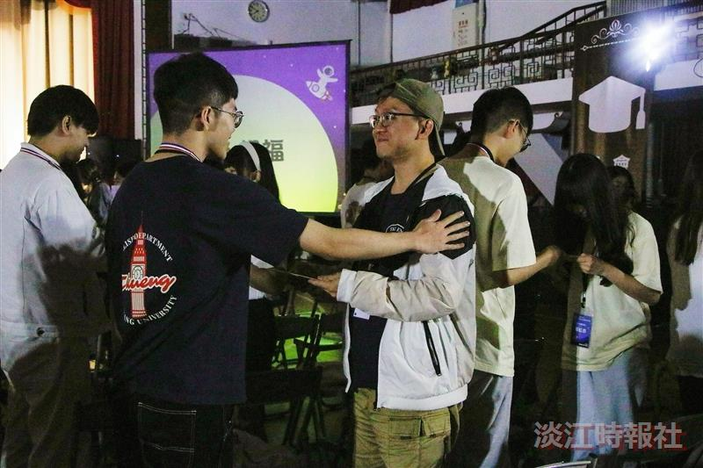
During the event, the current club leaders encouraged their successors to continue their efforts and carry on the club's legacy.

