Tamkang Times No.1184
11 EMI-Trained Teachers Certified, Share Teaching Experiences

On the morning of May 28 at 10:00 AM, the Center for English as a Medium of Instruction (EMI) at Tamkang University held an EMI Training Teacher Sharing Seminar and Certification Ceremony on the 2nd floor of the library. Vice President for International Affairs and Director of the EMI Center, Dr. Hsiao-Chuan Chen, awarded the joint certificates from AIT and Tamkang University to the 11 teachers who completed the two-phase training program. Jenning King, the English Education Coordinator from the Cultural and Information Section of the American Institute in Taiwan (AIT), attended the event. Dean of the College of International Affairs and Executive Secretary of the EMI Center, Dr. Cheng-Hao Pao, and Dean of the College of Business and Management, Dr. Li-Ren Yang, were also present at the ceremony.

In her opening remarks, Dr. Hsiao-Chuan Chen expressed her expectations and vision for further collaboration between Tamkang University and professional educational institutions in the United States. Following the certification ceremony, Jenning King shared how AIT currently assists universities with the online English Language Specialist Program and the in-person Fellow Program. She also anticipated deeper cooperation with Tamkang University in the future.

Dr. Kai-Su Wu, Head of the EMI Teaching and Learning Section at the Center, hosted the event. Several teachers shared their EMI teaching experiences. Dr. Ku-Jun Lin, an accounting department professor and Dean of Financial Affairs, shared that his English teaching career began at the Lanyang Campus. He detailed his valuable experiences teaching at the University of Michigan-Flint and receiving training at international institutions such as the University of Adelaide. Dr. Lin's career journey reflects the transition from initial confusion, anxiety, and unease to gradually accumulating teaching experience and professional growth. He emphasized that cultural differences are essential tools for attracting international students' attention and creating engaging interactions and interest in the classroom. Dr. Lin also discussed the challenges teachers face in designing courses, leading classroom activities, and grading assignments and the importance of strengthening professional knowledge and foreign language skills to meet students' needs. His experience highlighted the necessity of continuous self-improvement and adapting teaching strategies to fulfill student needs. Dr. Lin stressed that carefully designing course content, effectively leading classroom activities, and efficiently grading assignments are crucial for enhancing student learning outcomes. Additionally, he shared insights on how teachers should continually enrich their professional knowledge to maintain teaching quality and address the rapidly changing demands of education.

Dr. Chia-Chi Sun from the Department of International Business discussed his training experience at the University of Maryland in the United States. He shared the journey from facing initial challenges to receiving high praise from his trainers. He detailed the critical teaching strategies learned during the training, particularly how to plan a 50-minute lesson precisely. He emphasized that the foundation of appropriate course design is the teacher's clear understanding of the course's specific objectives, ensuring the course's maximum effectiveness. Dr. Sun concluded his sharing with a quote from Galileo Galilei: "Passion is the genesis of genius."

Finally, Assistant Professor Chun-Wei Ma from the Graduate Institute of International Affairs and Strategic Studies discussed his EMI teaching challenges at different teaching levels. He shared the valuable experiences he gained from participating in the training program jointly organized by Tamkang University and AIT, particularly emphasizing the importance of Flipped Classroom and Collaborative Learning methods. He stated that these approaches enriched his teaching methods and significantly enhanced student engagement and classroom interaction.

Dr. Kai-Su Wu stated that the sharing seminar allows teachers to share their experiences and insights. It demonstrates Tamkang University's determination and efforts in promoting English-medium instruction. He hopes such events will inspire more teachers to participate in EMI teaching, fostering students with international perspectives and high English proficiency.

The certified teachers are Dr. Chia-Chi Sun from the Department of International Business, Dr. I-Hsuan Shih and Dr. Shu-Chuan Chen from the Department of International Tourism Management, Dr. Yun-Ching Tsai, Dr. Chien-Hsin Wu, and Dr. Tzu-Lan Tseng from the Department of Management Sciences, Dr. Jyh-Jiuan Lin from the Department of Statistics, Dr. Hsiu-Hui Chuang from the Department of Business Administration, Dr. Kai-Su Wu from the Department of English, Dr. Ying-Lung Chou from the Department of Global Politics and Economics, and Dr. Chun-Wei Ma from the Graduate Institute of International Affairs and Strategic Studies.
2024/06/20

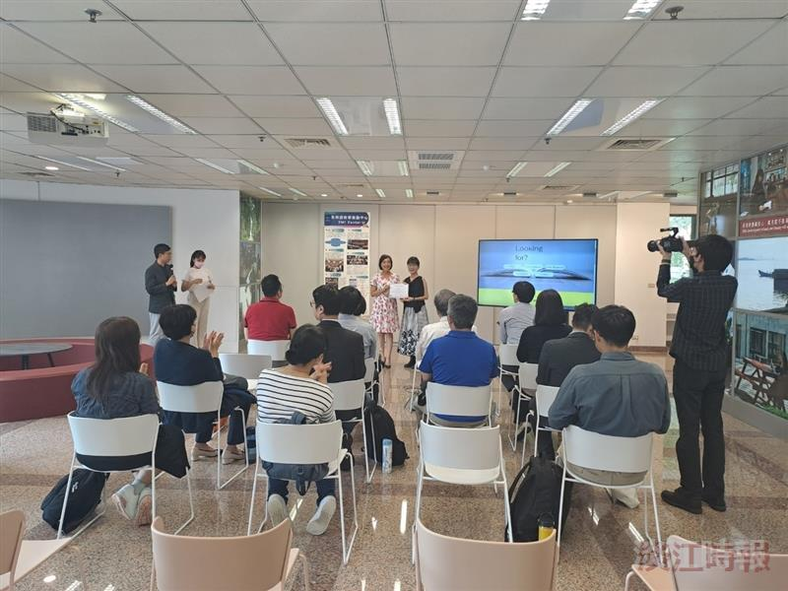
Vice President for International Affairs, Dr. Hsiao-Chuan Chen, awarded joint certificates from AIT and Tamkang University to the 11 teachers who completed the two-phase training program.

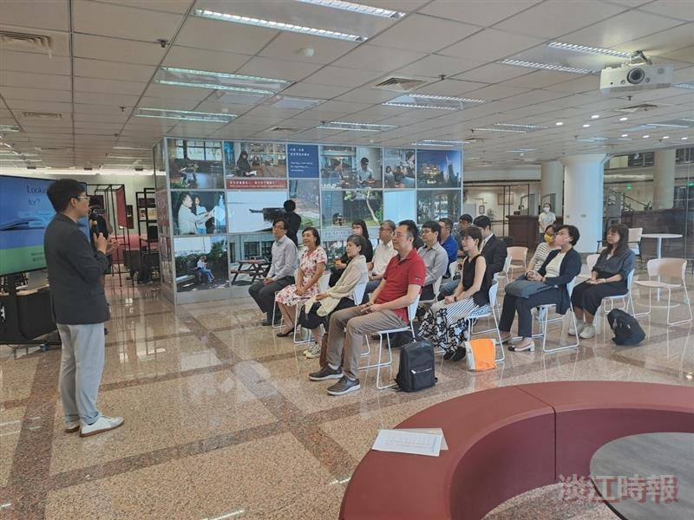
EMI Teacher Training Certification Ceremony

