Tamkang Times No.1184
Mutual Communication Between Teachers and Students: Club Leaders Share Insights

On May 17, the Extracurricular Activities Guidance Section held the “2023 Academic Year Club Leaders Forum” at the Chueh Sheng International Conference Hall, hosted by President Huan-Chao Keh. More than 100 attendees participated in the event, including Vice President for Administrative Affairs Chun-Hung Lin, first- and second-level supervisors from relevant units, and club leaders.

During the meeting, President Keh presented the National College and University Student Club Evaluation and Observation Activity Excellence Award to the Robotics Research Club, the Wind Ensemble Club, and the 2024 Outstanding Youth certificates to the award-winning students. In his speech, President Keh stated that participating in club activities helps students develop soft skills such as creative thinking and communication, providing a diverse set of abilities that offer an advantage in the future job market. This year, Tamkang University performed excellently in various corporate indicator surveys, demonstrating outstanding achievements in enhancing students' employability. He expressed hope that communication in this forum will address and improve the suggestions from club leaders.

During the Q&A session, Jun-Hao Hu, the president of the Choir Club and a sophomore in the Department of Industrial Economics, asked about the correlation between the reduction in the number of clubs and the decrease in subsidy funds. The Dean of Student Affairs, Dr. Shih-Jung Wu, responded that the funds for student activities are allocated according to the Ministry of Education's regulations based on the number of students. A decrease in student numbers consequently reduces club subsidies and the total revenue from tuition fees. Extracurricular Activities Guidance Section Chief Te-Cheng Cheng added that the school will consider each club's evaluation performance when allocating funds. Clubs are encouraged to seek subsidies through this channel actively. Additionally, external subsidy opportunities are available from organizations such as the New Taipei City Government Youth Bureau and various foundations. Once the information for applying for these subsidies is confirmed for the year, the Extracurricular Activities Guidance Section will announce it and assist with the application process.

Bang-Hong Yu, the leader of the Experimental Theater Club and a 3rd-year French major, requested coordination of the usage times for the L209 Experimental Theater. The Experimental Theater Club has difficulty using the venue between classes and hopes for flexible time allocation with the College of Foreign Languages and Literatures. President Keh stated that the allocation of the venue would be improved and that it would be made available to the club without disrupting the College of Foreign Languages and Literatures’ teaching activities.

Wong Tsz Lok, the leader of the Aikido Club and a junior in Information Management, raised the issue of damaged mats in the dojo of the Shao-Mo Memorial Gymnasium and requested the school's assistance in improving the situation. Jin-Tong Huang, the Chief of the Energy Conservation and Space Section, responded that they would have the supplier inspect the equipment, and any issues could be reported to the staff on duty for immediate handling. Dean of Physical Education I-Cheng Chen added that, following the President's instructions, the mats were completely replaced 2 years ago. After the meeting, he will visit the site with students to assess the extent and cause of the damage and then proceed with repairs.

Ching-Lin Huang, the leader of the Softball Club and a 2nd-year Transportation Management major, expressed that the club frequently needs to use the field for practice and hopes to have priority over external users during weekends. I-Cheng Chen responded that the university is an open campus, and residents and external visitors often visit the campus for activities. In the future, the university will assist the club in completing the application process for field use, ensuring that students' rights are protected and they can practice without issues.
2024/06/20

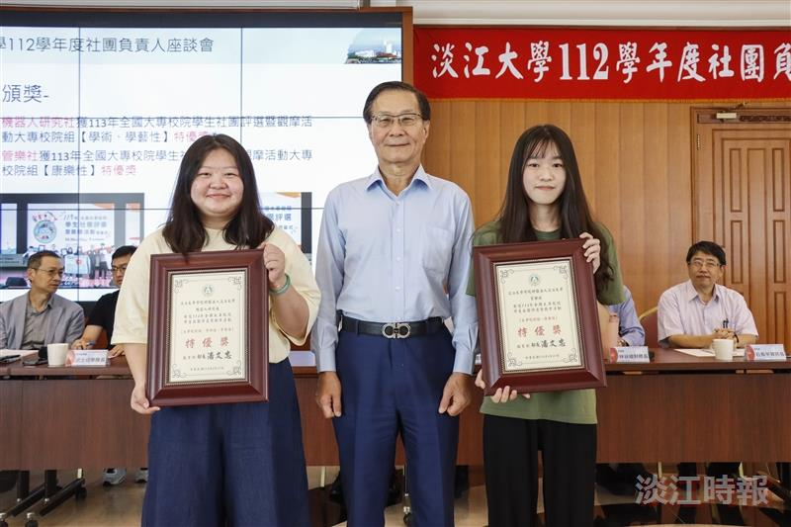
President Keh (center) presented the “National College and University Student Club Evaluation and Observation Activity Excellence Award” to the Robotics Research Club and the Wind Ensemble Club.

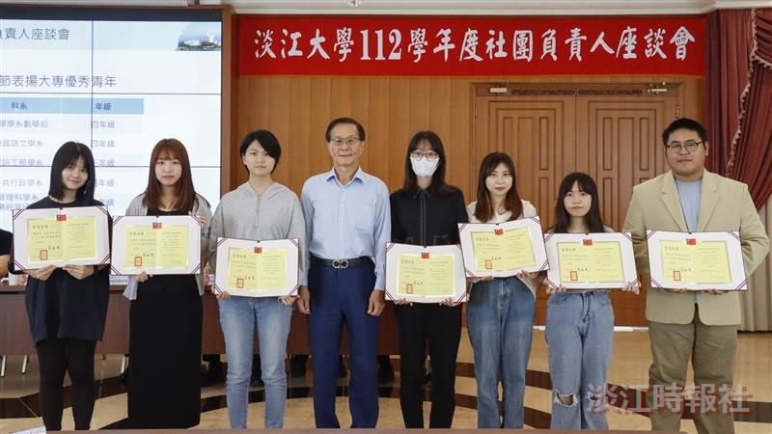
President Keh (4th from left) presented the “Outstanding College Youth” certificates to the award-winning students.

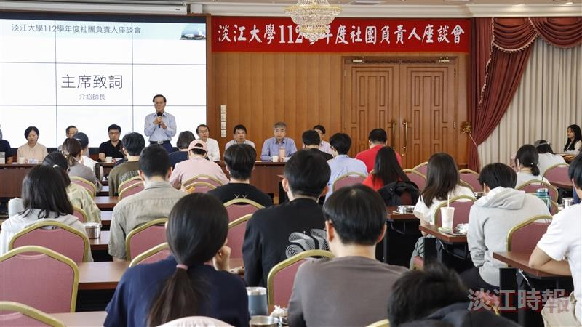
On May 17, the Extracurricular Activities Guidance Section held a “Club Leaders Forum” hosted by President Huan-Chao Keh.

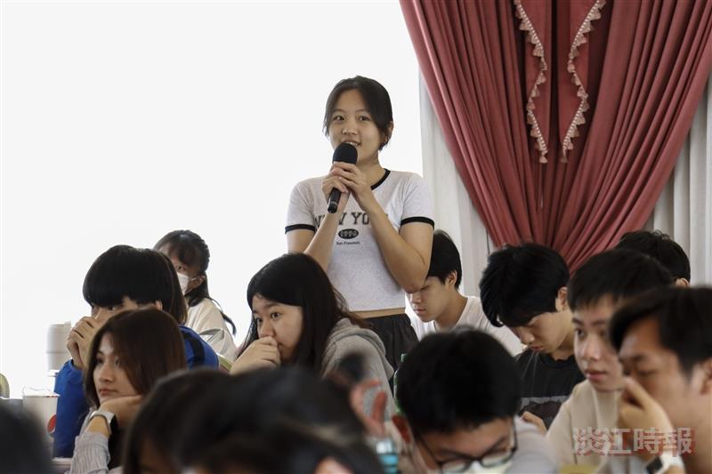
Club leaders offered suggestions, hoping to solve problems through mutual communication at the forum.

