Tamkang Times No.1183
Chat Corner into Main Engineering Building: Students from Various Regions Enjoy Engaging Conversations

The Office of International and Cross-Strait Affairs held the "Chat Corner" language exchange event on May 7 in the atrium on the 3rd floor of the Main Engineering Building to enhance students' language skills and promote interaction among students from different regions. The event attracted students from countries such as Japan and India.

The event started at 2 PM, with students gathering and conversing in various languages. The atmosphere was filled with laughter in English, Japanese, and other languages. Besides practicing their conversation skills, the students also grew closer to one another.

Nishikawa Misaki, a junior in the Department of International Tourism Management from Japan, Matsui Yuka, a junior in the Department of Business Administration, and Chia-Chih Hsiao, a junior in the Department of Diplomacy and International Relations from Taiwan, all expressed that they joined the event to learn different languages. "After participating, we got to know many students from various countries. We look forward to attending more activities hosted by the Office of International Affairs," they said.
2024/05/29

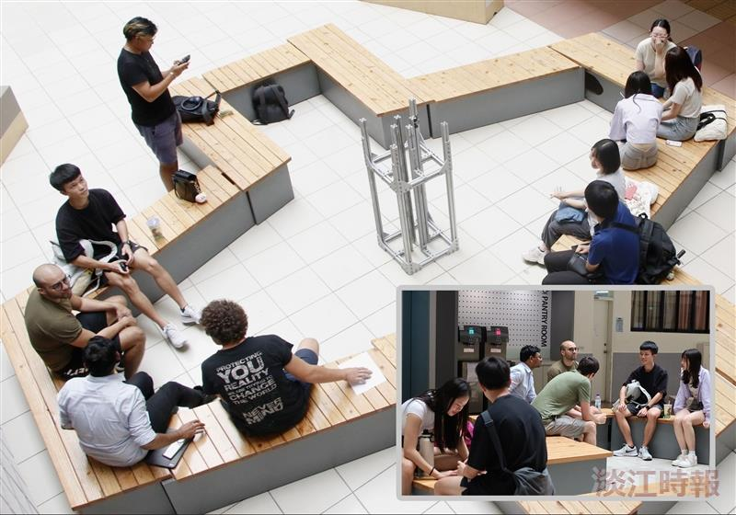
The Office of International and Cross-Strait Affairs held a Chat Corner event in the atrium of the Main Engineering Building.

