Tamkang Times No.1183
Water Sports Competition: Jun Hou Wins 2 Golds, 1 Bronze, and Breaks Event Record Again

On May 15, the Office of Physical Education held the "2023 Academic Year School-wide Water Sports Competition" at the Shao Mo Memorial Natatorium Complex. The competitive events included individual races for men and women in the 50-meter freestyle, breaststroke, backstroke, and butterfly; 100-meter freestyle and breaststroke; and the 500-meter mixed-gender freestyle relay. The fun competitions featured events such as "Rowing Together," "Underwater Treasure Hunt," "Mannequin Relay," "Rope Throwing Rescue," "Water Volleyball," and "Water Basketball." These events attracted many spectators who came to cheer on the participants.

This time, 3 students broke event records. Jun Hou, a senior in global politics and economics, set a new record for the men's 50-meter butterfly with a time of 28.6 seconds. Bo-Ya Chuang, a freshman in accounting, broke the women's 50-meter backstroke record with a time of 35.49 seconds. Ting-An Chou, a water resources and environmental engineering senior, set a new record for the men's 100-meter breaststroke with a time of 1 minute 19.72 seconds. Both Jun Hou and Ting-An Chou broke their previously-held event records.

In addition to the exciting competitions, the Water Lifesaving Club conducted a water safety presentation, which was simultaneously broadcast live on Facebook. They explained what to do in case of drowning during water activities, demonstrating the correct rescue and emergency procedures. They also held a quiz with prizes to reinforce these principles, helping students remember the lifesaving techniques.

Last year, Jun Hou won 2 golds and 1 silver at the Water Sports Competition, breaking 2 event records. This year, he won 2 golds and 1 bronze, breaking his event record. He expressed his surprise and excitement over his achievements this time, especially since he had surgery at the beginning of the year and couldn't engage in intense exercise, leading to insufficient training. As a result, he was very nervous during the pre-race inspection. In the 50-meter freestyle event, his opponent in the adjacent lane was neck and neck with him, pushing him to give it his all. Ultimately, he won the gold medal with a time of 27.36 seconds. This year marks Hou's last participation in the Water Sports Competition. He hopes to see Tamkang University's swimming culture flourish and looks forward to seeing his records broken next year.

Shin-Yau Huang, captain of the swimming team and a sophomore in banking and finance, who won the gold medal in the women's 50-meter freestyle, said that she is accustomed to swimming competitions, so she participated with a calm mindset and performed her best. She mentioned that the fun competitions were activities she was less familiar with, but she and her teammates thoroughly enjoyed the fun and excitement of the events.
2024/05/29

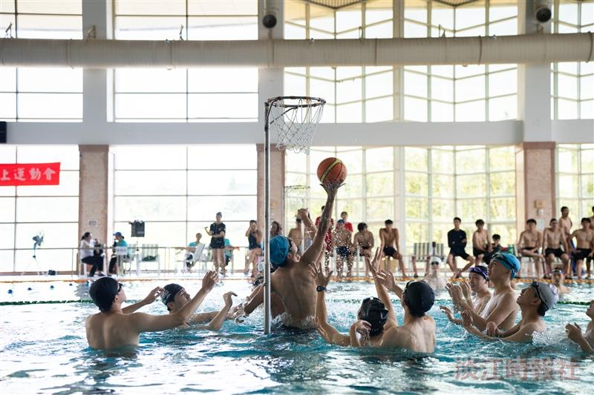
On May 15, the Office of Physical Education held the school-wide Water Sports Competition, featuring events in swimming races and water-based fun competitions.

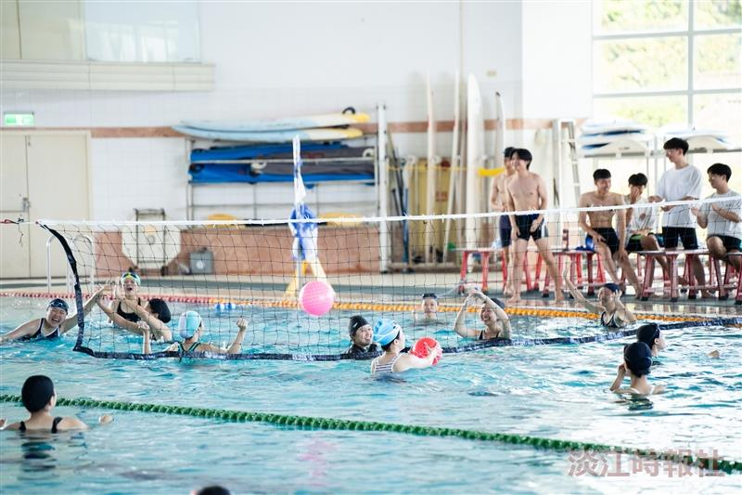
The fun competition, "Water Volleyball," was filled with laughter, testing the teamwork and coordination of the participants.

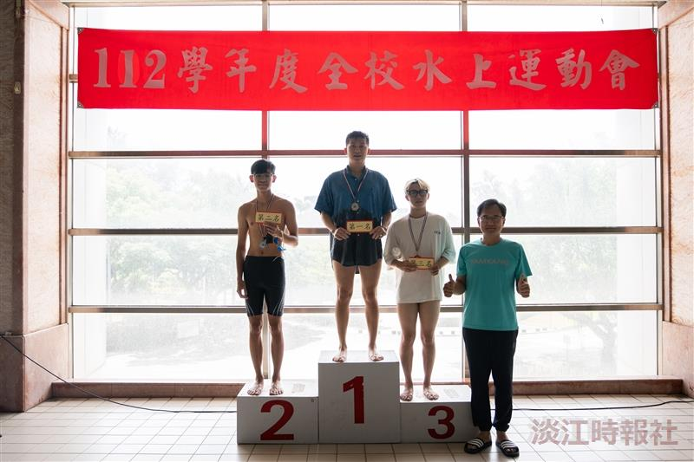
The awards for the Water Sports Competition were presented by the Dean of Physician Education, I-Cheng Chen (right 1). Jun Hou (left 2), a Global Politics and Economics senior, won 2 golds and 1 bronze, breaking his own event record again.

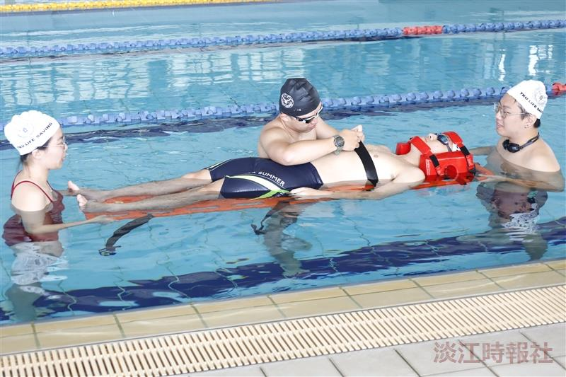
The Water Lifesaving Club conducted a water safety presentation, explaining what to do in case of drowning during water activities and demonstrating the correct rescue and emergency procedures.

