Tamkang Times No.1183
Dr. Jung-Kuei Chang Wins Inaugural K.T. Li AI Special Contribution Award

The annual meeting of the Institute of Information & Computing Machinery (iICM) was held on April 21 at the former residence of Kuo-Ting Li in Taipei. The meeting was chaired by the Chairman of iICM, Professor Han-Chieh Chao, a distinguished chair professor from Tamkang University's Artificial Intelligence Department and honorary president of National Dong Hwa University. Our alum, Dr. Jung-Kuei Chang, who holds a master’s degree in management sciences and a doctorate in Computer Science from Tamkang University, as well as being a Golden Eagle Award recipient, received the inaugural K.T. Li AI Special Contribution Award. Dr. Chi-Chao Wan, the secretary-general of the K.T. Li Foundation for Development of Science and Technology, personally presented the award.

This year, the "K.T. Li AI Special Contribution Award” and the " K.T. Li Sustainable Development Award" have been added to inspire domestic AI scholars and industry experts. These awards recognize significant contributions to AI technology research and practical work and individuals who demonstrate sustainable practices in information technology planning and implementation. Other awards include the K.T. Li Fellow Award, the K.T. Li Cornerstone Award, the K.T. Li Young Researcher Award, and the K.T. Li Women’s Outstanding Research Award. President Huan-Chao Keh of Tamkang University received the K.T. Li Fellow Award in 2021.

Dr. Jung-Kuei Chang, Chairman of Ai3 Co., and Professor Chin-Feng Lai from the Department of Engineering Science at National Cheng Kung University jointly received the K.T. Li AI Special Contribution Award. Dr. Chang mentioned that in 2017 when AI began to emerge, he believed that AI could change human life, but it needed a driving force. He firmly decided to contribute to Taiwan's AI industry. Over the past 6 years, his company has become a leader in providing technical service platforms for Taiwan's customer service industry, specializing in developing AI technology and cloud applications for customer service.

In 2021, Dr. Chang received the "WITSA Global ICT Excellence Award" at the World Congress on Information Technology (WCIT). In the same year, he was also recommended by the international consulting company Gartner as a benchmark AI enterprise in Greater China, showcasing Taiwan's information technology strength. He has served as a director of iICM and the founding president of the AI Big Data Intelligent Application Promotion Association (AI大數據智慧應用促進會). In these roles, he has been a critical driver in the digital transformation wave for Taiwanese SMEs, actively promoting the application of AI in industries. He has engaged with government agencies to understand industry needs and foster cooperation between the public sector, private sector, academia, and research institutions. He has facilitated over a hundred collaborations in AI technology within the information services industry.
2024/05/29

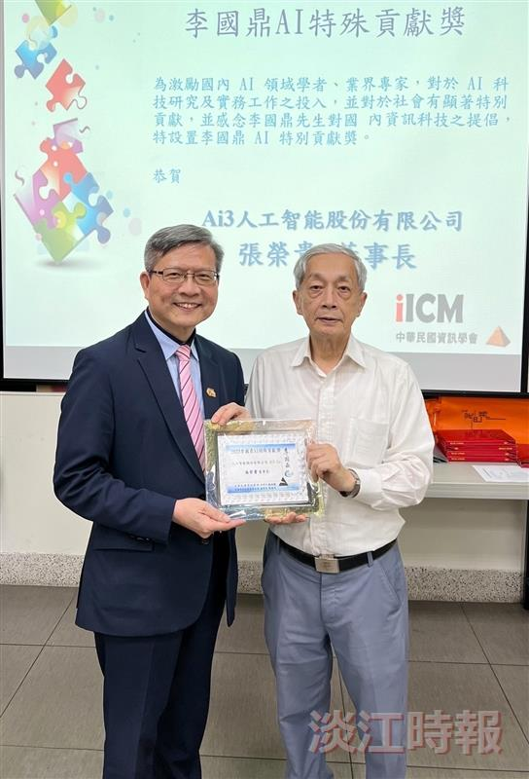
Golden Eagle Award alum Dr. Jung-Kuei Chang (left) receives the inaugural K.T. Li AI Special Contribution Award, presented by Secretary-General Chi-Chao Wan of the K.T. Li Foundation for Development of Science and Technology.

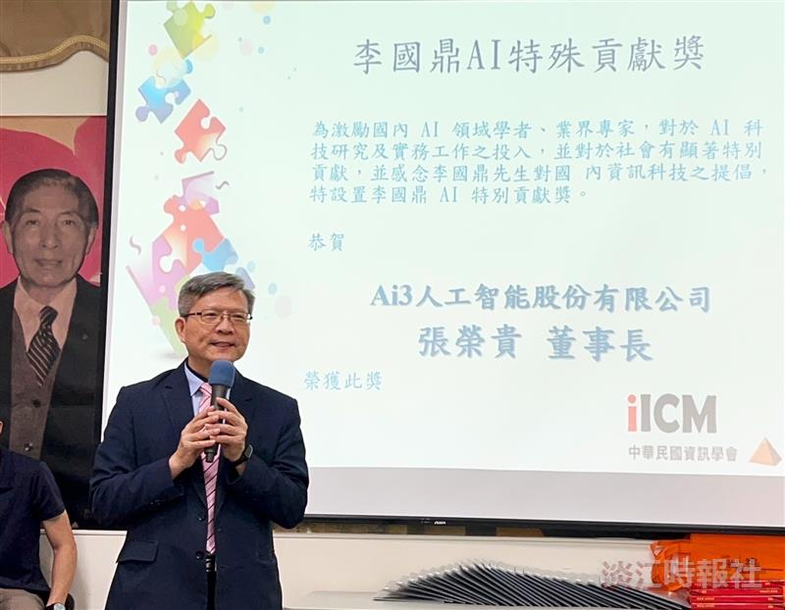
Dr. Jung-Kuei Chang receives the inaugural K.T. Li AI Special Contribution Award.

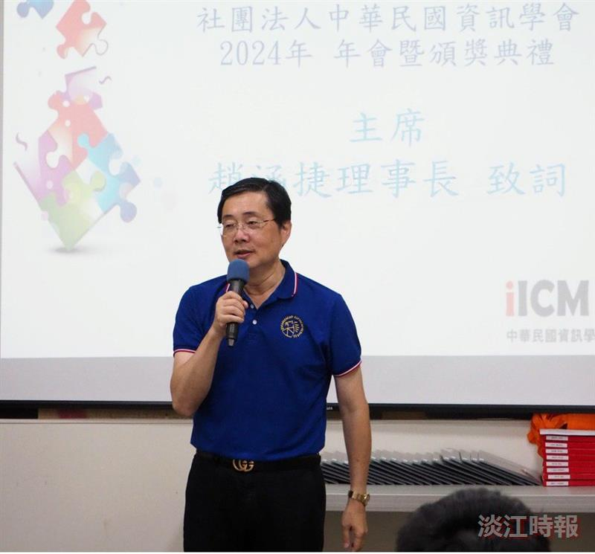
The Institute of Information & Computing Machinery (iICM) held its annual meeting. The opening speech was delivered by the Chairman of iLCM, Professor Han-Chieh Chao, a distinguished chair professor from Tamkang University's Artificial Intelligence Department.

