Tamkang Times No.1183
Yi-Jen Kuo Wins Championship in Solo Singing Category at 35th Jin-Shaw Awards Finals

On May 3rd at 5:20 PM, the Guitar Club held the finals of the 35th Tamkang University Jin-Shaw Awards for Composition and Singing Contest. 17 groups competed in the Solo Singing, Duet/Solo, and Composition categories at the Student Activity Center, attracting over 300 spectators.

The host of this year's finals was YouTuber Happyhao (快樂寶賤), with music composer Eurupa Huang, singer-songwriter and actor Nien-Hsien Ma, lead vocalist and guitarist of Wonfu Band Xiao-Min Yao, music producer Chien-Chi Chen, and founder of Riverside Message Geddy Lin serving as judges. Yao encouraged participants to discover their style and enjoy the beauty of the stage while striving to create. Ma praised all the participants who took the stage, highlighting the invaluable opportunity to compete with heroes and heroines from all walks of life during the finals and suggested focusing more on the connection between lyrics and melody.

After contestants showcased their full potential, the results of each category were announced: In the Solo Singing category, I-Jen Kuo from Tamkang University's Department of International Business won the championship with the song “Child Born in the Night” (《夜晚出生的小孩》); in the Duet/Solo category, the champions were “Gao Gao and Zhuang Zhuang” (高高與壯壯) from the Chihlee University of Technology; the winner of the Composition category was Chia-Tian Huang from National Ilan University, who also received the Best Arrangement Award and the Best Composition Award; the Best Musician Award went to Wen-Yuan Lin from National Yang Ming Chiao Tung University; the Popularity Award was won by “Nameless Hero” (無名超人) formed by students from Tamkang University; and the First Sound Proof Award went to Pei-Hsin Lai from Fu Jen Catholic University.

Chia-Tian Huang expressed gratitude for the affirmation from each judge. She mentioned that she pieced together her life story in fragments to create “Blossoming Before Withering” (《盛放前凋零》). She emphasized the importance of presenting details during the performance. As a musician, she believes it's essential to immerse oneself in the music industry to find inspiration. Zih-Wei Zeng, a Water Resources and Environmental Engineering freshman, shared that the band “Youngpeople”’s (仰風人) performance in the Composition category left a deep impression. The upbeat rhythm and overall performance deeply captivated him. Winning the top prize was utterly unexpected, and he was shocked and delighted!

During the break of the competition, the highly anticipated raffle was held. The grand prize, AirPods Pro2, was won by Zih-Wei Zeng, while the second prize, a guitar, was won by Ting-Yin Luo, a third-year Accounting student. With cheers and applause, this year's music extravaganza, the Jin-Shaw Awards, came to a successful conclusion.
2024/05/29

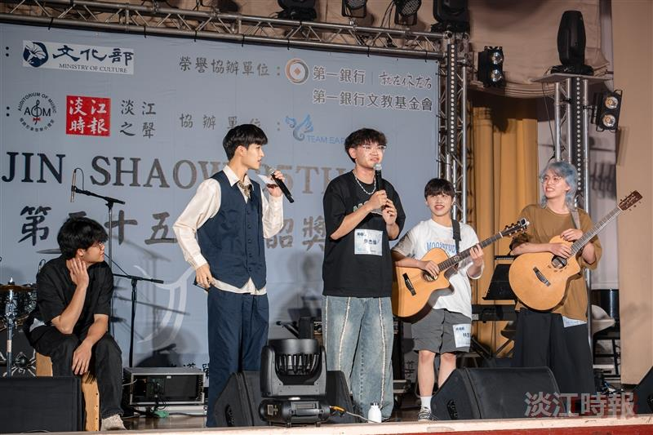
On May 3 at 5:20 PM, the Guitar Club holds the finals of the 35th Tamkang University Jin-Shaw Awards for Composition and Singing Contest.

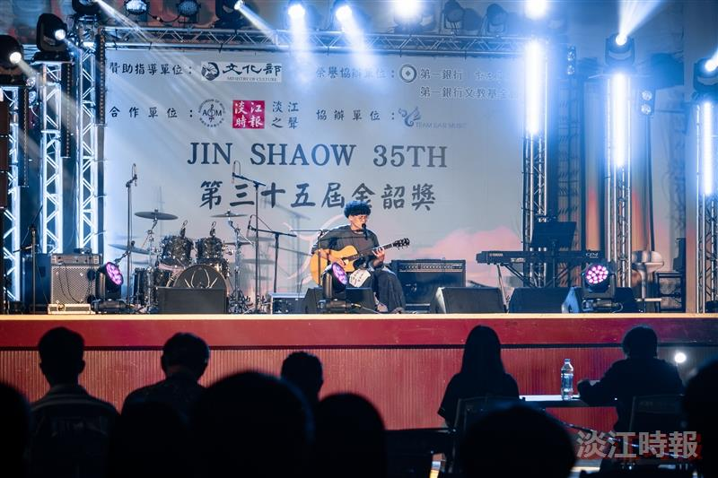
The contestants pull out all the stops on stage to showcase their talents.

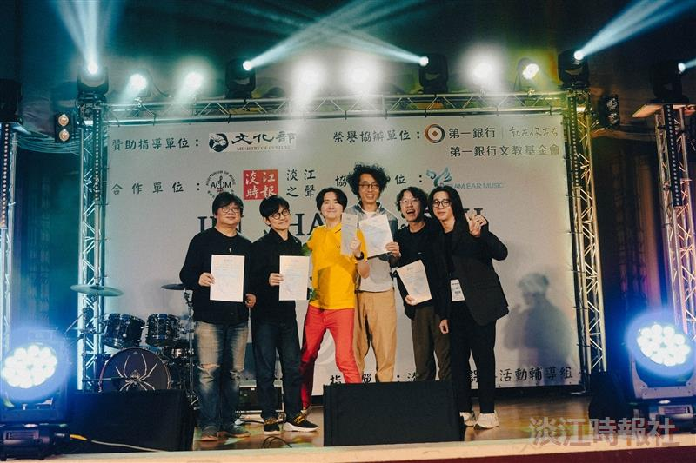
Director of the Jin-Shaw Awards and Electrical and Computer Engineering sophomore Kai-Jung Huang (second from right) presents certificates of appreciation to this year's final judges: Europa Huang, Nien-Hsien Ma, Xiao-Min Yao, Chien-Chi Chen, and Geddy Lin.

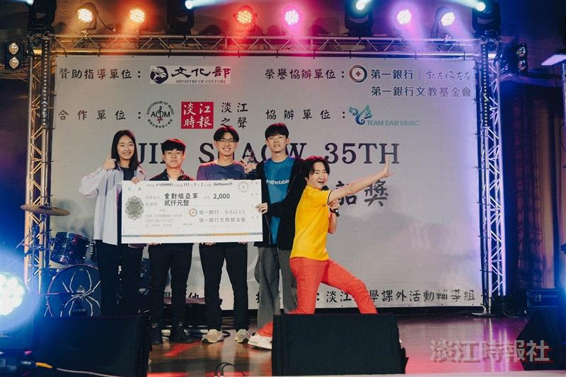
Xiao-Min Yao (right 1) presents the award to the second-place winners in the Duet/Solo category for “Counting to Three” (《我數到三》).

