Tamkang Times No.1183
National Intercollegiate Athletic Games Medal Tally: Tamkang University Claims 5 Gold, 7 Silver, and 11 Bronze Medals

The National Intercollegiate Athletic Games (NIAG) 2024 concluded on May 8, with Tamkang University fielding 11 representative teams. We secured 5 gold, 7 silver, and 11 bronze medals. Our achievements include 5th place in the Women's General Woodball Team competition, 1st place in Men's General Karate Team, 5th place in Women's Open Karate Team, 1st place in Women's General Soft Tennis Team, 2nd place in Men's General Soft Tennis Team, 3rd place in Men's General Fencing Team, and 5th place in Women's General Fencing Team.

In recent years, Tamkang University has achieved remarkable results in competitions. 2020 we secured 10 gold, 4 silver, and 8 bronze medals. In 2021, we obtained 4 gold, 1 silver, and 6 bronze medals. In 2022, our achievements included 4 gold, 2 silver, and 10 bronze medals. In 2023, we achieved 6 gold, 6 silver, and 3 bronze medals. This year, our performance ranks 20th among 131 schools. We are proud to be ranked first among private universities without sports-related departments or organized athletic scholarships.

In the karate event, Ji-Chien Yang, a first-year Chemical and Materials Engineering graduate student, won the gold medal in the "Men's General Individual Kata" and the bronze medal in the "Men's General 5th Weight Class". Po-Wei Lu, an Electrical and Computer Engineering sophomore, secured the gold medal in the "Men's General 2nd Weight Class". Wei-Che Hsu, a Mechanical and Electro-Mechanical Engineering junior, once again claimed the gold medal in the "Men's General 4th Weight Class". Chia-Shuan Wu, a freshman in Aerospace Engineering, earned the bronze medal in the "Open Women's 4th Weight Class".

In the badminton event, Yu-Chi Chang, a junior in Information Management, and Yu-Ting Lin, a senior in Russian, won the gold medal in the "Mixed Doubles" of the "General Men's and Women's Combined Group". Chang also secured the bronze medal in the "Men's Singles" of the "General Men's Group".

In the soft tennis event, the Tamkang University team won the gold medal in the "General Women's Team Competition" and the silver medal in the "General Men's Team Competition." Po-Hsuan Wu, a fourth-year student in French, and Yamasaki Ichika, a third-year student in International Tourism Management, secured the silver medal in the "Women's Doubles" of the "General Women's Group".

In the fencing event, Tamkang University obtained the silver medal in the "General Women's Sabre Team Competition" and the "General Men's Blunt Sword Team Competition" in the fencing event. We also secured the bronze medal in the "General Women's Blunt Sword Team Competition," "General Men's Foil Team Competition," and "General Men's Sabre Team Competition."

In the swimming event, Fang-Chieh Chen, a sophomore in Architecture, won the silver medal in both the "Women's General 100-meter Breaststroke" and "Women's General 200-meter Breaststroke", as well as the bronze medal in the "Women's General 50-meter Breaststroke".

In the Taekwondo event, Tsung-Lin Wang, a junior in Economics, won the silver medal in the "Men's General Over 87kg Weight Class". Ting-Wei Chang, a junior in Mathematics, secured the bronze medal in the "Men's General 74kg Weight Class".

In the track and field event, Yi-Xuan Huang, a senior in Information Management, won the bronze medal in the "Women's General Shot Put." In contrast, Jun-Ren Yang, a senior in Mathematics, secured the bronze medal in the "Men's General 800-meter Run".

In the Judo event, Jun-Wei Huang, a junior English student, won the "Men's General 6th Grade" bronze medal.

This year, after winning one gold medal and one bronze medal, Ji-Chien Yang expressed that he was overwhelmed with joy after learning of his consecutive victory in the individual kata event. However, he regretted not being able to secure the top position again. From this experience, he learned the importance of never underestimating any challenge. Due to a previous ankle injury, he devoted considerable effort to strengthening the stability of his lower body during training, and he expressed gratitude to Coach Cheng-Hui Kao for his meticulous guidance. With summer approaching and an upcoming internship, this competition might be his final one. Despite the pressure to perform exceptionally, he was thankful for securing a medal and bringing honor to Tamkang University. He hopes future students will wholeheartedly engage in competitions and enjoy the moment's happiness.

The captain of the karate team, Wei-Che Hsu, expressed great joy at winning the gold medal again this year. Faced with everyone's expectations, he feared disappointing them with a loss. He thanked the senior team member, Ji-Chien Yang, for his guidance, especially the psychological adjustment before the competition. He is determined to pass on this warmth and responsibility to the juniors.

Yamasaki Ichika and Po-Hsuan Wu achieved good results in both the women's doubles and team competitions in soft tennis this time. Yamaki Ichika expressed her gratitude to the seniors and teachers for their companionship. She mentioned that the women's doubles team in soft tennis won third place last year, and she was worried about not meeting expectations this year. Despite eventually losing to players equivalent to the level of the Japan Prefectural and settling for second place, she was pleased to win the team championship with the joint efforts of her teammates.

Po-Hsuan Wu shared that this was her last participation in the NIAG before graduation. She felt fortunate to represent the team in the competition. This time, the competition was thrilling, and she thanked her teammates for tightly grasping every match, leaving her with beautiful memories. She hopes that more people will join the sport of soft tennis in the future and enjoy this beauty together.
2024/05/29

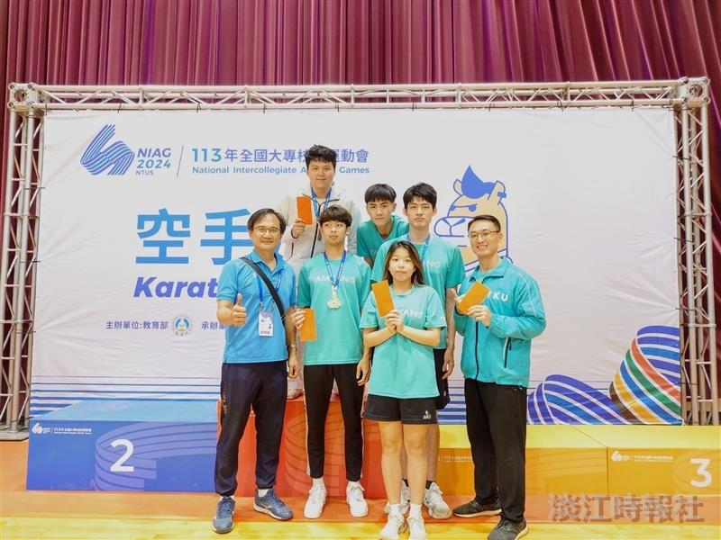
Dean of Physical Education I-Cheng Chen (left 1), Karate Coach Cheng-Hui Kao (right 1), and athletes happily pose for a photo together.

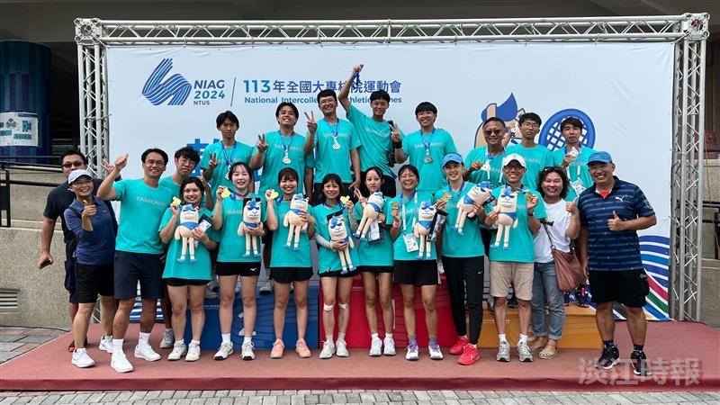
The Soft Net Team takes a joyful group photo after the competition at the National Intercollegiate Athletic Games.

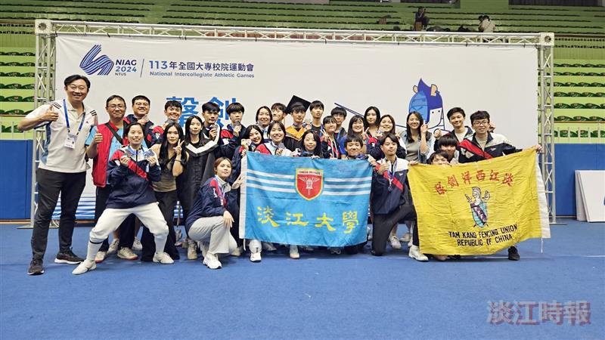
The Fencing Team takes a joyful group photo after the competition at the National Intercollegiate Athletic Games.

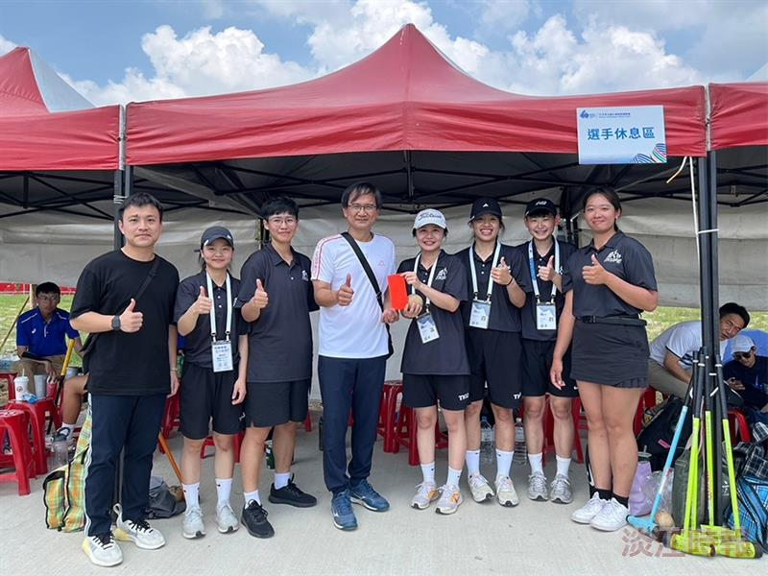
Dean of Physical Education I-Cheng Chen (left 4) presents bonus money to the TKU representative team, cheering the athletes on.

