Tamkang Times No.1182
2024 International Intelligent RoboSports Cup: Electrical and Computer Engineering Department's Robotics Achieves Outstanding Results Again

On April 19 to 21, Professor Ching-Chang Wong, Assistant Professor Chih-Cheng Liu, and Postdoctoral Researcher Yi-Chung Lin from the Department of Electrical and Computer Engineering led a team of 29 students to participate in the "2024 International Intelligent RoboSports Cup" hosted by the Ministry of Education at the National Kaohsiung University of Science and Technology. Continuing the team's legacy of excellence over the years, they achieved outstanding results with 14 gold, 2 silver, and 2 bronze medals.

The International Intelligent RoboSports Cup has been held for 13 years. Nearly 200 teams participated this year, comprising around 600 contestants and coaches. With 22 competitions, including adult-size and kid-size humanoid robot categories and an autonomous driving challenge, Tamkang University participated in 18 events and achieved outstanding results with 14 gold, 2 silver, and 2 bronze medals. Particularly noteworthy is the performance of the graduate student team in the adult-size humanoid robot category, which secured first place in all 6 events of the HuroCup: archery, marathon, weightlifting, obstacle run, and Sparta race. The undergraduate team also excelled, winning 5 gold medals (archery, basketball, marathon, weightlifting, and Spartan race), 2 silver medals (obstacle run and Spartan race), and 1 bronze medal (HuroCup) in the kid-size humanoid robot category. Furthermore, in the autonomous driving challenge, they obtained 3 gold medals (omnium, image recognition, obstacle run parking) and 1 bronze medal (HuroCup).

In addition to the adult-size robot competition, all other events were led by undergraduate students. Professor Wong stated that teamwork, time management, and adaptability are essential for students, but "the most important thing is the inheritance of technology." He mentioned that graduate students pass on their expertise to undergraduate students and continue to study on campus during summer and winter breaks. Apart from maintaining technical proficiency, learning hardware and software is crucial, as it ensures good performance.

Pin-Chen Chou, a senior from the Department of Electrical and Computer Engineering, who has previous competition experience, shared, "We first cultivate the ability of our junior students to solve problems." This year, the approach adopted was to initially teach undergraduate team members how to operate the robots, ensuring they have a sufficient understanding of the robots and learn how to repair them. They seek assistance from senior students when encountering issues, enabling them to solve problems on the day of the competition independently. Pin-Ju Chen, a junior from the Department, mentioned, "After going through various trial and error processes, adaptability improves with learning efficiency, which is a very beneficial experience." Last year, senior students led the undergraduate team members and directly assisted them when problems arose. However, this year's approach has yielded better learning outcomes. She also sees this competition as an opportunity for peer learning and mutual improvement.
2024/05/15

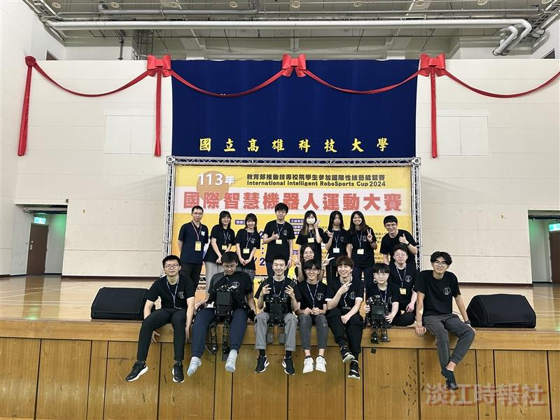
Group photo of the Electrical and Computer Engineering Department's Humanoid Robot Team.

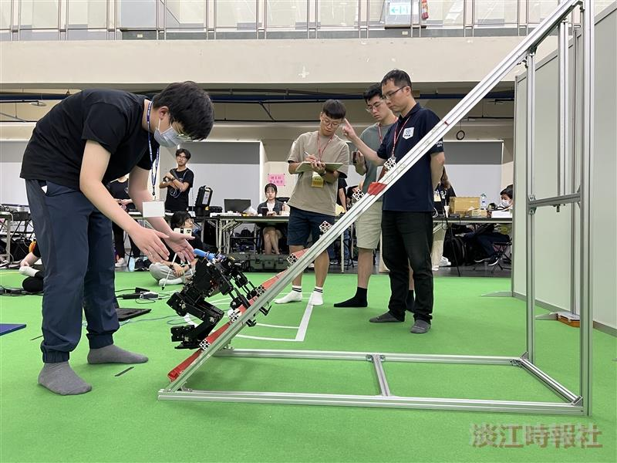
Yan-Peng Liu, a junior from the Department of Electrical and Computer Engineering, is participating in the ladder climbing of the Spartan Race for kid-size humanoid robots.

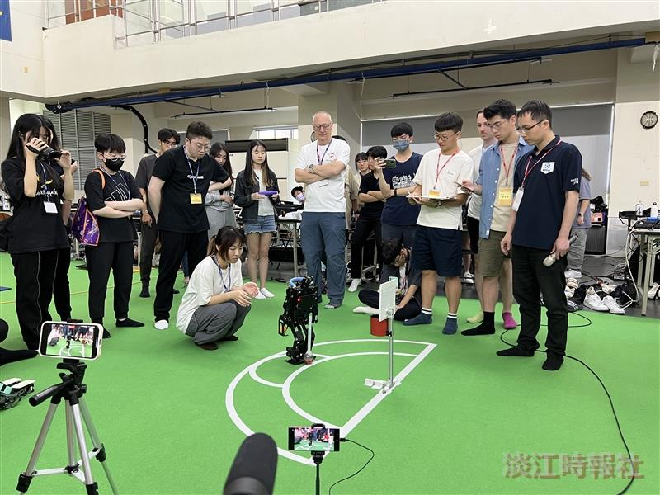
Li-Shan Huang, a sophomore from the Department of Electrical and Computer Engineering, is participating in the basketball event of the kid-size humanoid robot competition.

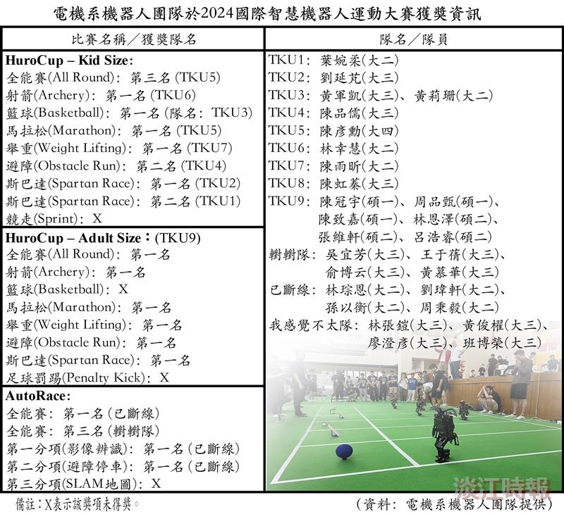
Awards Won by the Department of Electrical and Computer Engineering’s Robotics Team at the 2024 International Intelligent RoboSports Cup.

