Tamkang Times No.1182
NCL Academic Resource Energy Report: “Journal of Educational Media & Library Sciences” Awarded 4 Times

On April 26, the National Central Library held the "Taiwan Academic Resource Energy Report for the Year 2023 Release Conference." The "Journal of Educational Media & Library Sciences," edited by the Department of Information and Library Science of Tamkang University, was honored with the "Five-Year Citation" and "Long-Term Citation" awards for selected journal dissemination. This marks the 4th time this journal has received such recognition. Additionally, the "Tamkang Japanese Journal," edited by the Department of Japanese, received the "Popular Journal Dissemination" five-year citation award. Furthermore, the "Journal of Japanese Language Education in Taiwan," edited by Professor Tseng from the Department of Japanese, also received the "Five-Year Citation" and "Long-Term Citation" awards for selected journal dissemination. Dr. Jin-Yuan Liu, Chair Professor in the Department of Electrical and Computer Engineering and Director of the Center for Ocean and Underwater Technology Research, established the "Journal of General Education: Concept & Practice," which is issued by the Taiwan General Education Strategic Alliance and Quality Strategy Association, and received the "Popular Journal Dissemination" five-year citation award.

The "Taiwan Academic Resource Energy Report" utilizes the National Central Library's 3 major systems: the National Digital Library of Theses and Dissertations in Taiwan, NCL Taiwan Periodical Literature, and Taiwan Citation Index-Humanities and Social Sciences. It analyzes the authorization and reader usage of archived theses and journal articles over the past year, observes the dissemination process of cited theses and journals, and analyzes the keywords used in journal and thesis usage to understand popular research topics. The awards are divided into 2 categories: the "Selected Group," which focuses on core journals, and the "Popular Group," which focuses on non-core journals. Awards are given based on comparing the total citations of journals, theses, books, and book chapters within 5 and 30 years, respectively, for each category.

Professor Jeong-Yeou Chiu, the editor-in-chief of the "Journal of Educational Media & Library Sciences" and a professor at the Graduate Institute of Library, Information & Archival Studies at National Chengchi University, stated that the journal received funding from the Research Institute for the Humanities and Social Sciences, National Science and Technology Council last year. This funding was explicitly used to revamp the journal's official website to enhance retrieval demands. Within four months after the revamp, the web page views surpassed previous records for the same period. He further explained that the journal features an "open peer review mechanism," "brief point briefing presentations," and "academic writing format guidelines," among other characteristics. The download volume has also reached nearly ten thousand times, proving its significant role in academic dissemination.

Dr. Yu-Ching Liao, the editor-in-chief of "Tamkang Japanese Journal" and an associate professor in the Department of Japanese, explained that the journal covers diverse submission topics spanning literature, linguistics, socio-cultural studies, and political economy. Given the competition from similar journals, winning awards is no easy feat. Therefore, the journal actively establishes its uniqueness. For instance, the Department of Japanese hosts an annual international academic conference, and participants, including students and scholars, are encouraged to submit papers related to the conference theme to the journal, thus enhancing the quality and professionalism of the papers. There are plans to create dedicated columns for master's and doctoral students to expand the overall academic capacity. Besides celebrating the award, Dr. Liao also promotes the journal's ongoing call for submissions, with a deadline in September. Interested parties are welcome to submit their work.

Currently serving as the Chairman of the Association of Japanese Language Education in Taiwan, Dr. Tseng expressed not only joy at the recognition received by the "Journal of Japanese Language Education in Taiwan" but also noted that the journal's inclusion in the THCI index reflects the cumulative efforts of past chairpersons and members. She emphasized that the ongoing challenge is how to sustain this progress in the future. Dr. Liu particularly thanked the editorial team for their hard work, which led to such outstanding results, and stated the intention to continue striving to be included in the TSSCI index. He pointed out that although many universities have established general education centers, they still lack platforms for teachers' academic development. "By providing a venue for teachers to publish papers, we hope to accumulate resources for promotion," he added. He also commended the fruitful results of encouraging teachers at the university to apply for teaching practice research projects in recent years and promoting diverse promotions. This approach is particularly suitable for general education teachers to plan for promotion through teaching research. "General education is the foundation of diverse professions. Improving teaching quality and student learning outcomes through teaching practice research will further enhance students' competitiveness upon graduation."
2024/05/15

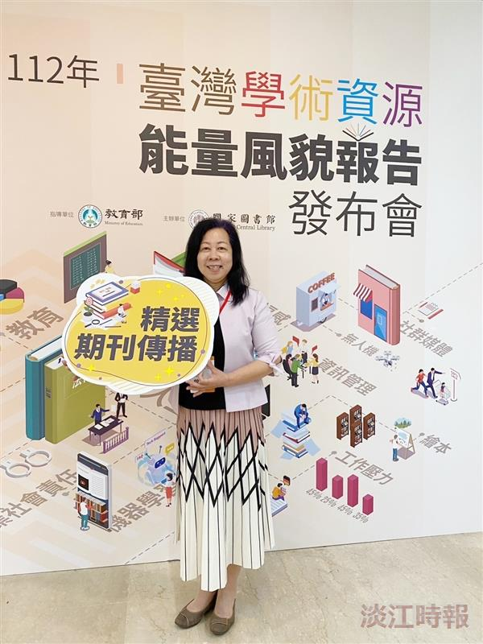
1. Professor Chiu-Kuei Tseng, Editor-in-Chief of the “Journal of Japanese Language Education in Taiwan,” happily receives the “Five-Year Citation” and “Long-Term Citation” awards for the NCL Academic Resource Energy Report Selected Journal Dissemination.

