Tamkang Times No.1182
Skywentex Entrusts Carbon Footprint Verification, Signs Agreement with TKU on the 25th

On April 25, Tamkang University signed a research project contract titled "Skywentex HDP Simulation Board Carbon Footprint Verification" with Skywentex International Corp. (SIC). The contract signing was represented by Dean Tzung-Hang Lee of the Colleges of Engineering and Artificial Innovative Intelligence and SIC President Johnny Chien. The signing ceremony took place in Artificial Innovative Intelligence College's virtual reality field. Also present at the ceremony were Chairman Andy Chen of SIC, Dean Li-Ren Yang of the College of Business and Management, as well as project members including Professor Sue-Huai Gau from the Department of Water Resources and Environmental Engineering, Associate Professor Isaac Yijia Tsai from the Department of Computer Science and Information Engineering, Associate Professor Hui-Chiung Lo from the Department of Business Administration, along with chairs from various departments of the Colleges of Engineering and Artificial Innovative Intelligence.

The HDP (High Definition Printing) simulation board is a building material produced by SIC. This time, with a million-dollar budget, SIC commissioned a team of teachers from Tamkang University's College of Engineering and College of Business and Management to conduct a carbon footprint verification research project. This initiative is in response to the Taiwan Financial Supervisory Commission's requirements for carbon disclosure and global demands for product carbon emissions audits, accelerating the transition to net zero emissions.

Dr. Gau stated that the TKU team had visited SIC and hosted an initial meeting with relevant members and training the day before the signing ceremony. This commissioned project is expected to be completed by the end of March next year.
2024/05/15

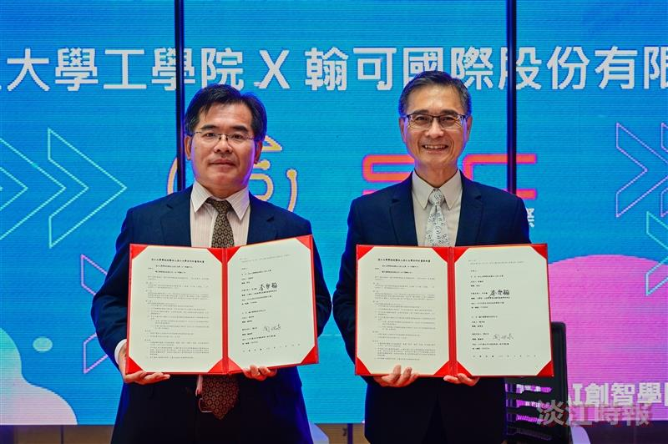
Tamkang University signs “Skywentex HDP Simulation Board Carbon Footprint Verification” Research Project Contract with Skywentex International Corp., Represented by Dean Tsung-Hang Lee (Right) of the Colleges of Engineering and Artificial Innovative Intelligence, and President Johnny Chien of Skywentex International Corp.

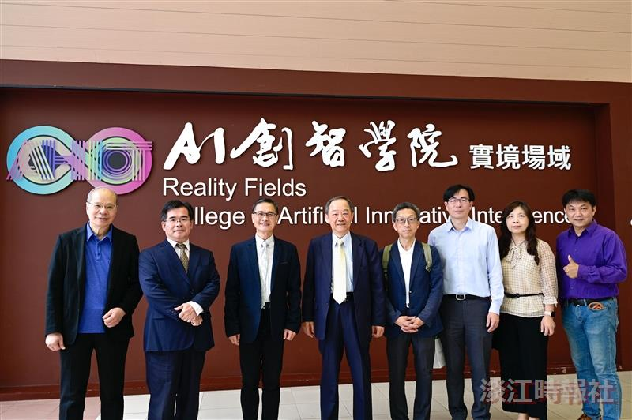
After Tamkang University signed the contract for the "Skywentex HDP Simulation Board Carbon Footprint Verification" research project with Skywentex International Corp. (SIC), the members took a group photo. From left to right: Professor Sue-Huai Gau from the Department of Water Resources and Environmental Engineering, SIC President Johnny Chien, Dean Tzung-Hang Lee of the Colleges of Engineering and Artificial Innovative Intelligence, SIC Chairman Andy Chen, and Manager Wen-Cheng Hsu, Dean Li-Ren Yang from the College of Business and Management, Associate Professor Hui-Ching Lo from the Department of Business Administration, and Associate Professor Issa Yijia Tsai from the Department of Computer Science and Information Engineering.

