Tamkang Times No.1182
Sustainability Ambassadors Become Instructors: Sharing Experience in Course Design

On April 25, the Center for Sustainable Development and Social Innovation held the workshop “Join Me! The First Step to Becoming a Green Talent”—focusing on sustainable design thinking and circular economy practices in Hsu Shou-Chlien International Conference Center. 3 sustainability ambassadors, Li-Yu Wang, a second-year graduate student, Kai-Ju Chou, a first-year graduate student, and Pin-Yi Li, a first-year graduate student, designed a course based on their own learning experiences in sustainability. Besides sharing their achievements, they also gained teaching experience and accumulated knowledge.

The opening remarks were delivered by the guiding teacher, Associate Professor Min-Fen Tu from the Department of Business Management, who explained the cultivation of 5 competencies for the three speakers: professional learning, process design, communication and collaboration, participation in practice, and empathetic reflection, all starting from sustainable actions. This lecture served as a showcase of their achievements and also marked their journey to becoming “Little Panda Instructors.” Sustainability coach and MBA graduate Cheng-Min Hsu pointed out that sustainability is not just a professional course or an abstract topic; it can cultivate future business development capabilities. “I have a lot of experience related to sustainability myself, and I hope to pass it on to the three sustainability ambassadors. I also hope that they will take their roles seriously.” Throughout the three sessions, he provided additional information to ensure the completeness of the course content.

First, Kai-Ju Chou presented "The Origin and Trends of Sustainability," introducing the most commonly heard SDGs and ESG, a new type of environmental assessment. Its content not only allows for the analysis of various indicators of enterprises but also assists in writing sustainability reports. The advocacy matrices of different organizational units towards both will vary. He then mentioned Corporate Social Responsibility (CSR) as the starting point for sustainability circles from their core, making "sustainability report" a significant trend. He used ASUS's sustainability report as an example to illustrate the framework, standards, ratings, and indices that constitute its content. Finally, Chou discussed the content of the Global Reporting Initiative (GRI) guidelines, which can help companies analyze the performance of their reports, communicate and engage in dialogue with stakeholders. He also shared how he used its functionalities to analyze his self-development capabilities during his university days.

Next, Pin-Yi Li presented "Divergence and Convergence of Sustainability Issues: Practical Teaching of the KJ Method." She explained that in Tamkang University's 2023 sustainability report, 38 issues are categorized under 5 codes: Governance, People, Operation, Environment, and Society. She then provided a comparison list of sustainability issues in the university's 2021 report and 66 sustainability issue cards from recent years as matching examples. She invited the participants to work in groups and use the KJ method to classify them while explaining that the pairing results of sustainability issues may vary depending on the stakeholders' perspective. Therefore, a great deal of effort and action is required from oneself and partners when compiling sustainability reports.

Finally, in the "Carbon Emission Practice Simulation: Greenhouse Gas Inventory" session, Li-Yu Wang led the participants outside the conference hall to simulate the inventory process, using fire extinguishers and water dispensers as inventory facilities. She explained the importance of inventory in climate change adaptation measures and its relevance to climate change and net zero emissions. Therefore, greenhouse gases need to be quantified. Common greenhouse gases include carbon dioxide, methane, and nitrous oxide. The inventory process involves boundary setting, emission source identification, emission calculation, inventory report preparation, and internal and external verification operations. She also shared carbon inventory calculation methods and tools to deepen everyone's understanding and application of inventory.

Ya-Ting Hsu, a second-year graduate student from the Department of Business Management, expressed that she has always been concerned about sustainability-related issues. In the past, she only listened to the speakers' presentations in similar themed lecture courses. She didn't expect this workshop to include a practical session, allowing her to gain a deeper understanding of the efforts behind sustainable design. She greatly appreciated the insights the three sustainability instructors shared and, overall, found the experience very rewarding.

News Vocabulary: KJ Method (Affinity Diagram), founded by Japanese Kawakita JIRO, is a data processing method that organically combines and summarizes large amounts of information according to their natural relationships.
2024/05/15

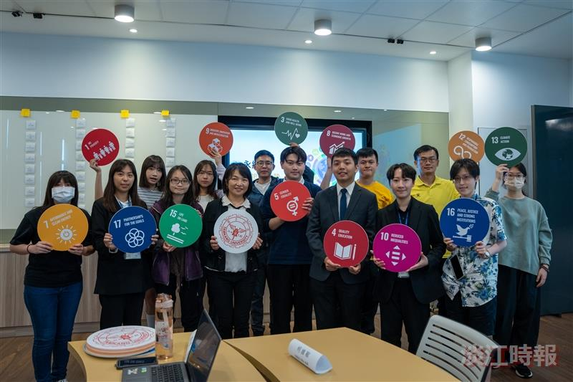
The Sustainability Center holds a workshop on sustainable design thinking and circular economy practices.

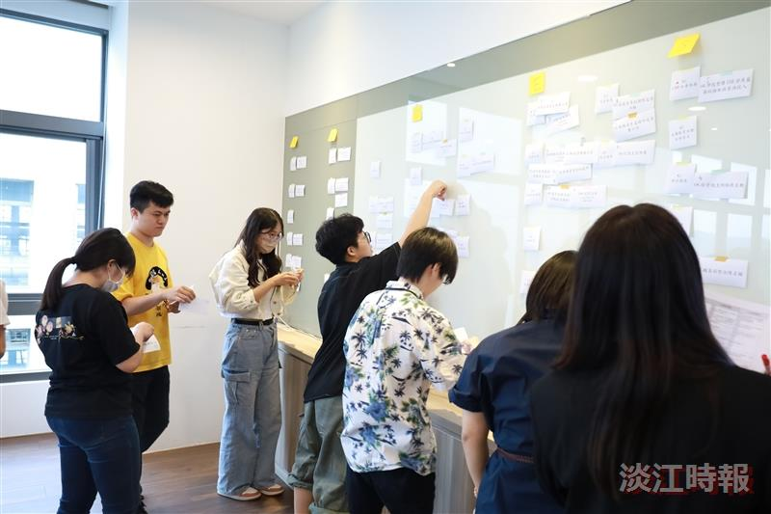
The participants utilize the KJ method to reorganize 38 sustainability issues in this year's university sustainability report.

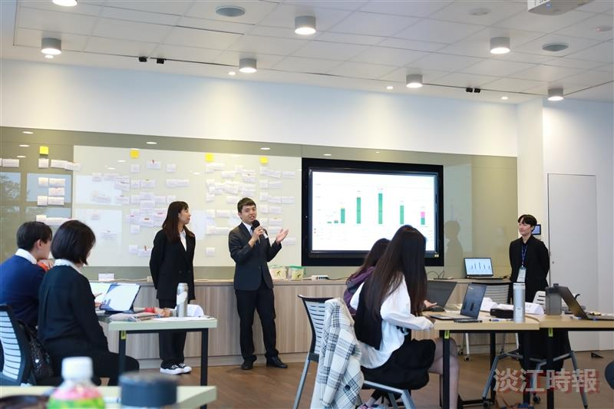
The sustainability ambassador, serving as a course instructor, shares teaching experiences.

