Tamkang Times No.1182
Read Riddles & Solve Puzzles: World Book & Copyright Day Invites You to Exercise Your Brain

“Oh no, Mr. Kozuka may have been murdered!" Officer Yuno nervously said to Officer Kitao. The Chueh-Sheng Memorial Library, the College of Foreign Languages and Literatures, and the Department of Japanese jointly organized the 2024 "World Book & Copyright Day" event with the theme "Crack the Code & Solve the Mystery: Secrets of Japanese Detective Literature." The opening ceremony was held on April 24 on the 2nd floor of the library, with nearly 50 faculty and students participating.

During her speech, Dean of Library Sheue-Fang Song first expressed gratitude to the College of Foreign Languages and Literatures for their support. They collaborate with the library every year to plan World Book and Copyright Day activities, leading faculty and students to experience cultures worldwide. This year, in cooperation with the Department of Japanese, they introduced Japanese detective literature. In addition to lectures, they added 3 student-led detective novel book clubs, tabletop games, and mystery games designed by the librarians. Everyone is welcome to come and experience the joy of reading detective stories. Dean of the College of Foreign Languages and Literatures, Dr. Wan-Bau Wu, explained that World Book and Copyright Day activities have a long history and commended the systematic and high-quality presentation of Japanese detective literature at this event. He fully appreciated his colleagues' dedication and encouraged everyone to participate enthusiastically, enjoying the thrill of uncovering mysteries. Vice President for Academic Affairs, Dr. Hui-Huang Hsu, stated that reading is the simplest way to understand a country's society and culture. He shared his experience of reading Keigo HIGASHINO's works, such as "Hakugin Jack" and "The House Where the Mermaid Sleeps," and felt the suspense and excitement of detective novels. He further encouraged faculty and students to make full use of the library's collection for reading, enriching their knowledge and spirits.

Chair of the Japanese Department, Dr. Pei-Ching Tsai, made a striking appearance in detective attire, joining Associate Professor Yu-Ching Liao and junior student Marilyn Man Ling Chan from the Japanese Department to collectively interpret Seicho MATSUMOTO's well-known short story "Railway Ports." They led the participants through the investigative process of the detectives in the story, gradually uncovering the truth behind the case. Dr. Tsai explained the distinctive features of Seicho MATSUMOTO 's works, which delve into the societal roots of crime, exposing social contradictions and vices. Matsumoto broke away from the fixed patterns of early Japanese detective novels, with no series or famous detectives, allowing readers to closely follow the footsteps of police officers or newspaper reporters to unravel the mysteries. Although the plots are grounded in everyday life and may seem commonplace, they focus on human psychology and elements of daily life, pioneering the world of social detective fiction, often referred to as the "Seicho MATSUMOTO spirit." His works have been widely adapted into TV dramas or movies, standing the test of time.

The exhibition will run until May 31, with audiovisual materials displayed in the 2nd-floor reading area and the 5th-floor non-book materials room of the library. A total of 366 books and 84 films are on display, featuring works by Japanese detective fiction writers with a focus on social realism and similar themes, including representative works by authors such as Seicho MATSUMOTO, Kyotaro NISHIMURA, Hideo YOKOYAMA, Miyuki MIYABE, Keigo HIGASHINO, Kanae MINATO, and Kotaro ISAKA, as well as related award-winning works. Salon lectures were held on April 30, May 1, and May 2 in the reading area, where experts and scholars interpreted Taiwanese-published detective novels and the classic works of authors.

A particular highlight is the library's immersive puzzle-solving game "Missing Person Notice," designed to enhance the interactivity and fun of the event, inviting everyone to join in the search for the mysterious Mr. X. On May 8 and 10, the "In the Bamboo Grove" (竹藪中) tabletop game is also an intellectual challenge not to be missed. Additionally, there will be a Thought Market Book Club, with discussions on May 7 and 21, respectively, focusing on sharing Keigo HIGASHINO's works "Samayou Yaiba" and "The Big Bee." All are welcome to join in brainstorming and exchange. For more details on these activities, please visit the event webpage. (URL: https://reurl.cc/703K5k)
2024/05/15

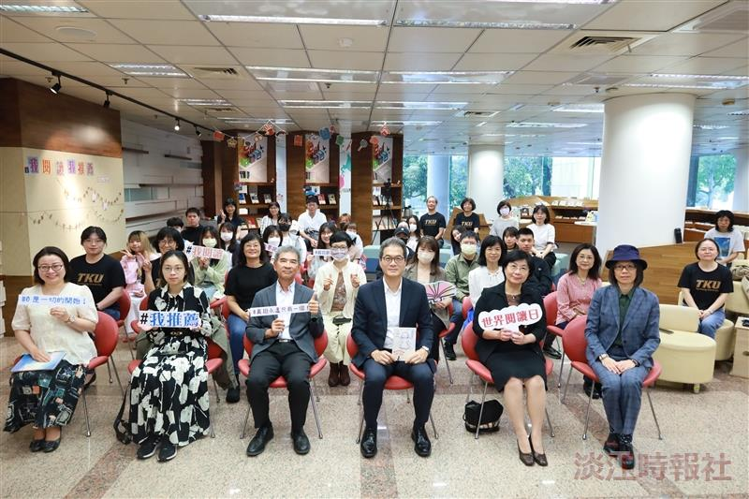
The 2024 World Book and Copyright Day Event opens on the 2nd Floor of the Library.

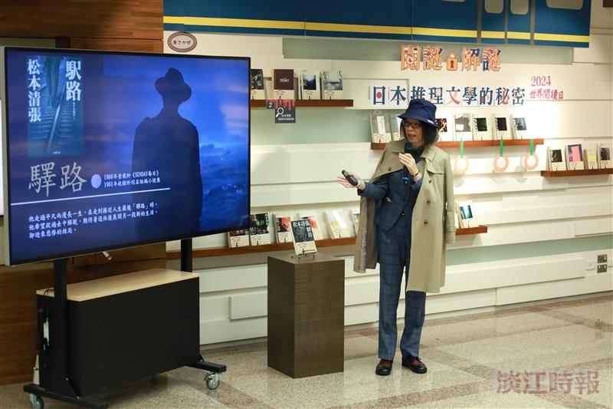
Chair of the Japanese Department, Dr. Pei-Ching Tsai, dressed in detective attire, introduces the work “Railway Ports” by Seicho MATSUMOTO.

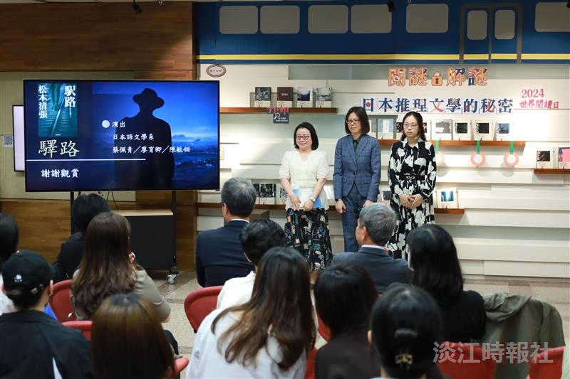
(From left) Associate Professor of the Japanese Department, Dr. Yu-Ching Liao, Department Chair Pei-Ching Tsai, and Marilyn Man Ling Chan, a junior from the Japanese Department, interpret the content of “Railway Ports” together.

