Tamkang Times No.1182
Unveiling of Advanced Quantum Computing Center on the 25th Propels Tamkang into the Quantum Era

The College of Engineering's Advanced Quantum Computing Research Center (CAQC) held its inaugural ceremony on April 25 in Room Sa108 of the Liou-Hsien Memorial Science Hall, symbolizing Tamkang University's formal entry into the quantum era.

CAQC, jointly organized by the Colleges of Science, Engineering, and Artificial Innovative Intelligence, is affiliated with the College of Engineering. It utilizes the space of the Science Building as its operational platform, with 3 quantum computer devices set up in the College of Science. Personnel expenses are provided by Tamkang alum and Chairman of Skywentex International Corp., Andy Chen, by offering a million-dollar research fund. The 3 colleges collaborate across disciplines and will continue to recruit talents from various fields across the university. Following the inauguration ceremony, Dr. Junyi Wu, Assistant Professor in the Department of Physics and Executive Director of the Center, briefed attendees, stating that the center's vision is to focus on research output and quantum talent cultivation using the center's resources. It will actively apply for and execute key research projects of the university, undertake relevant research projects commissioned by external organizations, collaborate with international scholars and institutions in related research, and expand the center's influence through a virtuous cycle.

After the unveiling, the Vice President for Academic Affairs, Dr. Hui-Huang Hsu, delivered the opening remarks, stating that although quantum computing processing has advanced significantly, it is currently limited to specific operations. This indicates that quantum computing cannot yet be widely utilized, hence the need for the center to invest in more research. He expressed his anticipation for collaboration among the three colleges to encourage more faculty members to engage in quantum research.

Andy Chen delivered a speech, stating that quantum technology is one of the future's star industries. He expressed his hope that CAQC could harness the combined efforts of teachers and graduate students to establish a firm footing in the field of quantum research. He also wished for Tamkang University to shine brightly on the world stage.

The director of CAQC and Dean of the College of Science, Dr. Tzenge-Lien Shih, expressed gratitude to the Dean of the College of Engineering, Dr. Tzung-Hang Lee, and Andy Chen for their assistance. He hoped to rally colleagues from across the university with a strong interest in scientific research to engage in this challenging research endeavor collectively. He stated that the center aims to cultivate outstanding graduate students to conduct fundamental research. He looks forward to the future publication of significant research papers and achieving remarkable results.

In his presentation, Dr. Wu explained the famous quantum mechanics thought experiment “Schrödinger's cat” to the distinguished guests present, accompanied by an image depicting the concept of “Clear Distinction as the waters of the Jinghe and the Weihe, while water waves are both from the Jinghe and the Weihe,” to delve into the principle of “quantum superposition.” He humorously used the probability problem of proposing to his wife as an example to illustrate the astonishing difference between quantum computing and conventional computing. Dr. Wu was previously selected as a Japan Society for the Promotion of Science Foreign Postdoctoral Fellowship and currently serves as a co-principal investigator of the “Quantum National Team” project on light quantum computing. He is also the principal investigator for the Taiwan side of the Taiwan-Netherlands Collaboration in Quantum Computing, jointly funded by the National Science and Technology Council (NSTC) of Taiwan and the Netherlands Organization for Scientific Research (NWO). This collaboration brings together leading teams from both countries in quantum computing, quantum optics, and silicon photonics to advance the forefront of optical quantum computing.

Dr. Wu stated that CAQC, established by Tamkang University, is one of the few teams in the country engaged in the theoretical verification of optical quantum computing. At the end of last year, IBM Q introduced a quantum computing module for distributed quantum computing using multiple quantum processors, aiming to break through the physical limit and achieve large-scale quantum computing. Currently, the primary development direction of CAQC is distributed quantum computing. The initial goal is to propose a novel framework for distributed quantum computing, combining AI machine learning to achieve efficient, high-speed, and stable distributed quantum computing. Therefore, the center is also one of the few research teams in the country focusing on distributed quantum computing.
2024/05/15

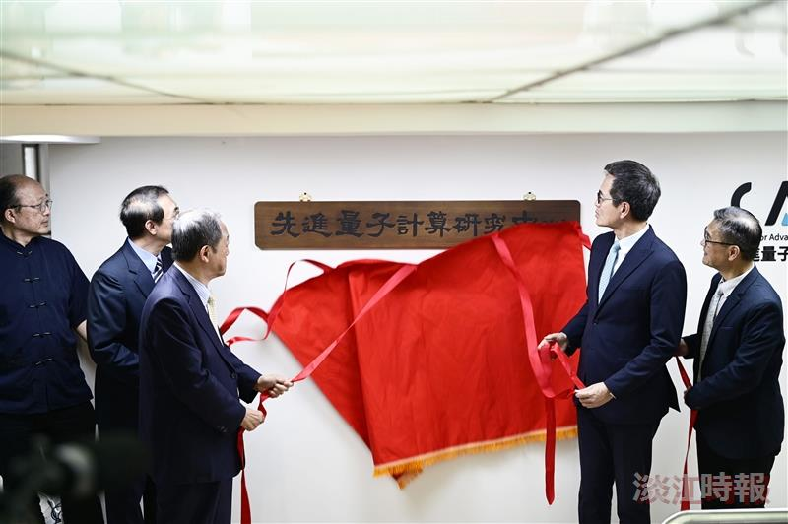
Tamkang University's Advanced Quantum Computing Research Center (CAQC) holds an inauguration ceremony attended by the Vice President for Academic Affairs, Dr. Hui-Huang Hsu (second from right), Vice President for Administrative Affairs, Dr. Chun-Hung Lin (second from left), Chairman of Skwentex International Corp. Andy Chen (third from left), Director of CAQC and Dean of the College of Science Tseng-Lien Shih (far left), and Center Advisor and Dean of the College of Engineering and Artificial Innovative Intelligence Tzung-Hang Lee (far right).

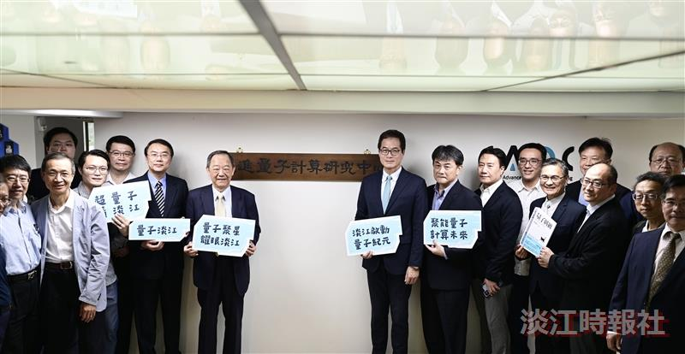
Tamkang University's Advanced Quantum Computing Research Center (CAQC) holds an inauguration ceremony, combining the human and material resources of the Colleges of Science, Engineering, and Artificial Innovative Intelligence, officially entering the quantum era.

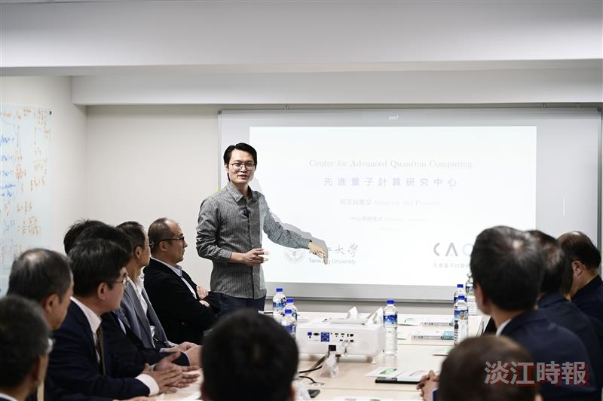
Executive Director of Tamkang University's Advanced Quantum Computing Research Center (CAQC), Dr. Junyi Wu, briefs dignitaries present on quantum research.

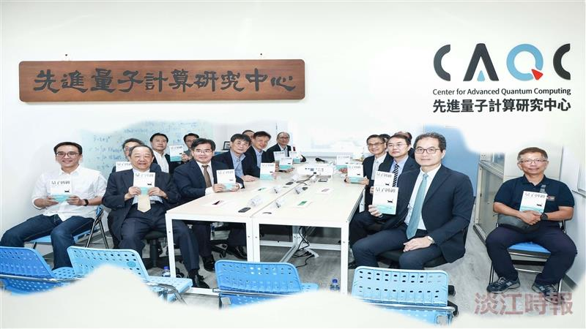
Guests participating in the inauguration ceremony of Tamkang University's Advanced Quantum Computing Research Center (CAQC) together display the limited-edition book sleeve of “Quantum Entanglement” from Tamkang.

