Tamkang Times No.1181
TKU and AIT Jointly Promote EMI Training: 11 Teachers Obtain Certificates

Professor Chia-Chi Sun from the Department of International Business and 15 other teachers from the College of Business and Management and College of International Affairs participated in the English-Medium Instruction (EMI) training program jointly promoted by the Center for English as a Medium of Instruction at Tamkang University and the American Institute in Taiwan (AIT). Among them, 11 completed 18 hours of online training and will receive certificates jointly issued by Tamkang University and AIT.

EMI and AIT proposed this project jointly for the first time to the Bureau of Educational and Cultural Affairs of the U.S. Department of State (ECA), and it successfully passed the review. Dr. Hsiao-Chuan Chen, Vice President for International Affairs and Director of the EMI Center, stated that the EMI Center effectively utilized the resources of the "U.S.-Taiwan Education Initiative" to obtain free English teaching training courses provided by the U.S. Department of State which greatly benefited the English teaching staff of Tamkang University. In the future, the EMI Center will continue cooperating closely with AIT to seek more English teaching training courses for Tamkang University. Dr. Cheng-Hao Pao, Dean of the College of International Affairs and Executive Secretary of the EMI Center, stated that bilingual teaching promotion is a project plan and a specific direction for developing Tamkang University's affairs. In the future, the center will gradually transition into a unit promoting bilingual teaching throughout the university and will strive to obtain more external resources to promote related initiatives.

Dr. Kai-Su Wu, Chief of the EMI Teaching and Learning Section at the Center, explained that the training course was conducted online in April. Doctoral-level instructors provided clear and in-depth explanations of EMI teaching theory, allowing teachers to directly engage in teaching practice on the platform and share their teaching experiences and improvement methods.

Having just participated in the "2024 Fulbright EMI Overseas Professional Teacher Training Program" and trained in the United States during the winter vacation, Dr. Sun expressed that this training has many similarities with the "Fulbright Program," including the implementation of EMI courses and assisting students in achieving collaborative learning strategies, both of which are thoroughly explored in these two programs. Over the six-day program, the teaching instructors detailed the challenges faced by EMI courses and EMI teaching strategies. They provided specific and compelling teaching techniques for responding to student questions and helping students engage in the classroom during EMI courses. These are highly practical for future teaching applications in EMI courses. The program also emphasized that future teaching strategies should be student-centered and suggested that course content could be paired with real-world case studies, which not only elicit more responses from students but also help them learn autonomously.

Dr. Shu-Chuan Chen, Chair of the Department of International Tourism Management, praised instructor Dr. Balderston's professionalism and teaching skills. Despite being an online course, the precise structure of the teaching materials and the teaching objectives are no less vivid and rich than those of face-to-face teaching: "From the dozens of pages of notes I've taken and the many course design inspirations sparked, it's evident that this is a highly successful teaching and learning event."
2024/05/07

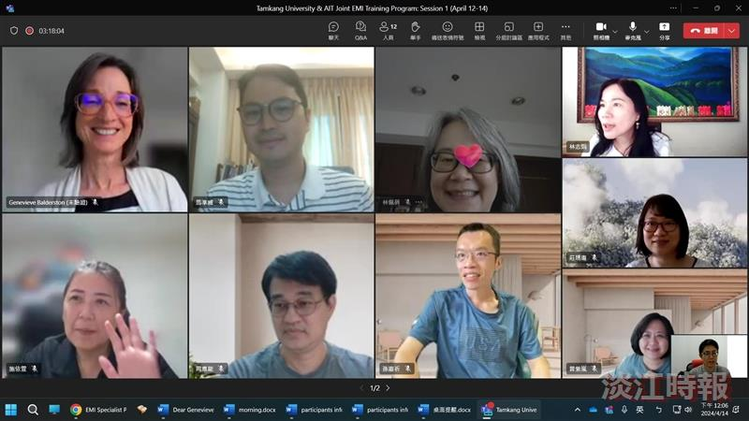
Tamkang University and AIT Jointly Promote EMI Training: Screenshots of Teachers Participating in Online Courses.

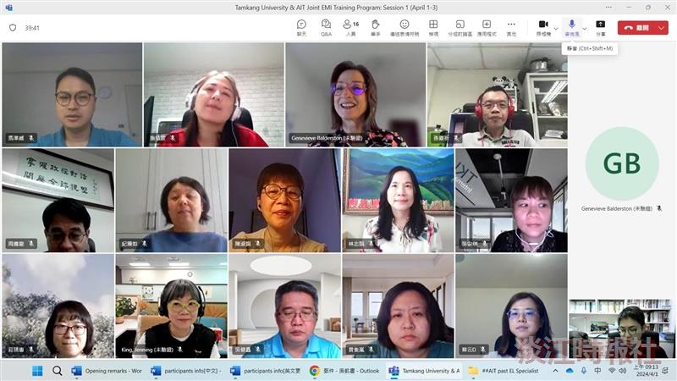
Tamkang University and AIT Jointly Promote EMI Training: Screenshots of Teachers Participating in Online Courses.

