Tamkang Times No.1181
Dr. Lee-Feng Chien: with the Sky as Canvas, Drones as Watercolors, Learn to Coexist with AI

Dr. Yi-Nan Lin, the Dean of Human Resources and a professor at the Department of International Business, in collaboration with Sinyi Realty, invited former the Managing Director of Google Taiwan and alumnus of the Department of Computer Science (now Department of Computer Science and Information Engineering), Dr. Lee-Feng Chien, to speak on "Future Talent: From Digital Transformation to AI Empowerment" on April 9 at the Chung-Cheng Auditorium on the Taipei campus. Academic Vice President Hui-Huang Hsu attended the event, which attracted nearly 200 participants. Dr. Chien stated that 2024 marks the beginning of human-machine collaboration, emphasizing the importance of understanding how to coexist with AI.

"AI may not necessarily replace our jobs, but those who use AI will replace those who do not," Dr. Lee-Feng Chien pointed out. He began by highlighting that Taiwan's GDP ranks 22nd globally and, as a major GPU supplier worldwide, Taiwan's influence in the AI hardware industry is significant. It should naturally become a model and pioneer in the AI era. However, currently, the prevalence rate of ChatGPT in Taiwan is only 25%.

He reminded us that only by seizing the opportunity brought by generative AI for rapid learning and transformation can we proceed with 3 significant points: creating new opportunities in the industry, social AI transformation, and empowering enterprises. Strengthening the application of generative AI will accelerate industrial upgrading and the integration of AI technology. This proactive approach will prevent being overwhelmed by the tide of industry.

Dr. Chien emphasized: "Emotion is not knowledge, but instinctive reaction." This is the reason why humans are not replaced by technology. Learning a new language is not just about translation; the culture and thought patterns behind it are even more valuable. People need to seek true "value." Today's industries will be replaced by rapidly developing technology. AI possesses robust decision-making and data integration capabilities, making digital transformation imperative for large and small businesses.

Dr. Chien, who specializes in analyzing new developments in industries, is also deeply concerned about the next generation's education. "We should not teach children to reject the emergence of new technology. Instead, we should tell them that the sky is their canvas, drones are their watercolors, and the robots around them are their partners," Dr. Chien explained. He elaborated that fields like art, medicine, and education will always exist; it's just the tools that change. Therefore, educational organizations and teaching methods must adjust accordingly to cultivate talent that can adapt to the future.

At the end of the speech, one of the audience asked how to prevent AI from getting out of control. Dr. Chien smiled and replied, "Humans only began learning to fly a little over a hundred years ago, and even today, flying is still risky. However, we have still found ways to control dangerous machines by raising international standards and implementing strict regulations." He concluded that technology has become powerful, stating, "AI is becoming more and more like humans, designed to help people. When it becomes as capable as humans, it will continue to develop in its direction. There's no need to worry about it replacing humans because, from the day it was designed, it was destined to surpass humanity."
2024/05/07

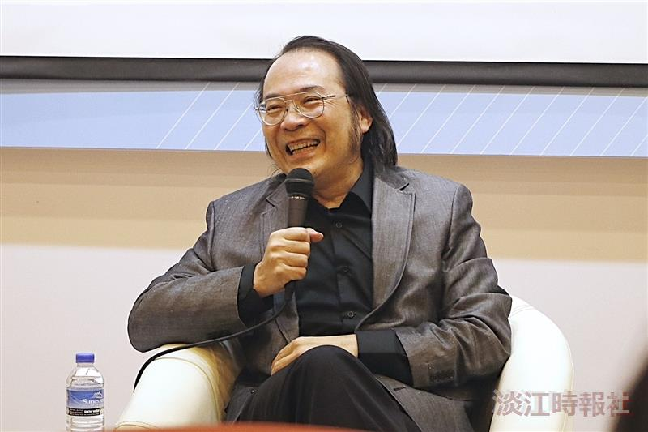
The Department of International Business invited Dr. Lee-Feng Chien, former Managing Director of Google Taiwan and alumnus of the Department of Computer Science (now Department of Computer Science and Information Engineering), to speak on "Future Talent: Enterprises Transitioning from Digital Transformation to AI Empowerment.”

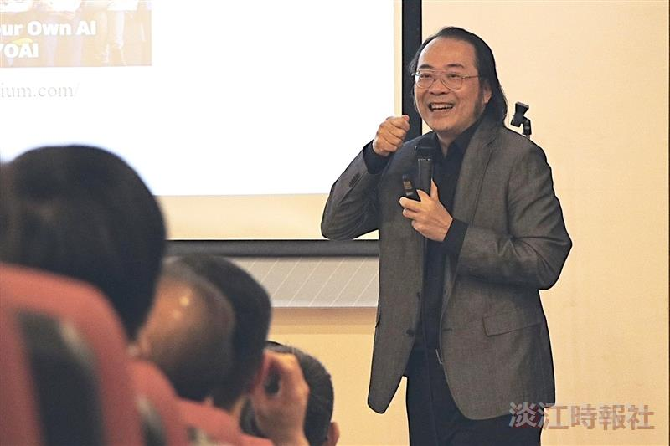
The Department of International Business invited Dr. Lee-Feng Chien, former Managing Director of Google Taiwan and alumnus of the Department of Computer Science (now Department of Computer Science and Information Engineering), to speak on "Future Talent: Enterprises Transitioning from Digital Transformation to AI Empowerment.”

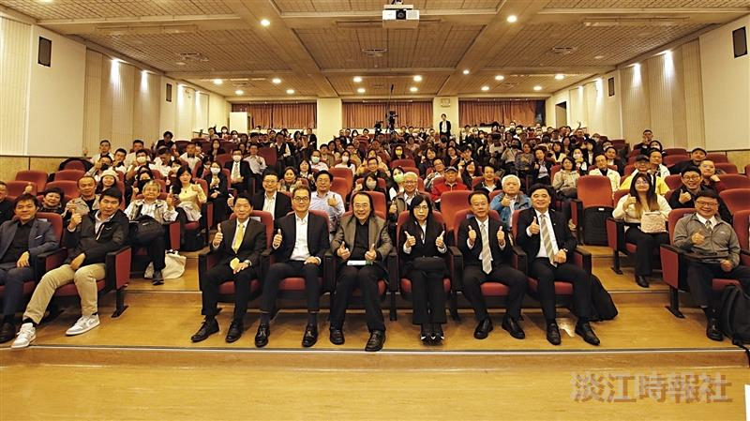
The Department of International Business invited Dr. Lee-Feng Chien, former Managing Director of Google Taiwan and alumnus of the Department of Computer Science (now Department of Computer Science and Information Engineering), for a speech, followed by a group photo.

