Tamkang Times No.1181
Over 40 Sister Schools Worldwide Send Letters to Tamkang Expressing Concern about Earthquake

Over 40 sister schools worldwide have sent letters of condolence regarding the earthquake, wishing for safety and swift assistance for all affected individuals.

Following the Richter scale 7.2 earthquake off the coast of Hualien at 7:58 AM on April 3, Tamkang University has received letters of condolence from sister schools worldwide. These include universities such as Reitaku University, Asia University, Tokyo Foreign Studies University, Tsuda University, Kyushu University, Hosei University, and Kanagawa University in Japan; University of Cologne in Germany; University of Granada in Spain; Vytautas Magnus University in Lithuania; Temple University, University of Massachusetts Lowell, and sister schools in mainland China such as Lanzhou University, Renmin University of China, Fudan University, Xiamen University, Nanjing University, and East China Normal University, expressing their concerns. Notably, Reitaku University, Asia University, Kagoshima University, J. F. Oberlin University, Shibaura Institute of Technology, and Kanagawa University in Japan, as well as Vytautas Magnus University and Lanzhou University, have expressed their concerns with signatures from their respective presidents.

Dr. Ruey-Shiang Shaw, the Dean of General Affairs, explained that the recent earthquake affected some campus facilities. Damage includes marble falling and damaging the front wall of the fitness equipment in the Shao-Mo Memorial Natatorium Complex on the Tamsui campus, severe cracks on the railing wall in front of room B611 in the Business and Management Building, ceilings and light fixtures falling in parts of the library, and elevator disruptions in the Hsu Shou-Chlien International Conference Center and the Chung-Ling Chemistry Hall. Additionally, there were instances of wall tiles falling off on the Taipei campus, projectors in 11 classrooms misaligned, light steel ceiling fixtures and pipelines falling or deforming in 15 classrooms, multiple walls cracking and paint peeling off, and 2 large water towers on the 6th floor being damaged and leaking water. Most of the damage has been urgently repaired. He also reminded faculty, staff, and students that if they encounter any related facility damage, they can report it through the "Repair" on the TKU iLife app or directly contact the General Affairs Office.
2024/05/07

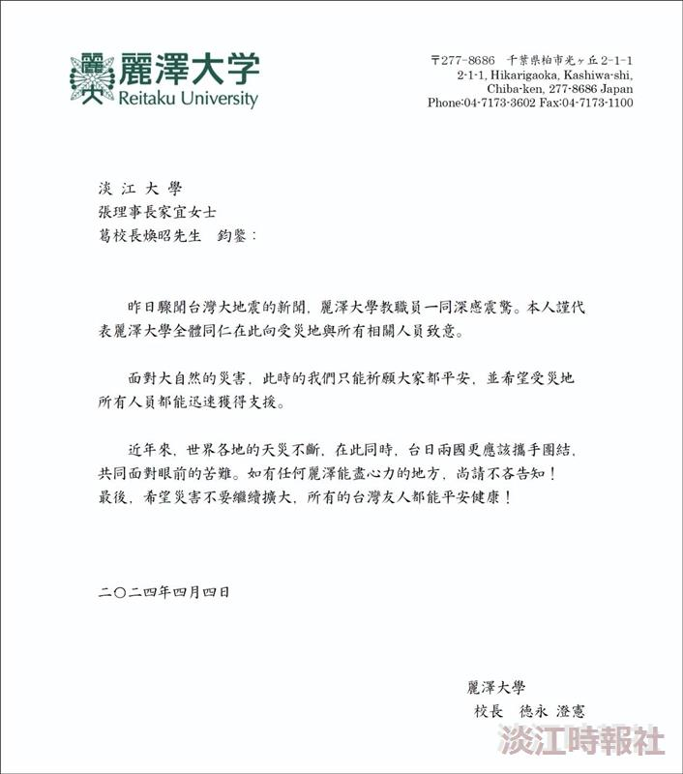
President Suminori TOKUNAGA of Reitaku University sends a letter of concern regarding the earthquake.

