Tamkang Times No.1180
Dr. Henri Berestycki Predict Epidemic Spread Scenarios with Mathematical Laws, Enjoy Tamsui Campus, Seek to Add Tamkang Clement and Carrie Chair to His Resume

The Department of Mathematics hosted a Tamkang Clement and Carrie Chair Lecture, inviting Henri Berestycki, a professor at the School of Advanced Studies in the Social Sciences (EHESS) in France and the University of Maryland in the United States, to speak on March 19 at the Chang Yeo Lan International Conference Hall, Hsu Shou-Chlien International Conference Center. The topic of his lecture was "Modeling Epidemics with Diffusion." He expressed concern about public health and emphasized the significant impact of local epidemics on humanity. Diseases with high mortality rates, such as tuberculosis, measles, malaria, and AIDS, were discussed in terms of mathematical modeling of epidemics, aiming to understand their dynamics, predict their spread, and find ways to control them.

Dr. Berestycki went straight to the point, stating that "epidemics have always existed in human history," explaining that epidemics usually result in numerous human deaths through contagious transmission, leading to a rapid decrease in population. He cited historical epidemics as examples: the "Spanish flu" from 1918 to 1920, which caused over 50 million deaths worldwide; the "Black Death" in the 14th century, which spread from Asia to Europe and wiped out one-third of Europe's population in just a few years; and the "Japanese smallpox," which killed one-third of Japan's population. He believed that epidemic diseases might vary over time and place, and could have different diffusion patterns. If it were possible to infer their occurrence, spreading methods, and transmission routes through mathematical models, it would further assist the medical community in understanding, reducing, or even preventing the spread of contagion. This was a development and outcome he greatly welcomed.

Chen-Hsiang Hsu, a junior student from the mathematics department who participated in the lecture, shared his insights. He felt that Dr. Berestycki explained how to use mathematical models to predict and understand the spread of epidemics in a clear and concise manner. He was particularly impressed by the introduction of various diffusion models. From the basic SIR model to more complex spatial diffusion models, he gained an understanding that models are not just abstract theoretical concepts but can be applied to solve complex problems in the real world. In the future, he wants to try constructing a model himself.

After the lecture, Assistant Professor Kaiti Wang from the Aerospace Engineering Department asked Dr. Berestycki about his example regarding the simulation of population density in France during an epidemic. She was pleased to see that the transmission of epidemics could be represented by such concise mathematical models, simulating virus spread patterns that better match real-world situations. She also pondered whether this could be applied to space science. Yi-Chen Kan, a freshman from the chemistry department suggested that infectious diseases could be predicted using mathematical models, but it is often challenging to require people's cooperation for investigations. Therefore, extensive investigations require government support.

“Thank you, Tamkang University, for inviting me to be the Tamkang Clement and Carrie Chair lecturer. I will cherish this title and include it in my resume." Professor Berestycki, accompanied by Dean Tzenge-Lien Shih of the College of Science, Director Cherng-Yih Yu Cheng of the Department of Mathematics, and Professor Jong-Shenq Guo, visited President Huan-Chao Keh and Chairperson Flora Chia-I Chang on March 19. President Keh and Chairperson Chang respectively presented the Panda trophy and a vase imprinted with calligraphy by Masters Chi-Mao Li and a painting by Master Ben-Hang Chang, featuring Tamkang campus scenery and the school anthem, to Dr. Berestycki as commemorative gifts.

President Keh and Chairperson Chang first extended a warm welcome and gratitude to Dr. Berestycki, while explaining the origins of the Tamkang Clement and Carrie Chair series initiated by the founders, Dr. and Mrs. Chang. As it was Dr. Berestycki's first visit to Tamkang University, he expressed great fondness for the campus environment and the Panda Suite at the Hwei-Wen Hall where he stayed. Coming from France, he also appreciated the significance of being appointed a Tamkang Clement and Carrie Chair lecturer, likening it to the rooster as a symbol of France, and felt honored. They then explained that arrangements would be made for a visit to National Cheng Kung University, as well as visits to the Chimei Museum, the Wusanto Reservoir, and the Southern Branch of the National Palace Museum, to acquaint him with the scenery of southern Taiwan. If time permits, they hoped to visit Sun Moon Lake, and they also wished for the opportunity to explore more scenic spots in Taiwan and experience its beauty.
2024/04/16

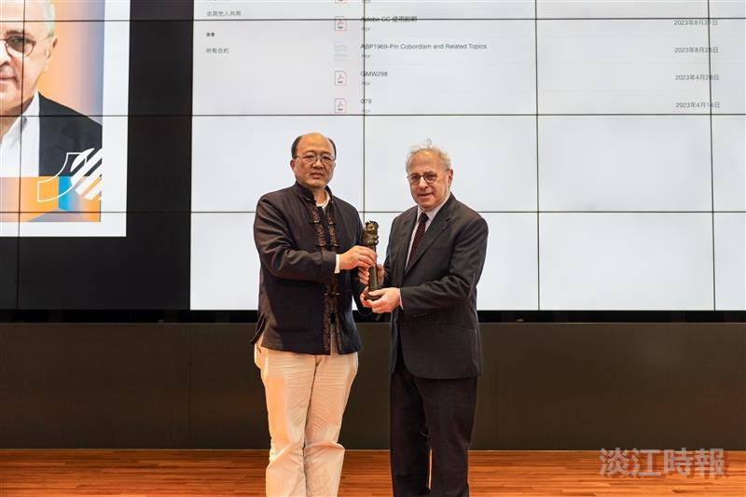
The Dean of the College of Science, Dr. Tzenge-Lien Shih (left), presents the Panda trophy to Professor Henri Berestycki.

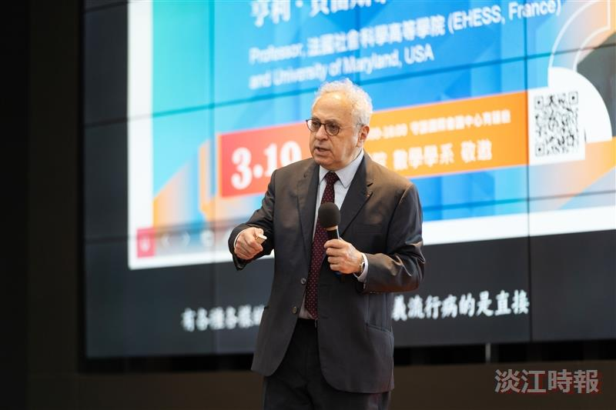
Professor Henri Berestycki lectures on “Modeling Epidemics with Diffusion.”

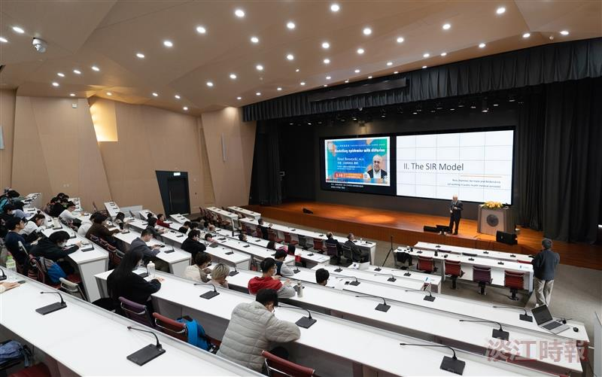
At the Lecture venue, simultaneous translation is provided, the lecture is captivating, and students listen attentively.

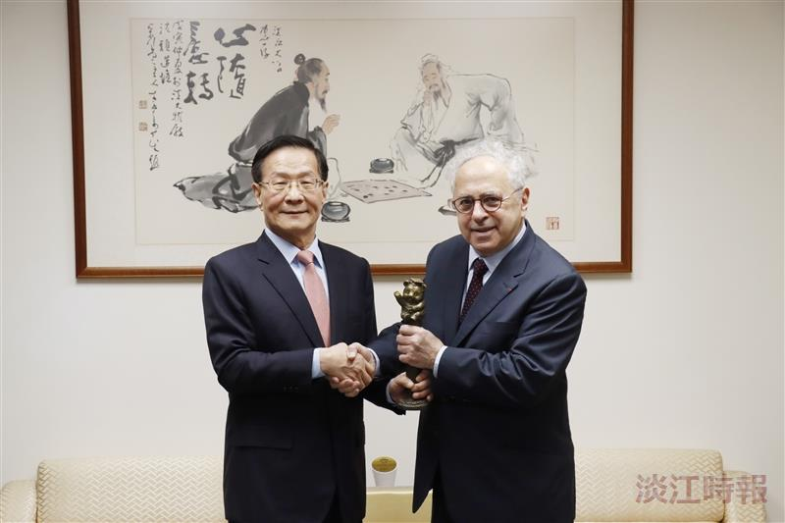
President Huan-Chao Keh (left) presents the Panda trophy to Dr. Henri Berestycki, the Clement and Carrie Chair invited by the Department of Mathematics.

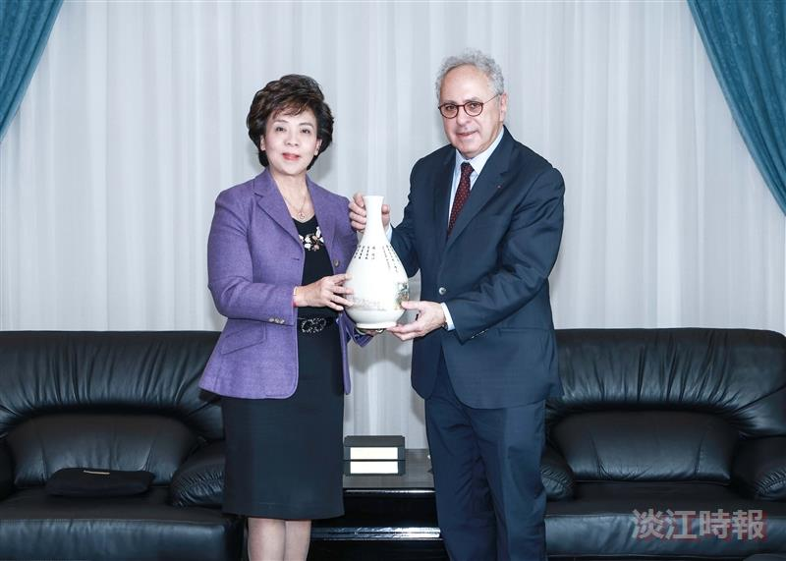
Chairperson Flora Chia-I Chang (left) personally presents a unique Tamkang University vase to Dr. Henri Berestycki, the Clement and Carrie Chair invited by the Department of Mathematics.

