Tamkang Times No.1178
Annual Meeting of the Physics Society of Taiwan: Wen-Chun Chen, Zong-Jhe Hsieh Awarded Best Poster Paper

In January, the 2024 Annual Meeting of the Physics Society of Taiwan was held at National Central University. Guided by Dr. Cheng-Hao Chuang, chair of the physics department at Tamkang University, fourth-year physics student Wen-Chun Chen and second-year master's student Zong-Jhe Hsieh presented their academic research papers on-site. They were awarded the Best Poster Paper Prize in the "Emerging Energy Science" category at the project results presentation.

Dr. Chuang stated: "The diligence and perseverance of Tamkang University's physics students, along with their passion for science, have been recognized by external evaluators from other universities. It is their dedication that has allowed them to stand out and receive awards. As their supervising professor, I am thrilled and proud of their achievements."

In response to rapidly changing emerging research fields, the Annual Meeting of the Physics Society of Taiwan encourages interdisciplinary collaboration among research teams from various universities. It co-organizes paper presentation events with the National Science and Technology Council each year. Papers are submitted by undergraduate to doctoral students and postdoctoral researchers from universities and research institutions. Papers from Astronomy/Gravity/Cosmology, Atomic/Molecular, Biophysics/Bioimaging Technology, Emerging Energy Science, and Plasma Physics are selected for oral presentations and awarded Excellent or Best Poster Paper Awards.

Wen-Chun Chen's topic is "In-situ Investigation of the Effect of the Ferromagnetic Properties on the Hydrogen Catalysis and Storage in Ni/rGO Systems." Upon winning the award, she was more shocked than surprised, feeling extremely honored and a sense of recognition for her achievement. Chen explained that the research samples were prepared using the drop-drying method, and controlling the time during experiments was challenging. She started accumulating her research step by step since the second half of her sophomore year, and she expressed gratitude to Professor Chuang and her laboratory partners for their guidance.

The topic presented by Zong-Jhe Hsieh is "Controllable Lattice and Chemical Structure of Large-scale Graphene Oxide and Oxygen Evolution Reaction of Reduced Graphene Oxide." He expressed, "I aim to contribute to environmental protection and energy conservation and to respond to the government's promotion of environmental protection. It's hard to say whether it attracted the judges, but I did my best to complete it. I am also very grateful for Professor Chuang's guidance in experimental data analysis."
2024/03/12

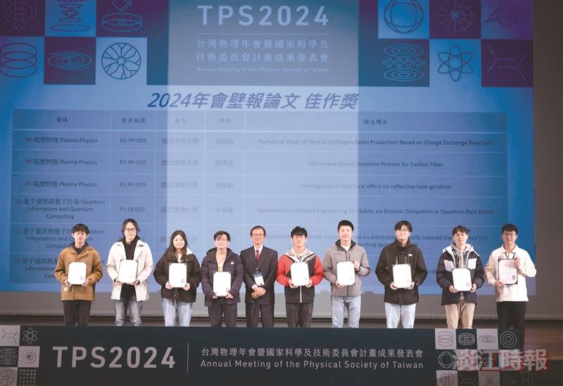
Physics Department's Wen-Chun Chen (third from the left) and Zong-Jhe Hsieh (fourth from the left) received the Best Poster Paper Award at the Taiwan Physics Society. Dr. Ying-Jer Kao, President of the Physics Society of Taiwan and a professor in the physics department at National Taiwan University (fifth from the left), presented the awards.

