Tamkang Times No.1178
2024 Webometrics Rankings of World Universities Ranks Tamkang as the Top Private University in Non-medical Fields in Taiwan

1111 Job Bank collaborated with TUN University Network to conduct the "2024 Corporate Favorite University Survey." They held a press conference on the morning of February 27, the day of the college entrance exam results announcement, to announce the rankings. Tamkang University ranked 9th overall, leading among private universities and winning the championship among private universities. Vice President for Administration of Tamkang University, Dr. Chun-Hung Lin, and Secretary-General, Dr. Yu-Pei Ma, jointly attended the press conference, and they were interviewed by FTV, TTV, USTV, SET, and PTS.

Spokesperson Vivi Huang of 1111 Job Bank pointed out that Tamkang University actively collaborates with Far EasTone Telecommunications (FET) and Microsoft Taiwan to jointly create the "first sustainable cloud in the country," which is a pioneering large-scale industry-academia collaboration in Asia. She introduced Tamkang University as "dominating the competition, demonstrating its leading position in the field of education."

During the press conference, Dr. Lin stated in an interview that Tamkang University has been deeply committed to the development directions of "the Triple Objectives of Education," namely globalization, information-orientated education, and future-oriented education, with a long-standing leadership position in the field of informatization. In recent years, Tamkang University has strategically collaborated with Microsoft Taiwan and FET to develop the "All-Cloud Smart Campus 2.0," with "AI+SDGs=∞" as the development direction. To ensure that every student possesses capabilities in both AI and sustainability, the university has reformed its curriculum in response to the development trends of the era and industry. Starting from the 2022 academic year, Tamkang University has introduced 2 new courses, "AI and Programming Language" and "Exploring Sustainability," as part of its general education curriculum. Dr. Lin emphasized, "Students from all disciplines must have both programming language skills and sustainability capabilities." He also mentioned that Tamkang University actively embraces ChatGPT to enhance administrative efficiency and student learning effectiveness in administrative work.

The survey includes categories such as "Overall Performance Ranking," "Ranking of Public and Private Universities," "Ranking of Public and Private Technological Universities," and "Ranking by 18 Academic Clusters." Tamkang University ranks 9th in the comprehensive ranking, leading among private universities. Additionally, we secured the championship in the category of private universities, while National Taiwan University leads among public universities.

On the day of the college entrance exam results announcement, many parents and students were unsure whether to prioritize selecting a major or choosing a university. Vivi Huang observed the top 3 schools, emphasizing their deep integration with digital and various field enterprises. "Graduates who possess AI skills while retaining personal expertise and have multidimensional skills are the most popular," she said. Employers favor 5 major abilities in candidates: problem-solving ability, teamwork, communication skills, enthusiasm and resilience, and rapid learning ability. She also noted, "A graduation certificate is the ticket to enter the workplace, and since the second job, the performance in the previous job matters." She advised students to seize their university campus life to accumulate both soft and hard skills, which will make them more appealing to employers.
2024/03/12

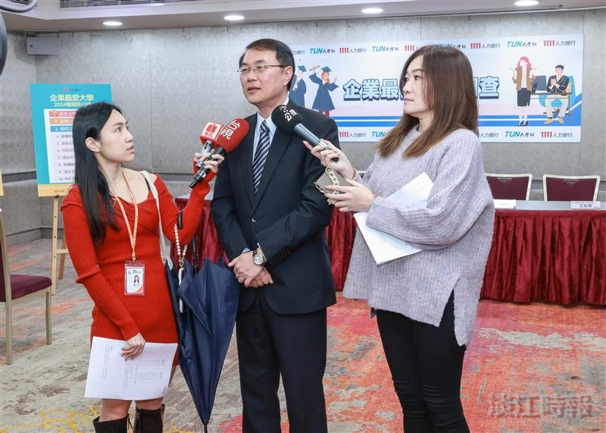
The Vice President for Administration Affairs of Tamkang University, Dr. Chun-Hung Lin, was interviewed by the media at the press conference.

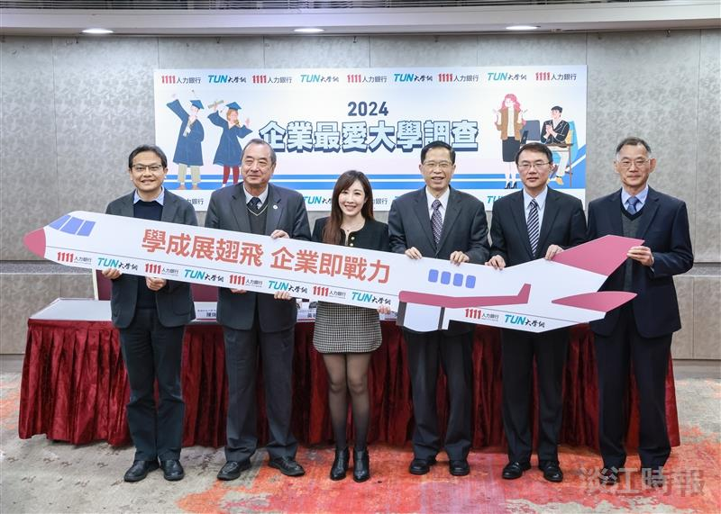
1111 Job Bank's "2024 Corporate Favorite University Survey" press conference, from right to left: Dr. Tsu-Shing Wang, Chief Secretary of Chung Shan Medical University; Dr. Chun-Hung Lin, Vice President for Administration Affairs of Tamkang University; Dr. Yao-Ting Sung, Vice President of National Taiwan Normal University; Vivi Huang, Spokesperson for 1111 Job Bank; Dr. Ju-Long Chen, President of Chihlee University of Technology; and Dr. Chun-Yen Chung, Executive Vice President of Kun Shan University.

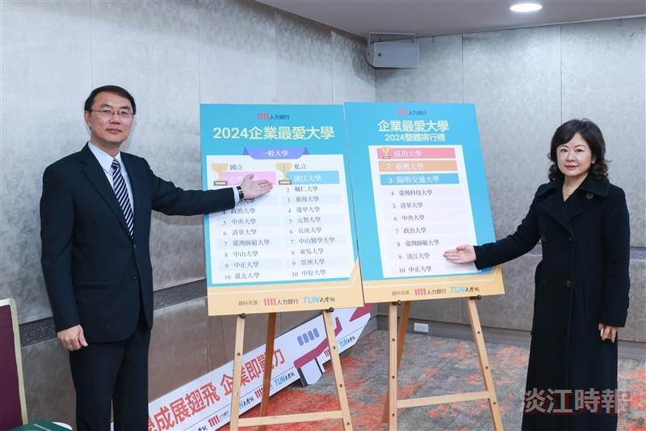
The Vice President for Administration of our university, Dr. Chun-Hung Lin (left), and Secretary-General, Dr. Yu-Pei Ma, jointly attended the press conference and were interviewed by the media.

