Tamkang Times No.1175
The Art of Calligraphy with the Intelligent e-Pen - Yun-Yi Yeh & Shao-Hsun Lin Lead the Way

The results of the "Art of Calligraphy with the Intelligent e-Pen - AI-Generated Calligraphy Creative Contest" and the "2023 College Student e-Pen Calligraphy Contest," organized by the Carrie Chang Fine Arts Center, were recently announced. In the former, Yun-Yi Yeh from outside the university secured first place, while in the latter, Hsin-Ju Hsieh from the Department of Architecture and Chao-Yue Yang from the Department of Public Administration tied for second place. In the e-Pen calligraphy contest, Shao-Hsun Lin from the Department of Information Management received the Special Award, and Cheng-Hsin Lin from the Department of Advanced Materials Science and Engineering claimed second place.

The "Art of Calligraphy with the Intelligent e-Pen - AI-Generated Calligraphy Creative Contest" is a first-time competition aimed at encouraging participants to use generative AI drawing applications to creatively incorporate calligraphic features, generating imaginative calligraphy artworks. Through the creative process, participants are encouraged to understand the meaning, characteristics, and heritage of calligraphy, paving the way for the integration of technological elements into calligraphy art in the new century. Yun-Yi Yeh's work, titled "SDGs多維空界," employs AI-simulated flying white calligraphy, combined with the bold characteristics of semi-cursive brushstrokes, making the artwork unique and intriguing. Hsin-Ju Hsieh's piece, titled "荏苒," uses commands to showcase the smooth lines and intense brushwork of calligraphy art, resulting in a strongly-styled piece. Chao-Yue Yang's creation, titled "Elegance in the Flow," conveys the unpredictability of life through abstract calligraphy, with each stroke representing free-flowing ink lines, narrating the changes in time and demonstrating the beauty of the fusion between tradition and modernity.
2023/12/27

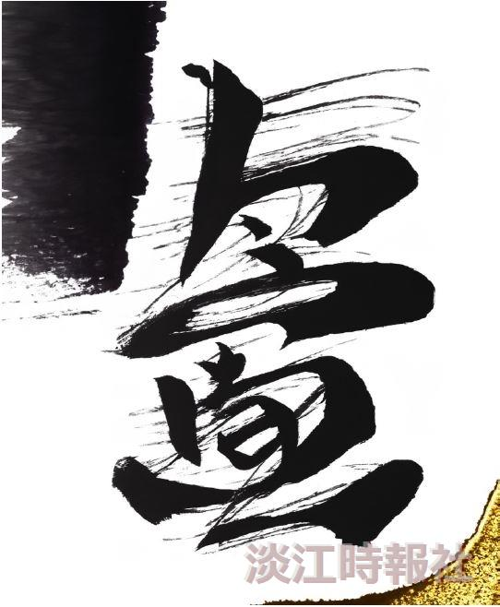
First Place in the “Art of Calligraphy with the Intelligent e-Pen - AI-Generated Calligraphy Creative Contest”: Artwork titled “SDGs多維空界” by Yun-Yi Yeh.

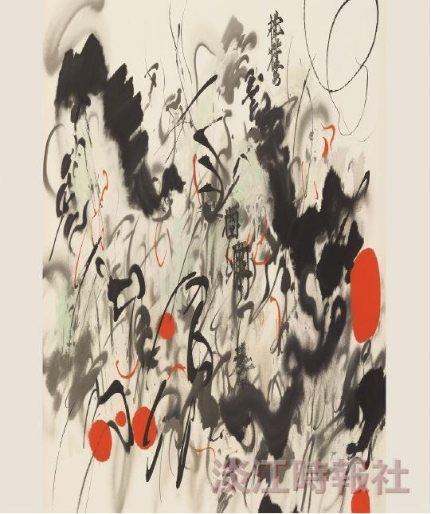
Second Place in the “Art of Calligraphy with the Intelligent e-Pen - AI-Generated Calligraphy Creative Contest”: Artwork titled “荏苒” by Hsin-Ju Hsieh.

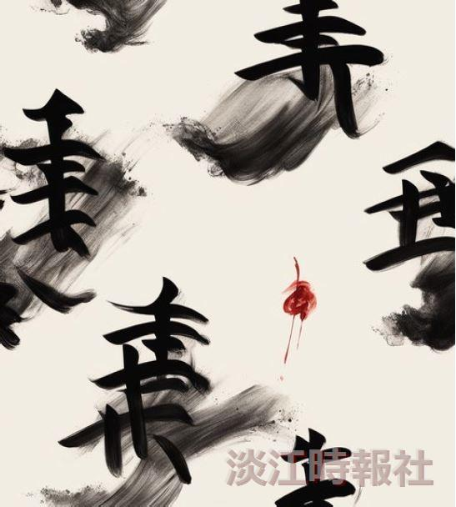
Second Place in the “Art of Calligraphy with the Intelligent e-Pen - AI-Generated Calligraphy Creative Contest”: Artwork titled “風華流轉” by Chao-Yue Yang.

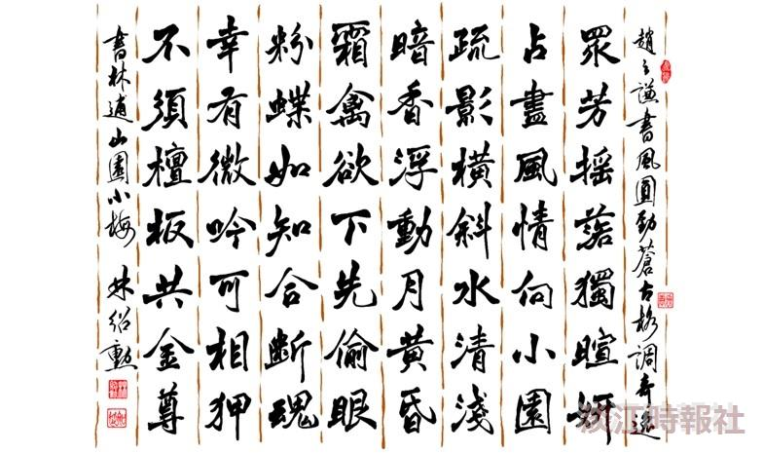
Special Award in the “2023 College Student e-Pen Calligraphy Contest”: Calligraphy artwork by Shao-Hsun Lin.

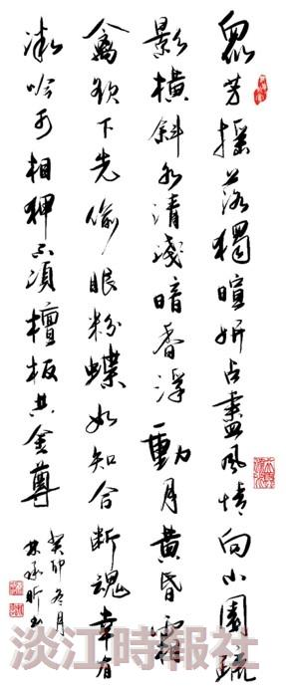
Second Place in the “2023 College Student e-Pen Calligraphy Contest”: Calligraphy artwork by Cheng-Hsin Lin.

